The REGNET Portal

Comparison to ‚Baseline Portals’.
WEB-Portals provide access to different functions provided to a user/client of IT-services offered by an organisation. In the field of Cultural Heritage most commonly used WEB-presentation provide general information like this:
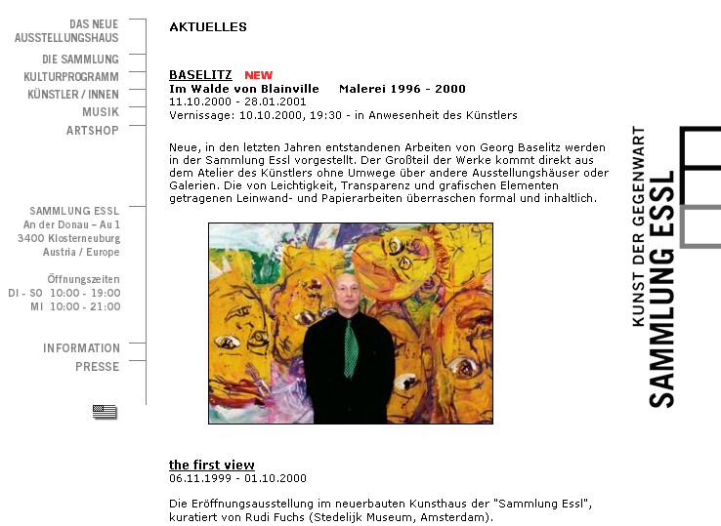
The REGNET System will provide - besides this ‘generic’ entry – access to dedicated functions which are grouped by:
- Data Generation
- Search System
- eBusiness
Examples of portals supporting these functionalities are:

Data Generation
For example: Data Entry to the Document Server within the Cultivate Project:
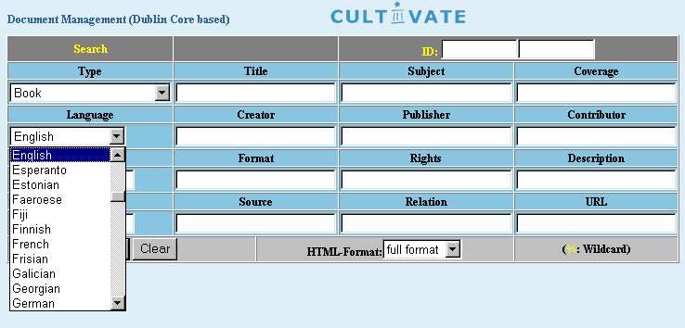

Harvesting functions for example are provided by the system “DC-DOT” like this:
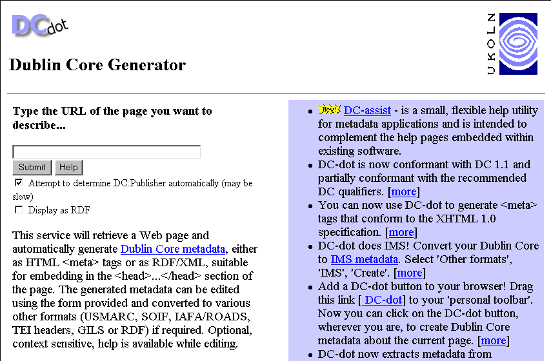
Another option for generating metadata is the ‘Reggie’ Meta Data Editor:

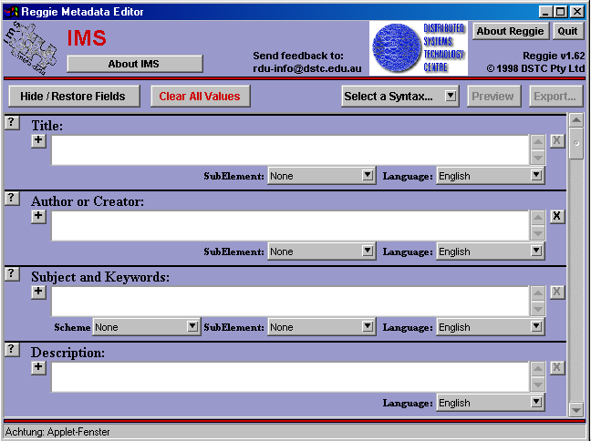
Search Systems
Examples of portals enabling access to search systems (MOSAIC Project; “Cultural Online Browser”):
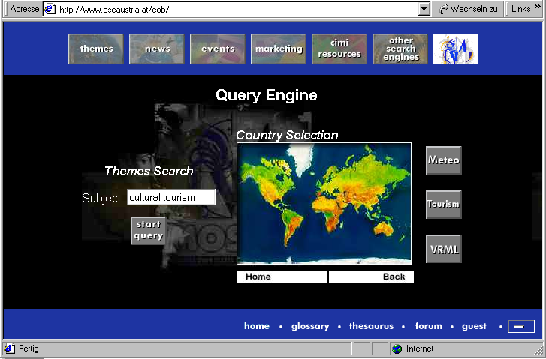
Or (http/z39.50 protocol gateway based on the YAZ/ZAP system):
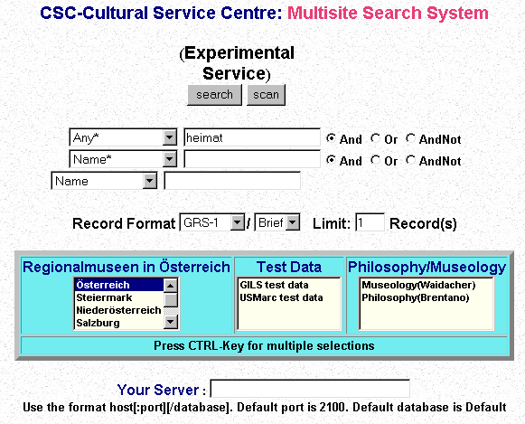
A query and order process using the REGNET-WAP search access mode will look like this:
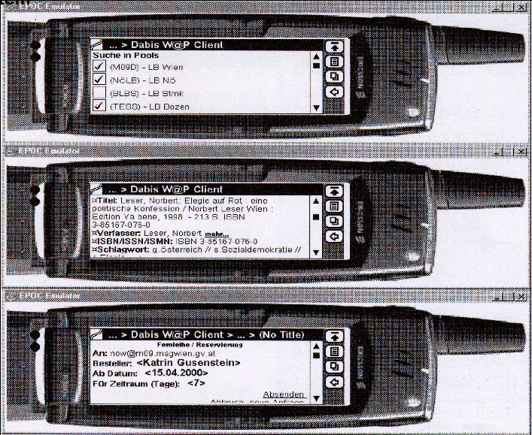

eBusiness
Portals providing access to B2C functionality look like:
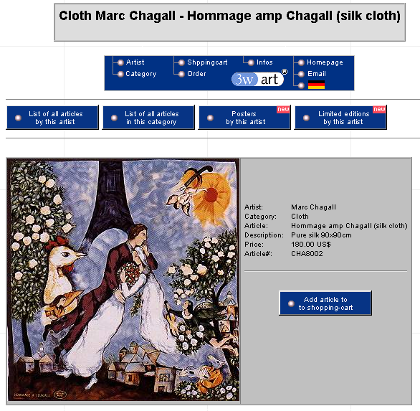

http://www.museum-shops.com/

left side.
Another example (http://museumstuff.com/):
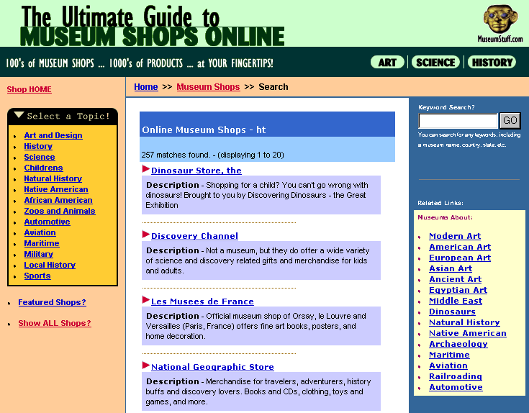
An ecommerce solution based on a software from the public domain (minivend) looks like this:
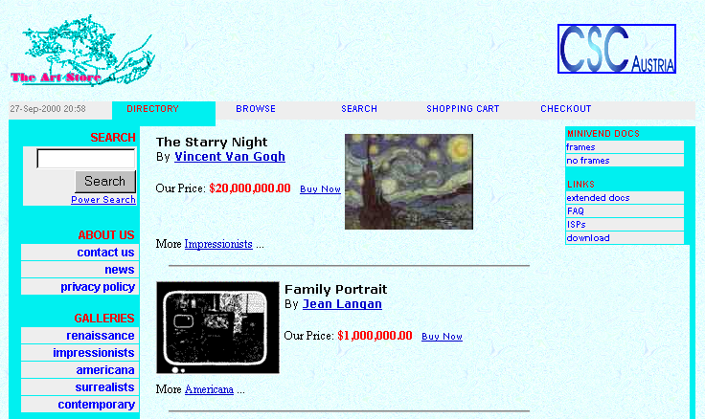
An auction activity looks like this:
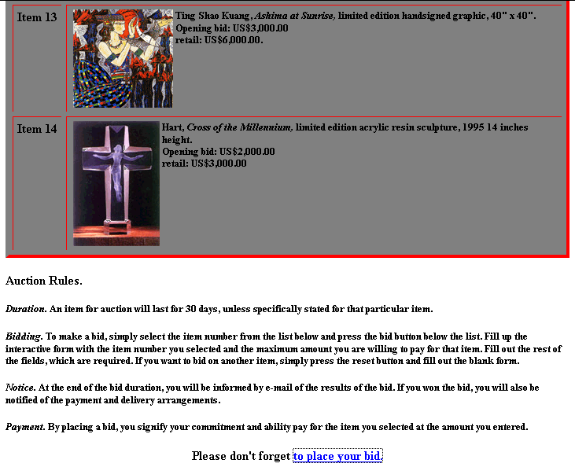

There is no appropriate example showing the functionality of REGNETS B2B solutions (eg: electronic publishing component).

REGNET provides not only these functionalities via a unique portal but also implements the necessary technical infrastructure (set of servers located on the REGNET nodes; see REGNET System Architecture). The REGNET system will be scalable to the needs of cultural heritage organisations also in term of functionality not only in terms of presentation on the portal. This will be done by the introduction of a flexible middle ware component (application server).

OpenHeritage provides these functionalities on the portal but concentrates on the implementation of a CM (collection management) component which is a small functional subset of components provided by REGNET.

