REGNET-Cultural Service Centre vs OpenHeritage-Territorial Service Centre

Both terms CSC (Cultural Service Centres) and TSC (Territorial Service Centre) could be used in exchange if, and only if TSC relates to specific services for cultural heritage organisations. TSC as outlined in the proposal is based on several dedicated and manufacture dependent hardware and software component (eg. Oracle RDBMS, Application Servers). The service infrastructure is a standard IT-infrastructure with no dedication to cultural heritage application (eg ontology related component).
REGNET is based on and committed to Open Software solutions, dedicated to Cultural Heritage related applications. REGNET distinguishes different application domains (museums, libraries, archives, …) and dedicates a special work area (D) to domain specific questions. REGNET also recognizes region based differences by having introduced also a special work area (E).
Furthermore REGNET takes as baseline the concept of the CSC-Austria which is a spin off of the MOSAIC Project.
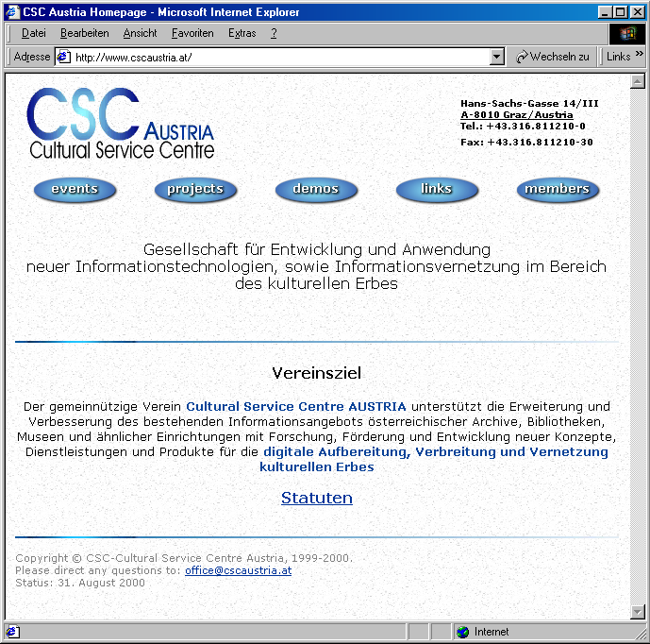
This CSC is already established and called: “Enterprise for develop-ment and application of modern Information Technology as well as Information Networking in the Cultural Heritage domain.”

It is “a non for profit enterprise (Verein) and its mission is targeted to support the improvement of existing data services of Austrian Archive, Libraries, and Museums or similar organisations by doing research, support and development of innovative concepts, offering services and products in the field of digitisation, distribution, and networking of Cultural Heritage related data.”

The constitution (‘Statuten’) of this Cultural Service Centre can be accessed via the CSC-Austria Homepage (http://www.cscaustria.at/ above).

