

REGNET-IST-2000-26336

Date: 5th July 2001
Author: Sam Habibi Minelli
Company: Fratelli Alinari, Firenze.

IMAGES WEB ARCHIVE BEST PRACTICES

Index:

1- Abstract
2- Methodology
3- Analysis of three on-line archives:

- CORBIS (U.S.A.)
- BRIDGEMAN (U.K.)
- SCALA (ITALY)
4- Conclusions
5- Tables of images:
- Front pages
- Best practices
- Worst practices

1- ABSTRACT:

This document analyses three important archives that offer images online: CORBIS (U.S.A.), BRIDGEMAN (U.K.) and SCALA (ITALY). The method chosen to execute this analysis is a “breathe-first-method”, examining the web sites on the basis of five main features.
A direct comparison among the sites is made and summarised. Lastly some screen capture show front pages, best and worst practices. Great difference among the sites come out if considering : image file formats, size, resolution, watermarking, thumbnails, services.
All the sites use a proprietary general-search engine and few of them use specific advanced engines.

2- METHODOLOGY:

The “breathe-first-method” is a fast and user-oriented technique: some web sites have large numbers of pages (an average of 800 active links) and usually they offer lots of services that would need excessive amount of time to be analysed and compared.
The functionality of the site is detected horizontally after selecting some fundamental features :
- Web tree
- Key subjects (if published)
- Volume of data
- Technical information
- Best and worst practices

3- ANALYSIS OF THREE SITES

CORBIS : Corbis main offices are in Seattle, Hong Kong, New York, London, Los Angeles, Paris and Kuala Lumpur, the privately-owned company (Microsoft) has approximately 1,300 employees worldwide. The Corbis Collection includes significant photography and fine art from more than 3000 creative sources, including Ansel Adams, Annie Griffith Belt, David Muench, Roger Ressmeyer, Galen Rowell, David and Peter Turnley, Mark Seliger, The National Gallery - London, The State Hermitage Museum - St. Petersburg, Lynn Goldsmith, Morton Beebe, Nick Kelsh and Chuck O'Rear.

url: http://www.corbis.com/

Tree:

Front page (total different front pages 14: it changes each time the user opens the site or refreshes the frame window)
Shopping (“pictures for home and office”)
Shopping (total different front pages 3: the changes each time the user refreshes the frame window)
Create
Decorate
Gift ideas
About

Shopping chart
My account
My portfolio
Help

Professional licensing (“licence photography for advertising, news, editorials and other professional use”)
Professional licensing (total different front pages 1)
About
Contact
What’s new

Search engine:
Traditional licensing
Royalty free
Footage
News
Biz presenter (“power point presentations, cartoons, templates”)
Biz presenter (total different front pages 10)
Products
Services
Subscriptions
Expert advice
About CORBIS

Shopping chart
My account
My portfolio
Help

About CORBIS (“corporate web site”)
Corporate information (total different front pages 7)
Company
Press room
Employment
Partners
Photographers
Key subjects:

City Views | Prints
On the Move | Photography
Digital Pictures | Animals
Photography | Architecture
Art | Flowers & Foliage
Editors' Picks | Food & Beverage
A Bee's Eye View | Holidays/Traditions
All Aboard! | Humour
All That Jazz | Landscapes
Angels in Art | People
Degas Delight | Performing Arts
Digital Domain | Romance
Dinner Party | Space & Astronomy
Fairway Fantasy | Sports & Games
Fall Harvest | Still Life
Fresh Flowers | Transportation
Great Art | Travel
Life's a Beach | Art
Marilyn! | Collections
Mountain High | Framed Sets
National Parks | Screensavers
Rose Garden | Ansel Adams
Space Odyssey | Limited Editions
Streamlined Design | Explore all images
The King | Slice of Life
Travel Treasures | Historic Moments
Viva Volcanoes | Style
Winter Wonderland

Search engines:

- Free text search with refinement option.

Volume of data:
- 6.5 millions of images.
- 2.1 millions of images online.
- 56 subjects.

Technical information
- thumbnail size: 88x128 pixels
- selected thumbnail size: 177x256 pixels
- enlarged size: 332x480 pixels
- file format JPG

Best practice by CORBIS:

- The front page and some secondary pages changes aspect every time you open the url.
- There exists a page dedicated to the partners describing them and giving an active link to them.
- The users can send their images to the archive after compiling a submission module.
- New partners can join the archive submitting a specific module.
- Press releases page gives an update overview on what had been written on newspapers and publications.
- Easy menu by subject.
- Possibility to enlarge the thumbnail.
- Good graphical presentation.
- Good basket for ideas (downloading images for power point; screen saver images; …).
- Fast loading for images.

Worst practice and errors by CORBIS:

- Subjects are not well separated (you can find astronomy put together with fantasy).
- Some image are not visible (empty thumbnails): error.
- Some image have cropping errors.
- Low definition search engine.
- Thesaurus on subject (restricted).
- Low differentiation of images (in the set “boxing” you can find 10 images representing boxing gloves on a total of 26 images found).
- Redundancy of menu in the same page (in the “Professional licensing” there are two apparently different menu) .
- Truncated key words give no search result.

BRIDGEMAN : The Bridgeman Art Library (founded in 1972) , collects art images for reproduction: 800 museums, galleries, private collections and artists. Almost 3,000 Bridgeman images are available for purchase at a site created by stock agency Getty Images. Some Bridgeman’s sources are the British Library, the National Galleries of Scotland, Sweden and South Africa, the National Galleries of France and Italy. Offices are located in London, New York and Paris.

url: http://www.bridgeman.co.uk/

Tree: (no submenus)

Browse
Search (quick)
Portfolio
News
Features
Copyright
About us

Search engines:

- Free text search
- Advanced search (fields: item number; title; artist; nationality; century; broad topic; medium group; location; keywords).

Volume of data:
- There is no information on the web site referred to the number of images on line nor on the number of key words.

Technical information
- thumbnail size: 62x75 pixels
- file format JPG

Best Practice by BRIDGEMAN:
- The database is available to all unregistered users without logging in.
- Good graphical presentation.
- Text-only option (fast way to get information).
- Registering of user search criteria.
- Simple architecture.
- Press releases.

Worst Practice and errors by BRIDGEMAN:
- Some image are not visible (empty thumbnails): error.
- Too small thumbnails and the watermark is too large.
- Truncated words give no results by the search engine.

SCALA The Scala Art Library was founded in 1953 by the historian Roberto Longhi. Scala is an archive of colour reproduction (painting, sculpture, architecture, decorative arts, archeology, travel). Italian art makes up the core of the collection, but the Library contains thousands of first-rate works from the rest of Europe, the United States, Russia, the Middle and Far East and Africa.

url: http://www.scala.firenze.it/

Tree (front page):

Primary menu:
About us
The SCALA picture library
How the site works
Contact us
News
Photographic campaigns and additions
Newsletter
Utilities and services
How to request SCALA photos
Forgot your password?
Prices and conditions
SCALA paintings CD-ROM
Photographic Lab
Themes
Jewel
Battles and music
Hunting
Princesses
Knights
Sport
Screen saver

Secondary menu:
Art:
SCALA catalogue
Art resource catalogue (U.S. museums).
Main museums list

Travel and culture:
Travel catalogue
Locations list

Search engines:

- Full-text searches. Free text inquiries in three catalogues (Art, Travel, Art Resource ).
- Advanced searches, available to registered users, for more than one type of inquiry in each of the three catalogues (Art, Travel, Art Resource), producing larger images and allowing the user to select and order subjects on line.
Search Fields in “travel and culture section”: title, location, town, state, area, keywords, code.
Search Fields in “SCALA catalogue”: artist; title; location; code.
Search Fields in “Art resource catalogue (U.S. museums)”: keywords; artist; title; museum/location; city; genre; code.
Volume of data:
- 4.000 museums included .
- 50.000 colour reproductions of works of art.
- 15.000 images of culture and travel.
- 7.000 keywords.

Technical information

- thumbnail size: 64x32 pixels (secondary menu).
- thumbnail size: 180x143 pixels (Themes).
- file format JPG

Best practice by SCALA:
- Truncated words can give some search results.
- English version.
- A search ca be sorted by city, location, title in ascending or descending order.
- The user can choose the number of images to be visualised.

Worst practice and errors by SCALA:

- Slow loading of the images.
- Redundant column in the search page.
- Too small thumbnails for free search (poor editing quality) for the secondary menu.
- Mistaken key words give no results for the search (while truncated words can give a search results).
- Static pages.
- Not homogeneous pages (even the same page has not a defined style for characters: see museums page).
- Not synthetic menu.
- Discussible theme subjects (i.e. “Battles and music”).
- Some images are not marked and some are marked.
- The menu gives no tree information: risk of cycling.
- Some thumbnails are not displayed (error).
- Some pages contain few information (i.e. http://www.scala.firenze.it/in.dir/photolab.asp in this page the images lead to misunderstanding ).

4- CONCLUSIONS

- Common problems have been found for all sites i.e. not displayed thumbnails (even after some days on the same pages).
- Images sometimes can be found in sets to which they have almost nothing in common.
- Some sites use too big static watermark on very small images.
- Some web sites need lots of time to be explored and cycling is common .
- Copyright information are necessary.
- Not enough technical information on images (resolution, format, size, colour channels) to the disposal of the professional user.
- Graphical aspects of the web site sometimes are undertaken.
- Using only generic search engine with at most a list of refinement causes a great loss of time for the professional user who would have to examine lot of pages before finding a specific image.

 | CORBIS | BRIDGEMAN | SCALA
Free text search | Yes | Yes | Yes
Advanced search | No | Yes | Yes
Volume of images on-line (declared) | 2.1 millions | Not found | Not found
File format | JPG | JPG | JPG
Thumbnail size (qualitative) | Big | Too small | Too small
Watermark | Yes | Yes | Yes
Graphical presentation | Good | Good | Sufficient
User friendly | Good | Good | Sufficient

5-TABLES OF IMAGES: front pages

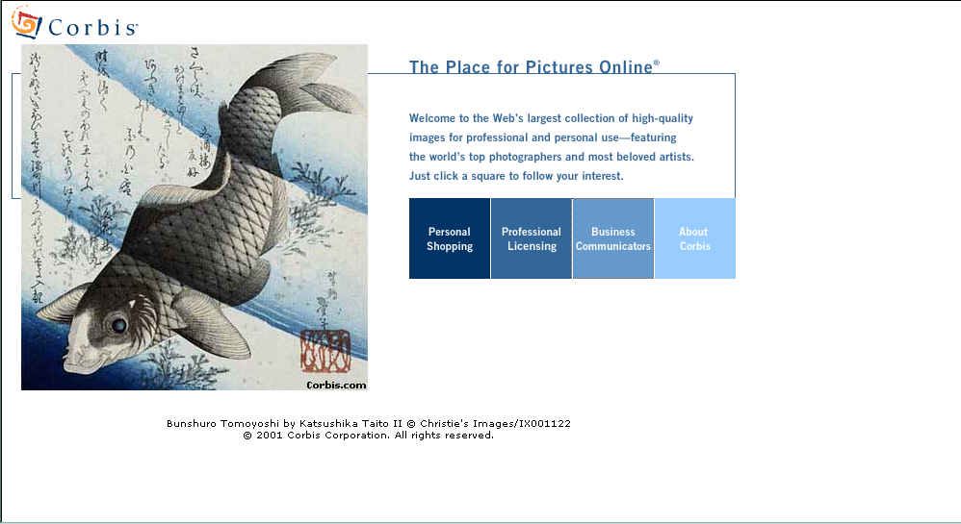

CORBIS : There are 14 different front pages that change each time the user opens the web site or refreshes it.
Note the simple starting menu with a sinthetic description that is shown passing with the mouse on the bar.

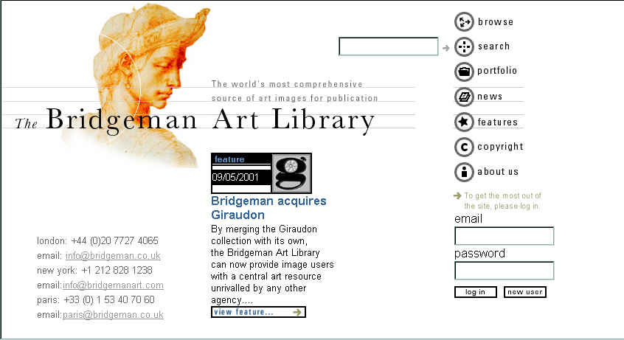
BRIDGEMAN: clear icons and direct entering. Note the external search engine.

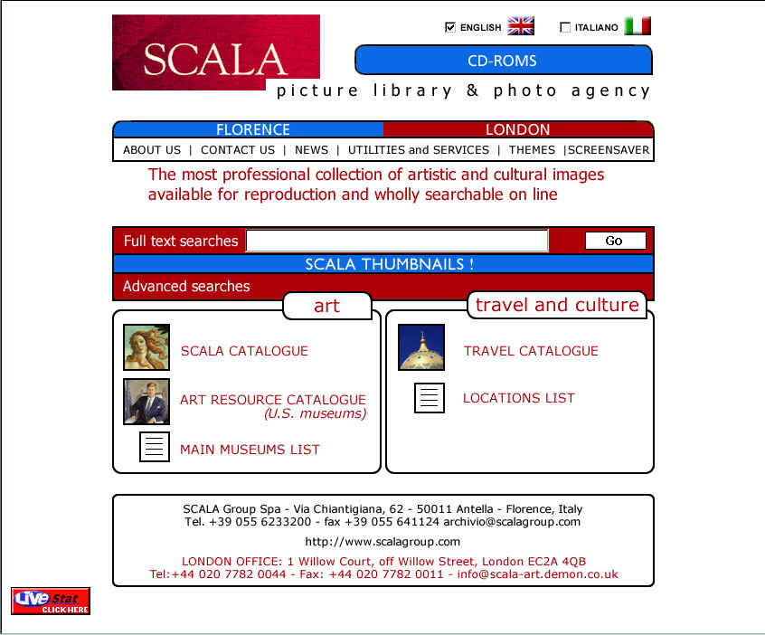
SCALA: three ways to see images from the front page: 1- from the top menu (THEMES); 2- from the search engine; 3- from the secondary menu. Note the English vesion.

5- TABLES OF IMAGES: best practices

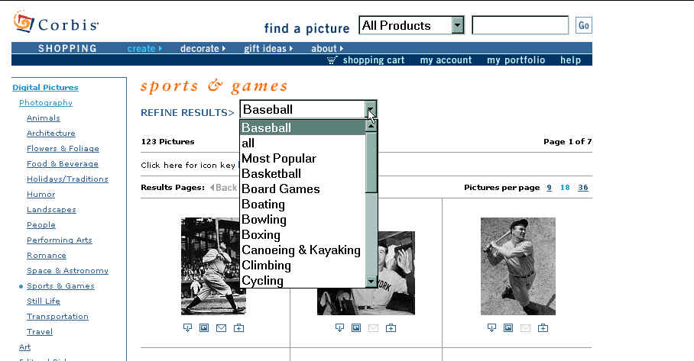

CORBIS: refinement of a search. Note the size of thumbnails.
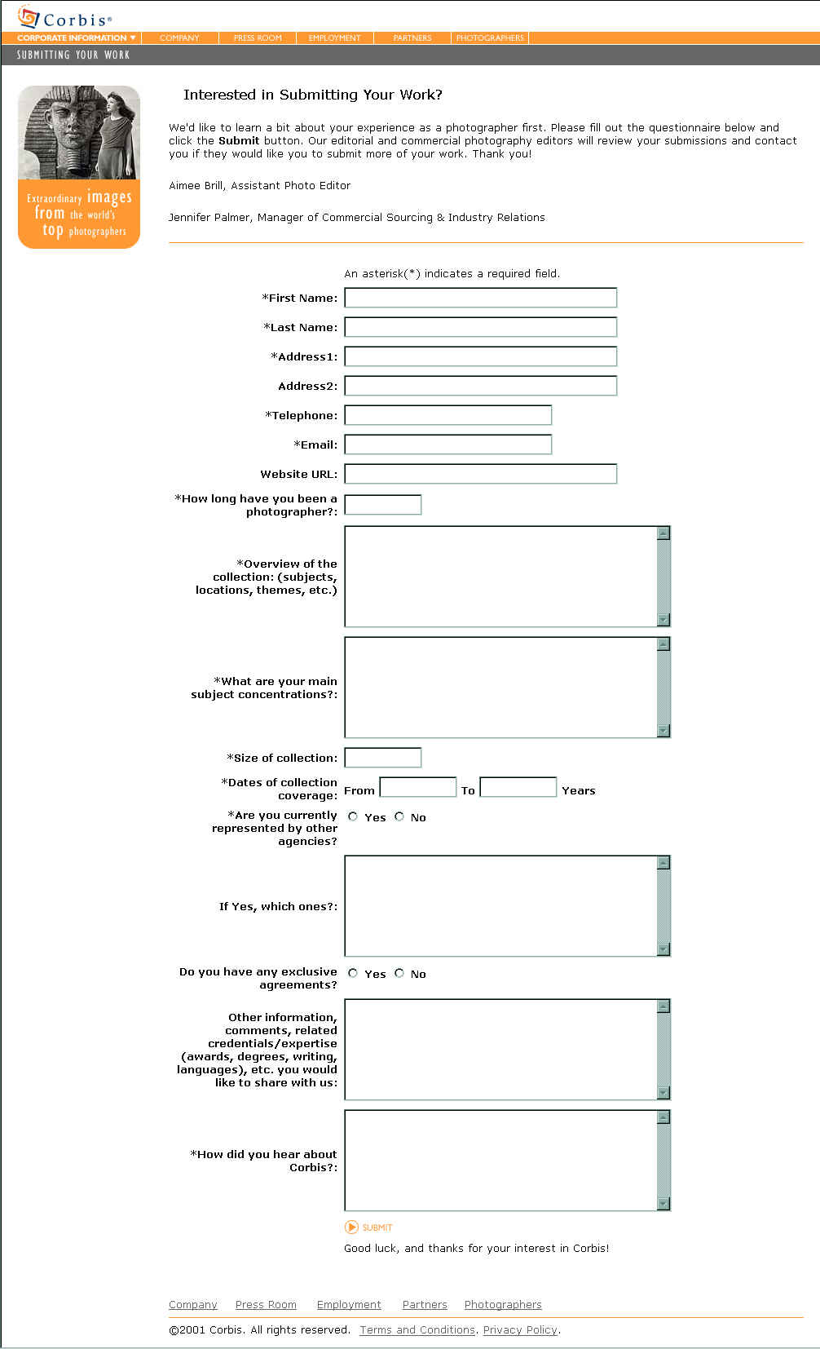
CORBIS: the submission module in order to contact new photographers.
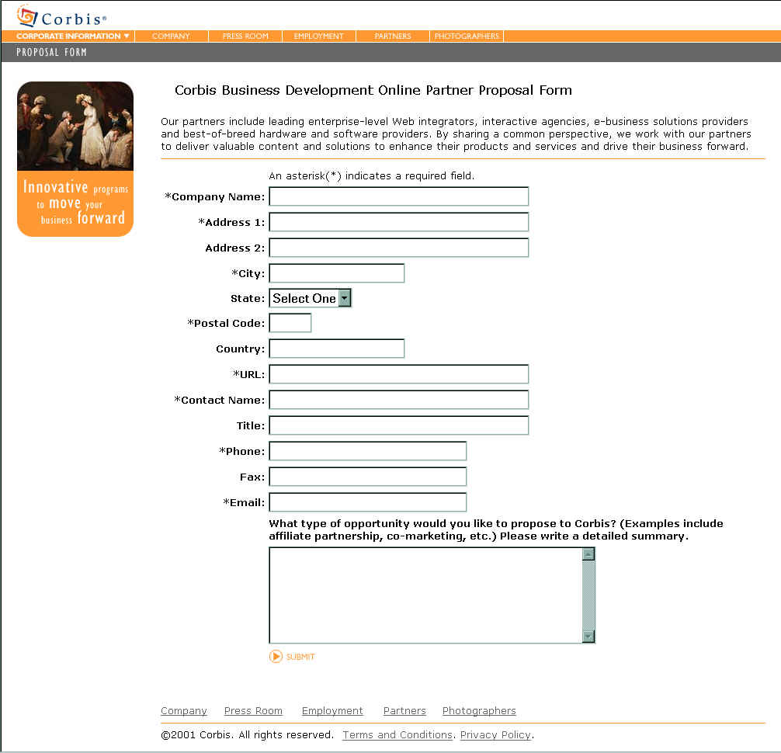
CORBIS: submission module for new partners.
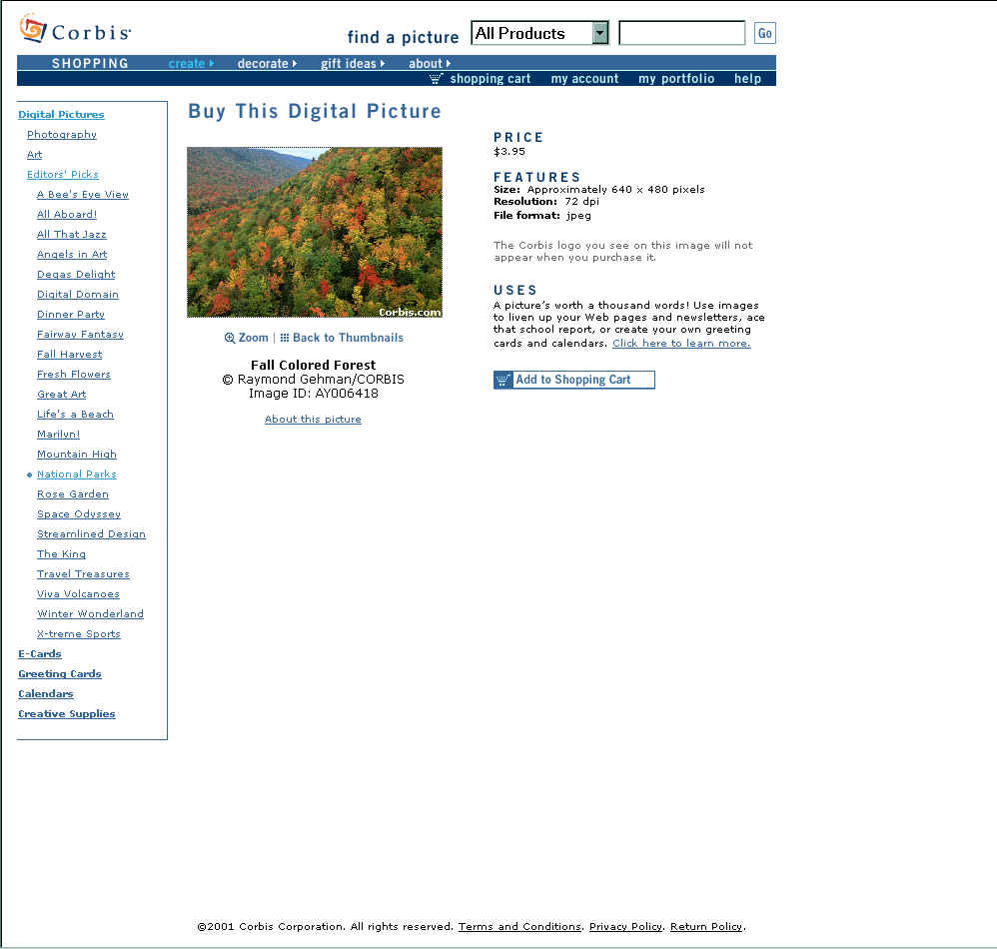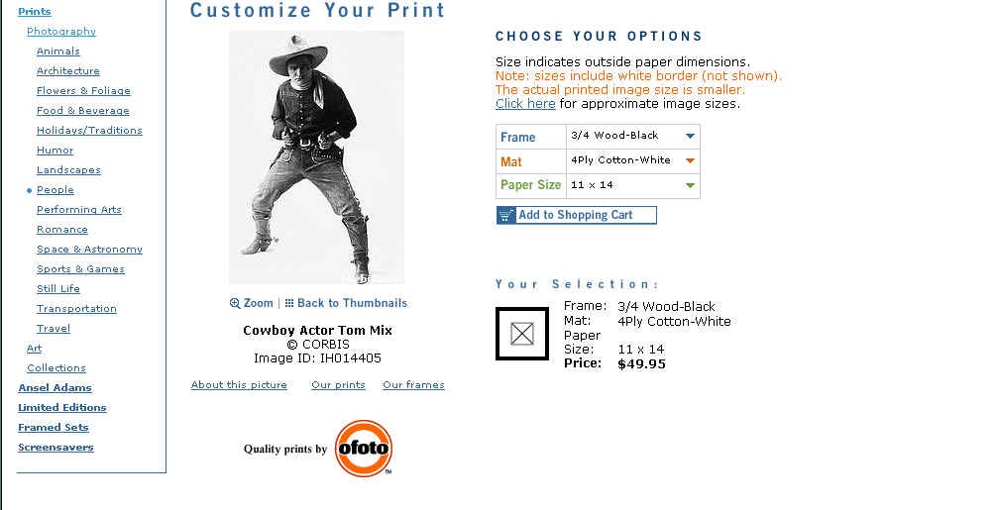

CORBIS: choosing a print and customizing it (you can select a specific frame, paper mat and size) and see the selections displayed. You can also zoom the image.
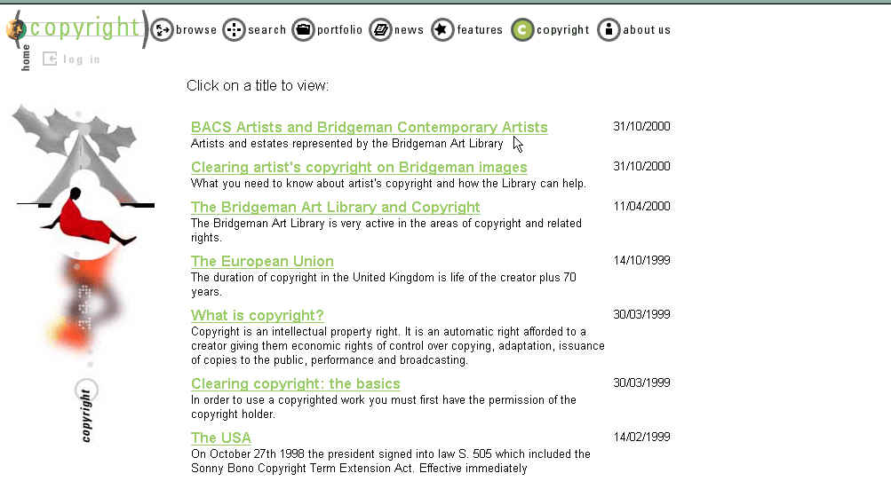BRIDGEMAN: clear documentation about copyrighting. 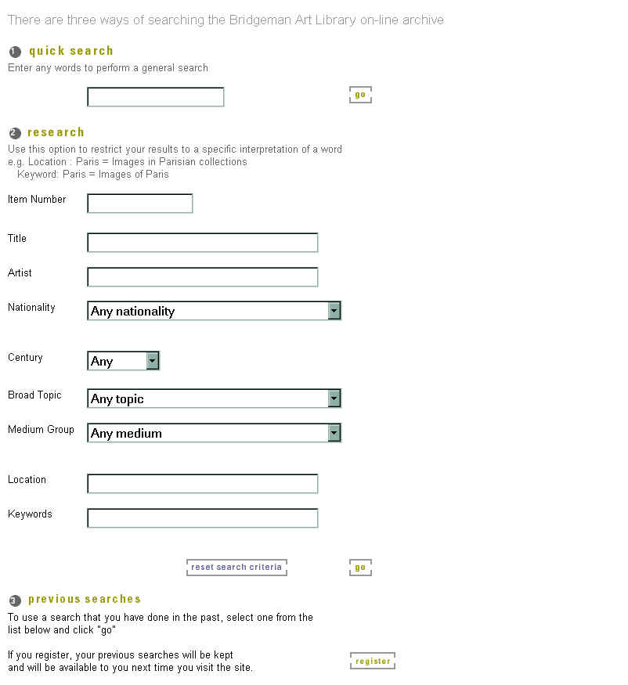 BRIDGEMAN: advanced search engine. Note the possibility to record a search criteria.
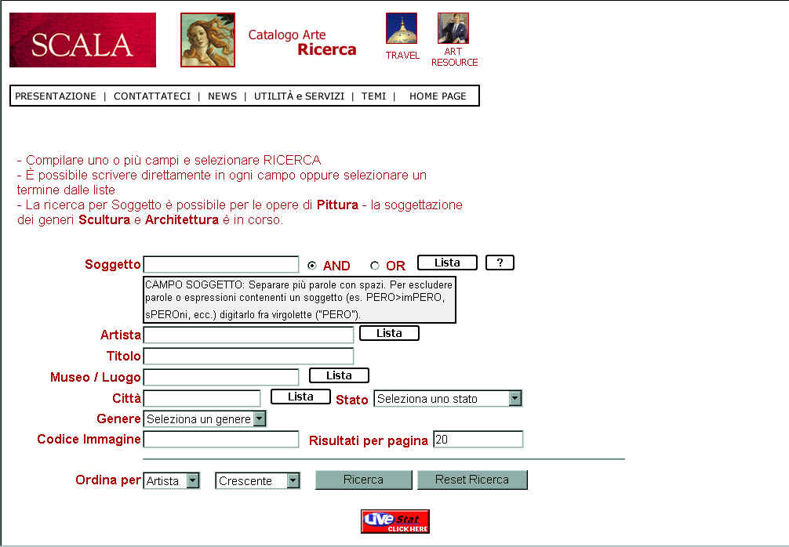SCALA: advanced search engine in the catalogue of works of art. Note the sorting option of the output and the possibility to choose from a selection list.

5- TABLES OF IMAGES: worst practices and errors

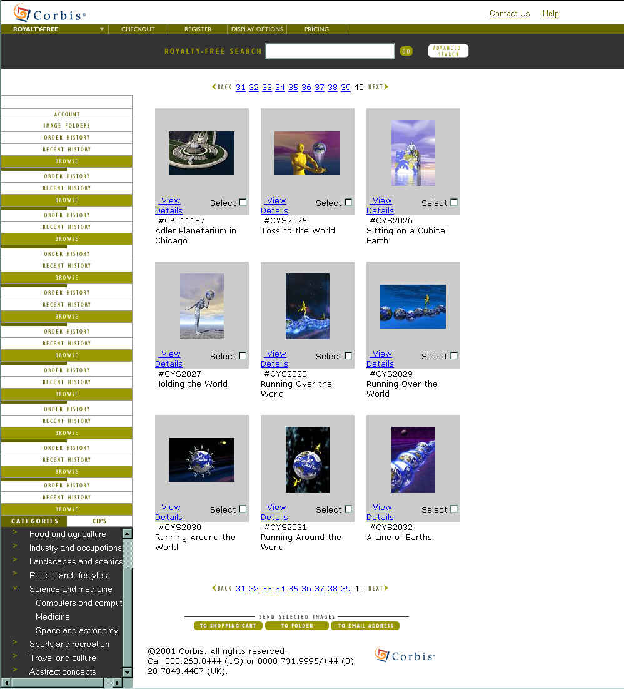
CORBIS: Adler Planetarium has been put together with creative images.
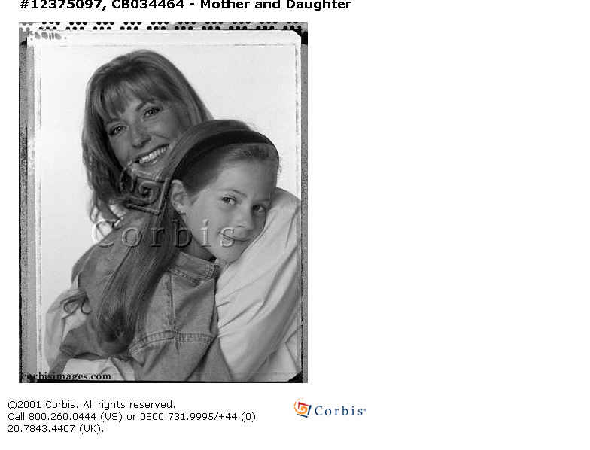
CORBIS: error in cropping the image.
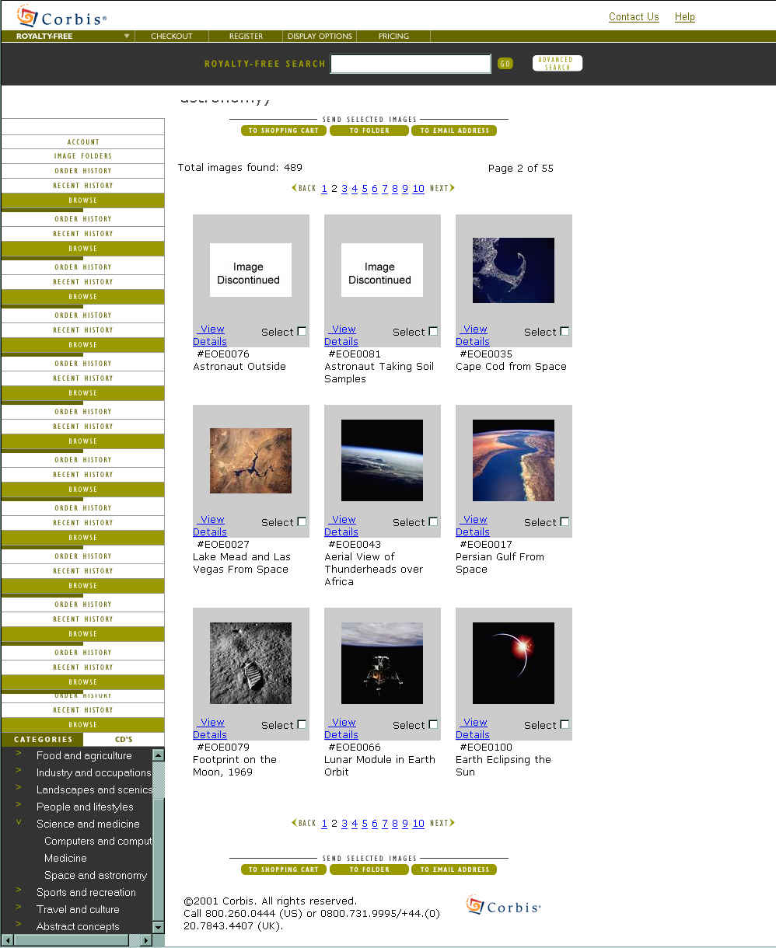

CORBIS: images missing.

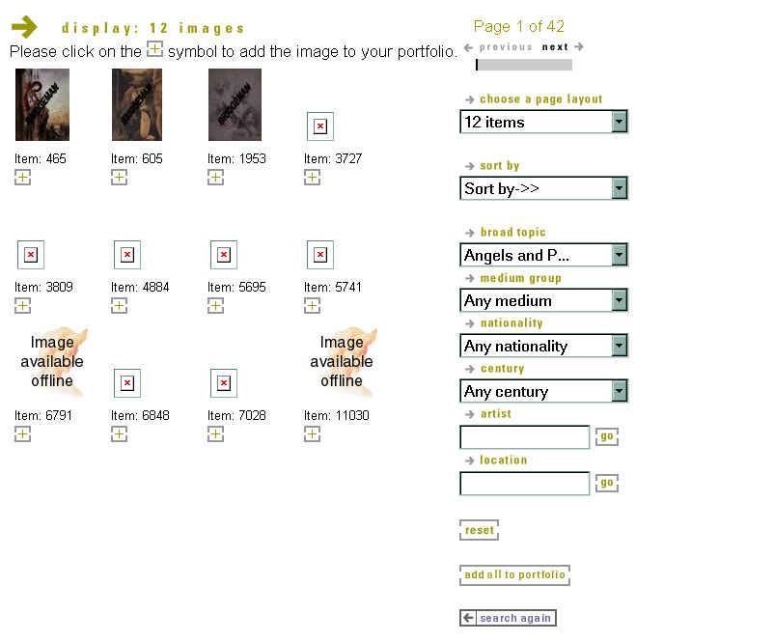
BRIDGEMAN: advanced search engine by list of options. Note the images missing.
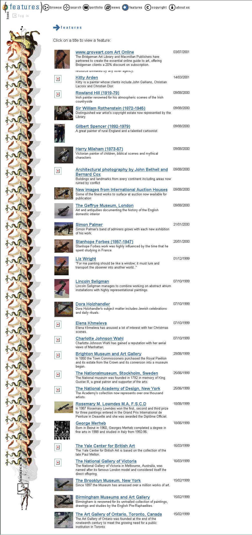

BRIDGEMAN: search output. Note : some image are missing.

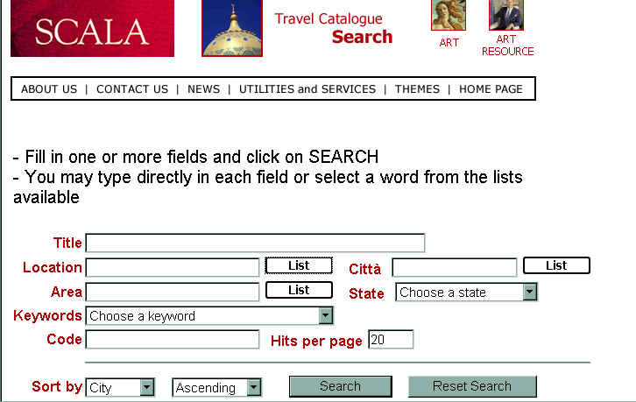

SCALA: the field “town” is written in Italian (“città”) instead of English.
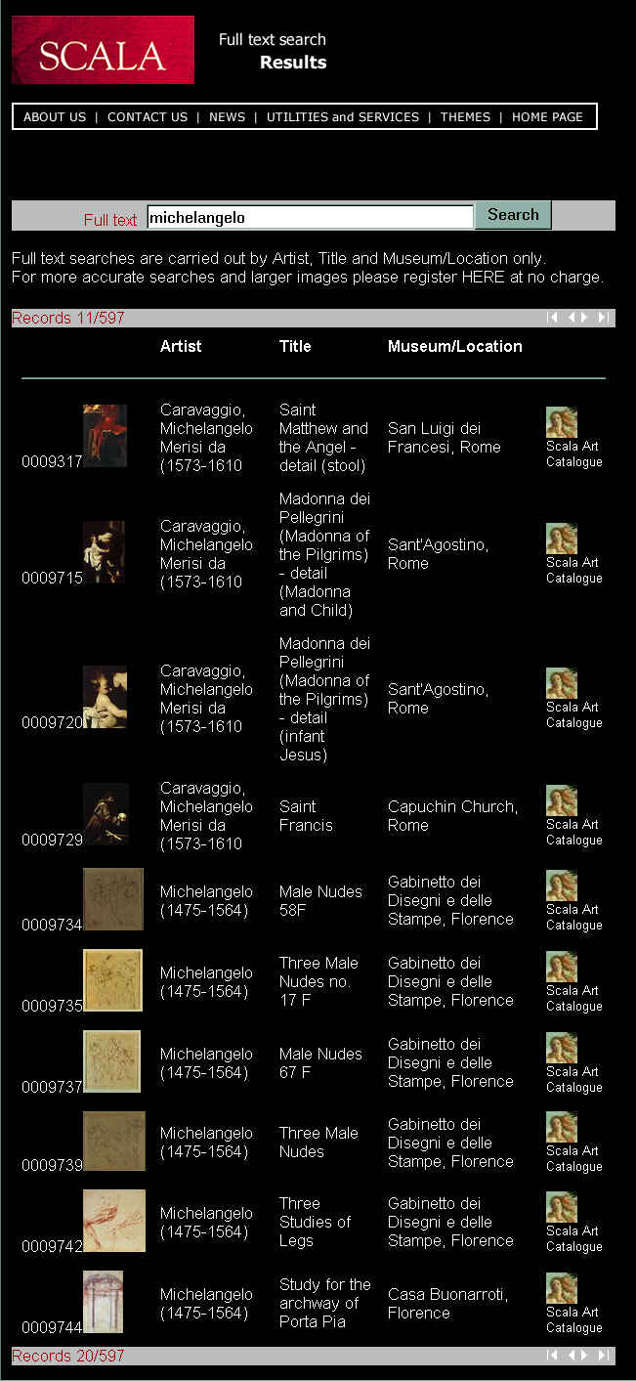
SCALA: the last column is redundant .
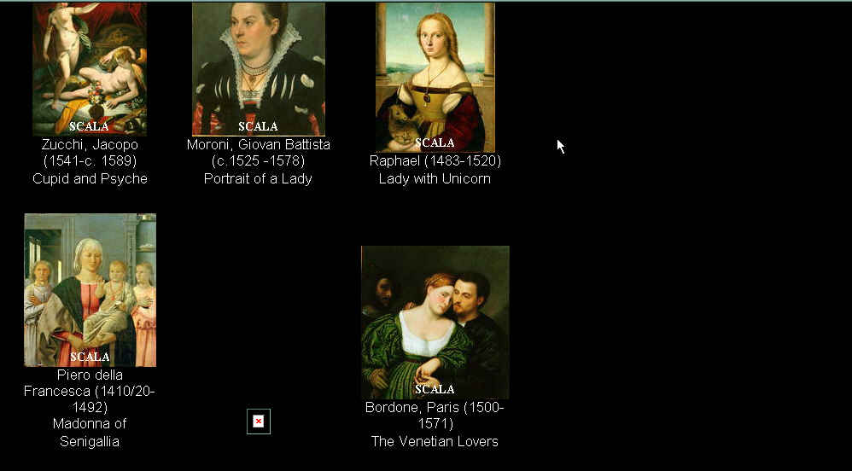

SCALA: image missing.

