Best Practise Museum Shop

Introduction
The number of museum websites is already vast and the number of museum shops on-line is quickly rising. Due to the many ways in which one can structure a museum shop it eventually turned out to be impossible to integrate all features used by the larger museumshops into one (understandable) spreadsheet.
In this study 56 museumshops were studied of which 7 were dealt with in more depth. These are listed in paragraph 3 along with their strong and weak points.

In paragraph 2 I have listed (with examples) those features which are outstanding and should be incorporated in my view (of course in an adjusted version) into the REGNET-shop.
Several of the feature/standards are (and also perhaps for some of the larger museums) not to be lived up to for smaller museums. E.g. A guaranteed delivery period of two days.

The next paragraph is a compilation of aspects of museumshops studied. These should, in my view be incorporated in the REGNET-shop. Most of them are already present in www.museumshop.com and www.smithsonianstore.com which in my view is to be regarded as the best museum on-line shops. Other Best practise museum shops are www.louvre.fr, www.metmuseum.org, www.britishmuseum.co.uk , www.bmashop.com.

1.1 Startpage

Overall impression
The first impression is most important: an attractive webdesign and not an old-fashioned one (www.metmuseum.org) or an bleak appearance with much white in the background (www.britishmuseum.co.uk) .
The amount of text should not be too much (www.nhm.ac.uk), one does not get control over the information offered. Good examples: www.louvre.fr and www.museumshop.com
The preferred layout consists of an central flexible frame and permanent “border” frames containing all important categories and navigation tools (www.bmashop.com).

Features
- Full search; free entry, should always be present.
- Prelisted category search; is optional, not needed if all categories are orderly arranged in the “border” frames.
- Categories; the categories should be clearly visible in the “border” frames.
- Search by Artist
- Search by period
- Search by museum
- Search by theme; this is not the same as categories! e.g. Religion, Animals etc.
- Search by price; this feature is most of the time incorporated in the feature: Gift ideas/Gift guide
- Visual hierarchical system tree (VHST) is a must since this Best Practice study has revealed that the interpretation of categories is very variable (good example: www.britishmuseum.co.uk)
- Help function
- Gift ideas/gift guide this feature can not be missed for those who do not know where to start looking. (Good examples: www.museumshop.com and www.metmuseum.org)
- Gift certificate; a useful feature to attract more clients by having them sent a certificate to friends with which they can buy items from the shop.
- Create a wishlist; make an list with those gifts you would like to receive for your birthday etc. sent it to friends or make it available on the site by entering your name (www.museumshop.com)
- More about us; needed to give certainty to the customer with whom they are dealing etc.
- Special offers; always people looking for them.
- Customer services; these are essential and are subdivided:
- Inquiries & information (www.louvre.fr)
- Give us your opinion (www.museumshop.com)
- Track your order; gives the customer a safe feeling. But the standard offered might be difficult to live up to for all museums offering objects for sale. (www.louvre.fr)
- Sign up for a newsletter
- Shop member; sign up to become a member and receive the discounts and/or special features
- B2B entrance; apart from museums we will also need to attract companies which will endeavour in making new products with logo´s originating from the Cultural Heritage deposited in the museums. (www.museumshop.com ).
- Licensing; manufacturers to produce licensed products using the Museum's collections as inspiration.
- Museum-shop-item manufacturers; Companies interested in producing items for the museumshop.
- Corporate sales; items to be offered to the staff of museums or other organisations. The sales usually comes with deductions on the price (www.smithsonianstore.com )
- Become an affiliate; this is an important feature. Regnet wants to expand and therefore we should attract and facilitate new museums to join. This will benefit Regnet larger array of items and the museums will also benefit from extra income. (www.museumshop.com)
- Basket; this feature should be present on all screens. Under the basket logo the items selected sofar are depicted.
- General text; about the categories etc. does not add much value, but is often used.
- Images of categories and/or items; these are objects which are most appealing to the general public and persuade to look further in the shop.

1.2 First level page: categories
This level is used to give more information about the chosen category. It can confirm the choice of the customer by showing several images of the category and the subcategories.

Features
- Subcategories
- title of the subcategory
- an image
- a short description (only if sufficient space is available)
- Page location; shop➔replica’s
- Add to shopping basket; for the subcategory examples

1.3 Second level page: subcategories
This level gives an overview of all the items in the chosen subcategory.

Features
- One item featured more in detail:
- title of the item
- Description of the item
- reference: “your purchase supports the exhibits and programs of ……museum.”
- an image
- 2D
- 3D; in case of sculptures, but also for toys etc.
- Click here to browse some pages of the book
- Click here to get the original painting etc.
- Multimedia: Click here to get a video sample
- enlargement image
- Choose style/size of the item; size in case of e.g. rings or T-shirts; Style for example different colours for museumbags: basic colour blue or red etc.
- price for affiliates (members)
- in Euro
- in dollars
- price for all other customers
- in Euro
- in dollars
- Special handling fee; display only if appropriate
- ordering notes: gift wrapping available or not
- Item availability; if an item is temporarily out of stock this is indicated here, together with the expected new availability date or an email address is given to be contacted for information about new availability date
- scale reference; e.g. 12 x 15 cm
- physical description item; the composition of the data types depicted depend on the sort of item: books have other needs than sculptures etc.
- number of pages
- colour/black-white
- version [edition etc.]
- type of material
- TO BE MORE WORKED OUT
- explore history item/more background info on item
- choose a gift wrap; if the item is to be sent to a friend as a gift it can be packed as a present. Several colours/designs of wrapping paper/boxes should be available.
- your personal message; if the item is to be sent to a friend as a gift a gift card with your personal message can be added to the gift.
- email this to a friend; if the customer is very pleased with the object or for example sees this as an item a friend may have interest in he can sent an email with all the information to a friend (www.bmashop.com )
- add to wishlist
- Suggestions for related items; all items are attributed links to other items, these can be based on topic depicted by the object, type of materials used, the artist it was made by etc.
- Items overview (www.bmashop.com) subcategories with many items may depict all items on one page (scroll horizontally) or also offer the alternative at the same time: show the items page by page.
- View all (gallery);
- page view
- next page
- previous page
- title of the item
- image
- Page location; shop➔replica’s➔Egyptian; all individual steps link directly to the “step” chosen.
- Add to shopping basket; for the highlighted item.
- quantity of items wanted
- total amount (Euro’s) for this item

1.4 Third level page: item level

Features
- One item featured more in detail:
- title of the item
- Description of the item
- reference: “your purchase supports the exhibits and programs of ……museum.”
- an image
- 2D
- 3D; in case of sculptures, but also for toys etc.
- Click here to browse some pages of the book
- Click here to get the original painting
- Multimedia: Click here to get a video sample
- enlargement image
- Choose style/size of the item; size in case of e.g. rings or T-shirts; Style for example different colours for museumbags: basic colour blue or red etc.
- price for affiliates (members)
- in Euro
- in dollars
- price for all other customers
- in Euro
- in dollars
- Special handling fee; display only if appropriate
- ordering notes: gift wrapping available or not
- Item availability; if an item is temporarily out of stock this is indicated here, together with the expected new availability date or an email address is given to be contacted for information about new availability date
- scale reference; e.g. 12 x 15 cm
- physical description item; the composition of the data types depicted depend on the sort of item: books have other needs than sculptures etc.
- number of pages
- colour/black-white
- version [edition etc.]
- type of material
- TO BE MORE WORKED OUT
- explore history item/more background info on item
- choose a gift wrap; if the item is to be sent to a friend as a gift it can be packed as a present. Several colours/designs of wrapping paper/boxes should be available.
- your personal message; if the item is to be sent to a friend as a gift a gift card with your personal message can be added to the gift.
- email this to a friend; if the customer is very pleased with the object or for example sees this as an item a friend may have interest in he can sent an email with all the information to a friend (www.bmashop.com )
- add to wishlist
- Suggestions for related items; all items are attributed links to other items, these can be based on topic depicted by the object, type of materials used, the artist it was made by etc.
- Page location; Shop➔Replica’s➔Egyptian➔Cat of the goddess Bastet; all individual steps link directly to the “step” chosen.
- Add to shopping basket;
- quantity of items wanted
- total amount (Euro’s) for this item

1.5 Basket

- general text; use basket and possibility to become
- Itemnumber
- Itemname
- Name Museum partner; the name of the museum partner who supplies the item
- Price
- in Euro
- in Dollars
- Quantity of item; should also in this stage of the purchase be possible to adjust
- member discount
- Subtotal
- in Euro
- in Dollars
- delete/remove item
- add to wishlist
- total price
- currency converter; link to a converter site
- continue shopping

1.6 Order form
TO BE WORKED OUT

1.7 Guided search
TO BE WORKED OUT

2 Important museum shop features
- All general functions of the startpage stay in place: only the centre of the screen shows the links asked for (first-, second-, third-level pages)
Example: www.bmashop.com

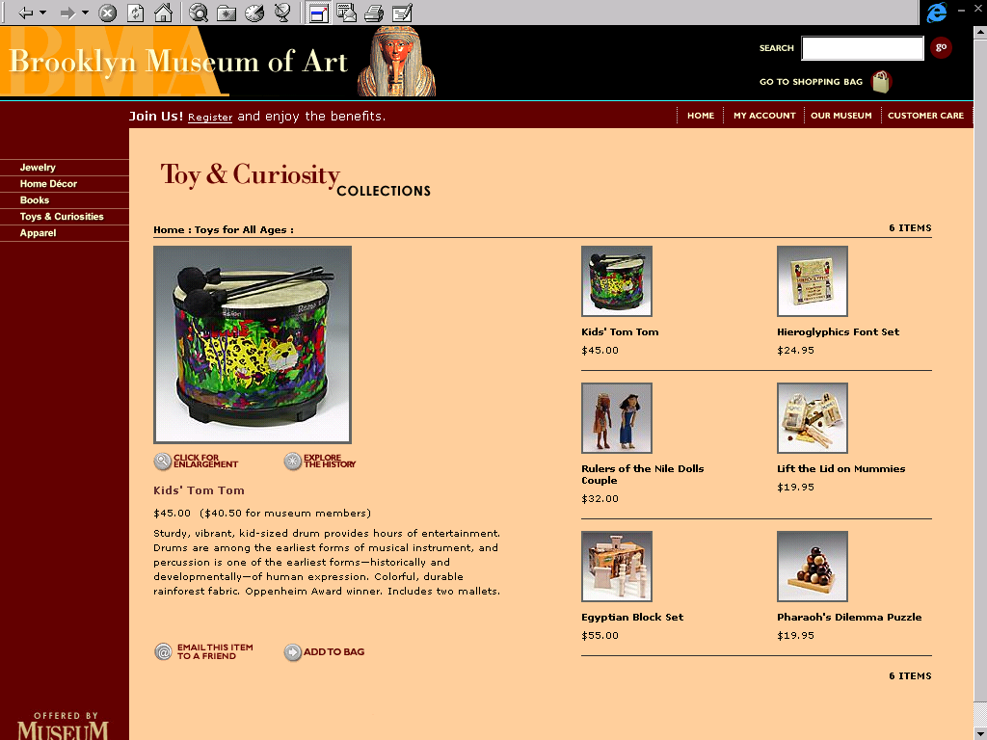

- visual hierarchical system tree (VHST)
Example: www.britishmuseum.co.uk

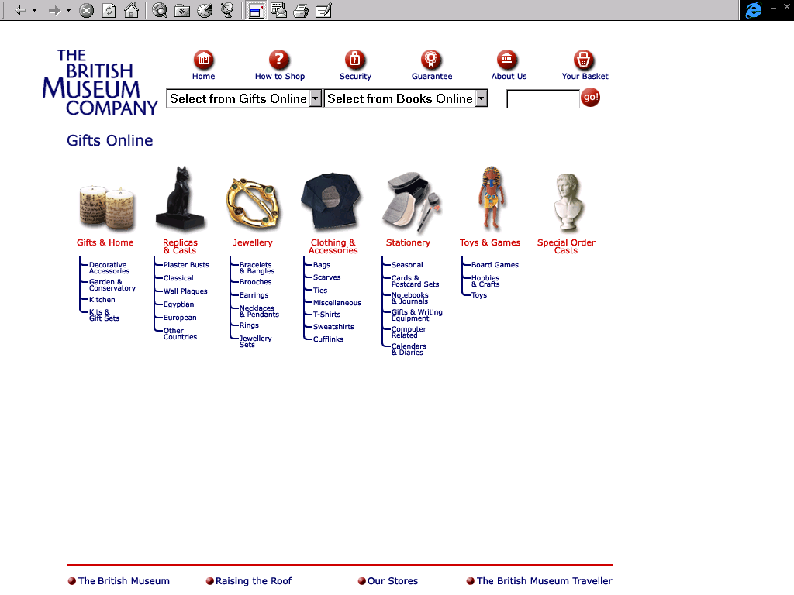

- User’s guide
Example: www.louvre.fr

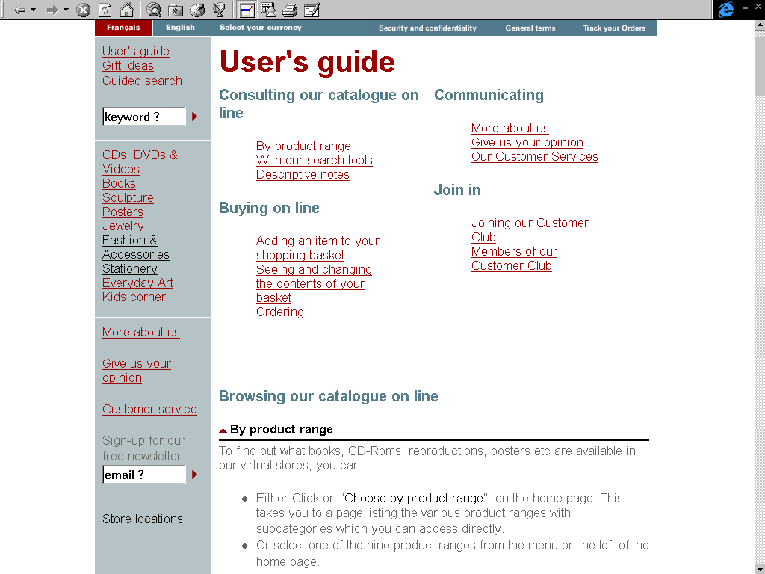

- Customer services facilitate feedback and thus the possibility to optimise the MSOL
Customer services may contain:
- Inquiries & information
- Give us your opinion
- Track your order
Example: www.louvre.fr
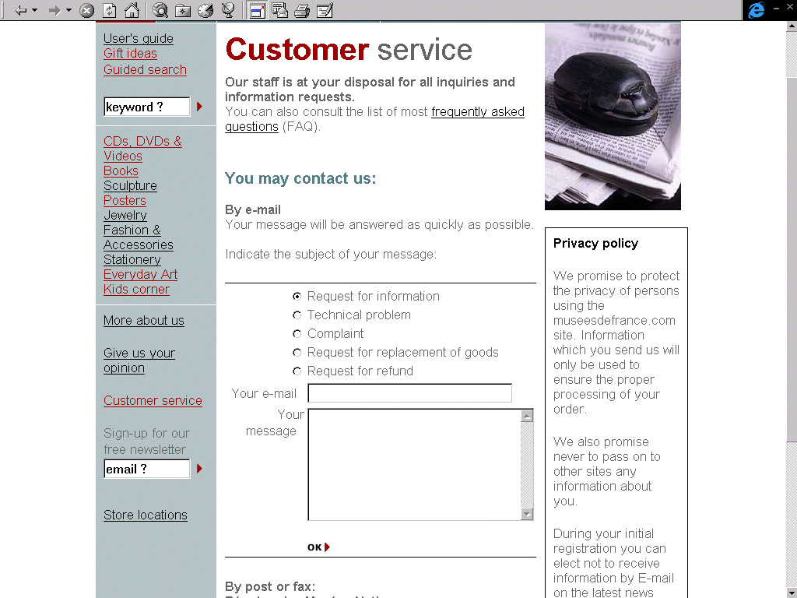

- Customer services: Give us your opinion
Example: www.louvre.fr and www.museumshop.com

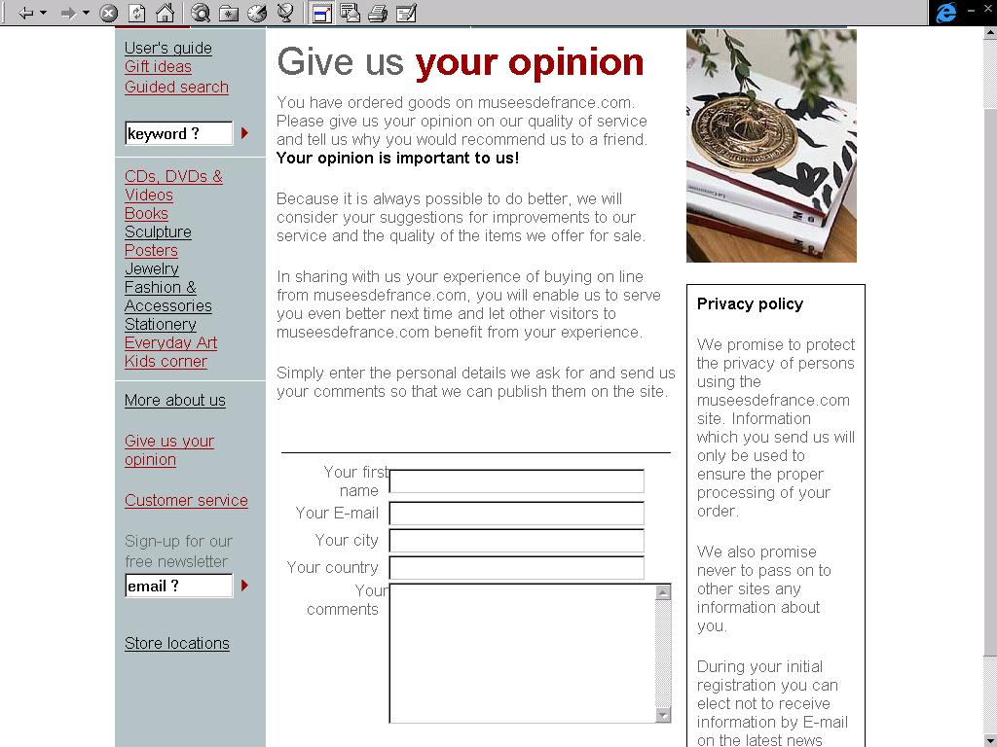
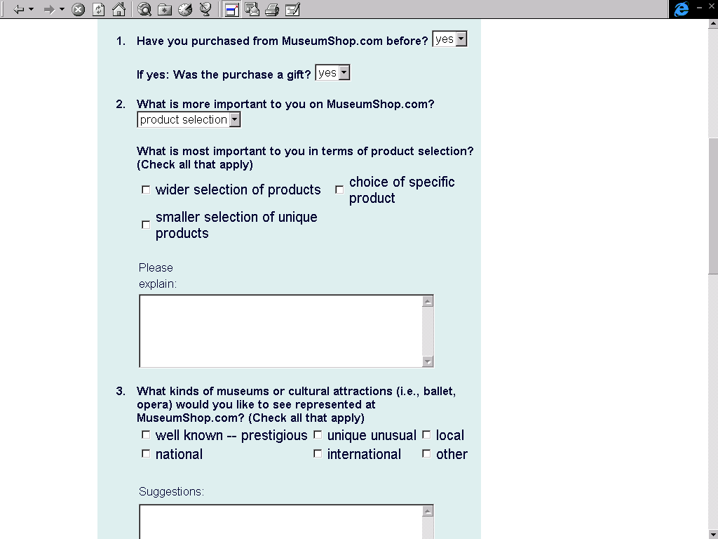

- Track your order
Example: www.louvre.fr

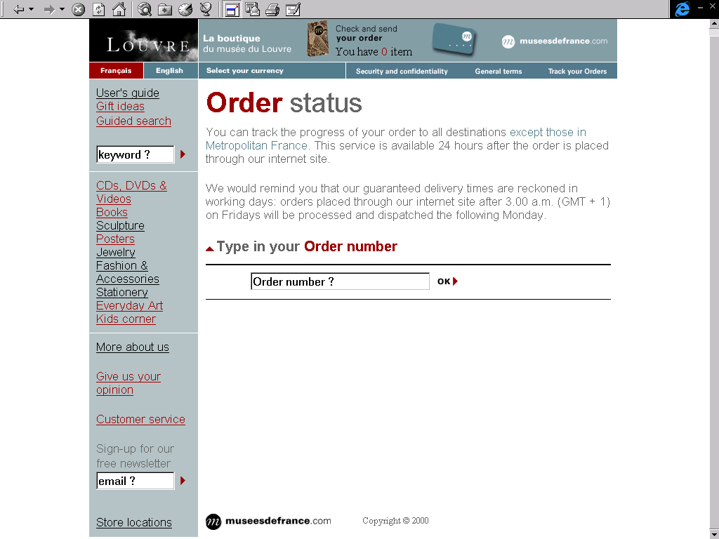

- Forward to a friend
Example: http://www.bmashop.com

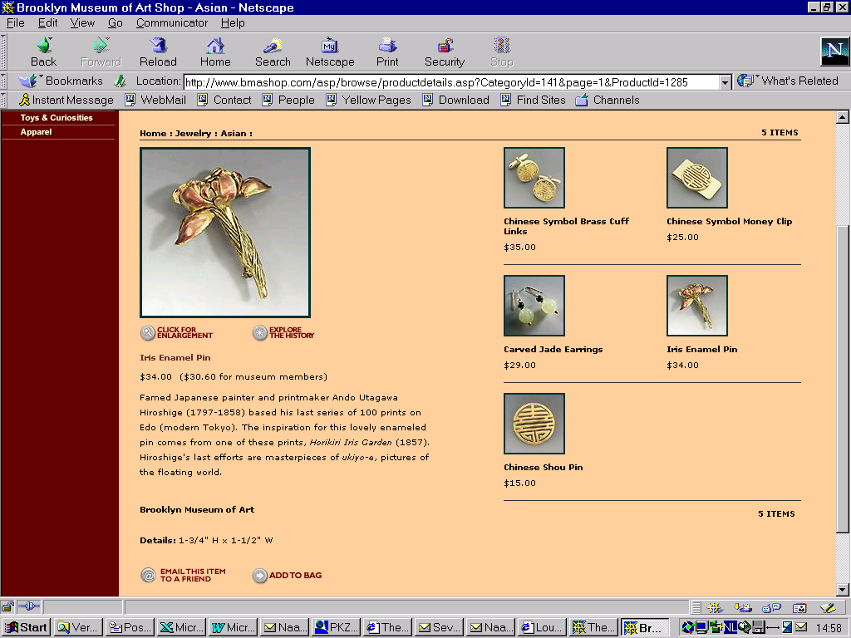
- Create a wishlist
Example: www.museumshop.com

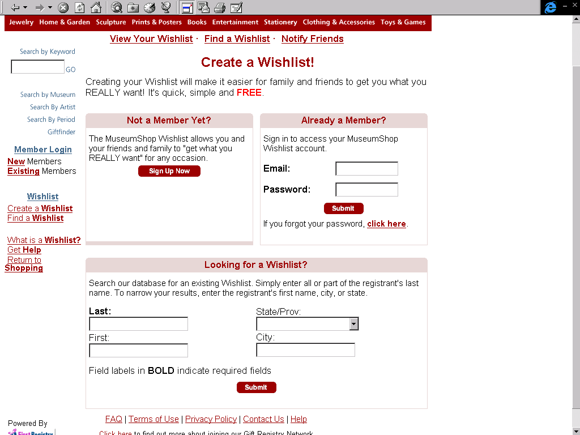

- Gift Ideas may be a facility for those among us without a very creative mind.
Example: www.metmuseum.org

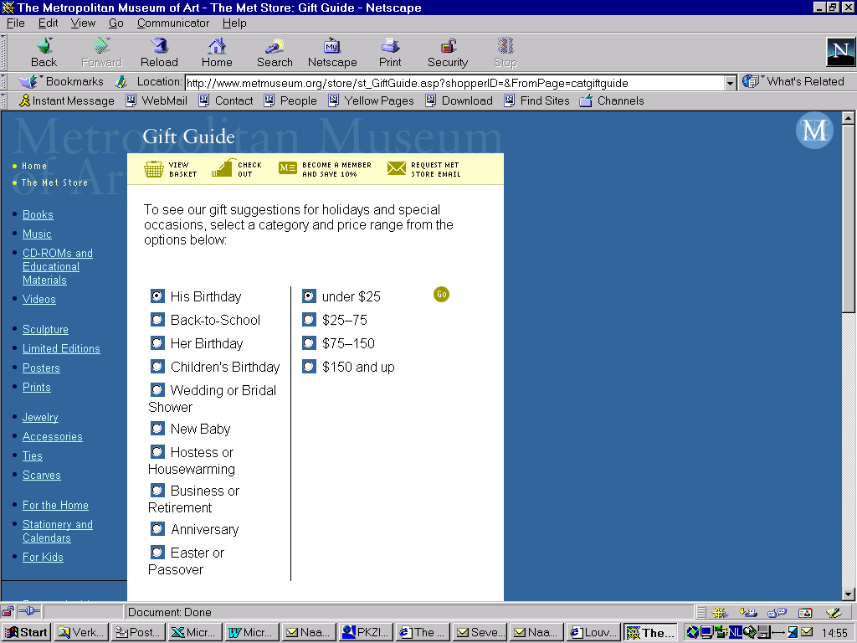

- Gift certificate
Example: www.museumshop.com

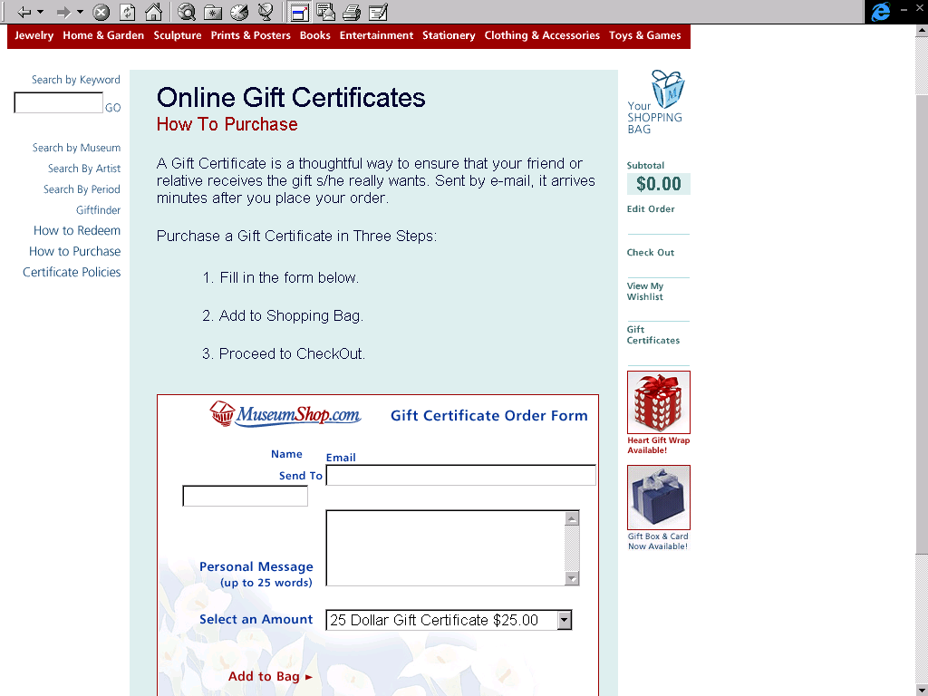

- suggestions for related items
Example: http://www.metmuseum.org/store/index.asp

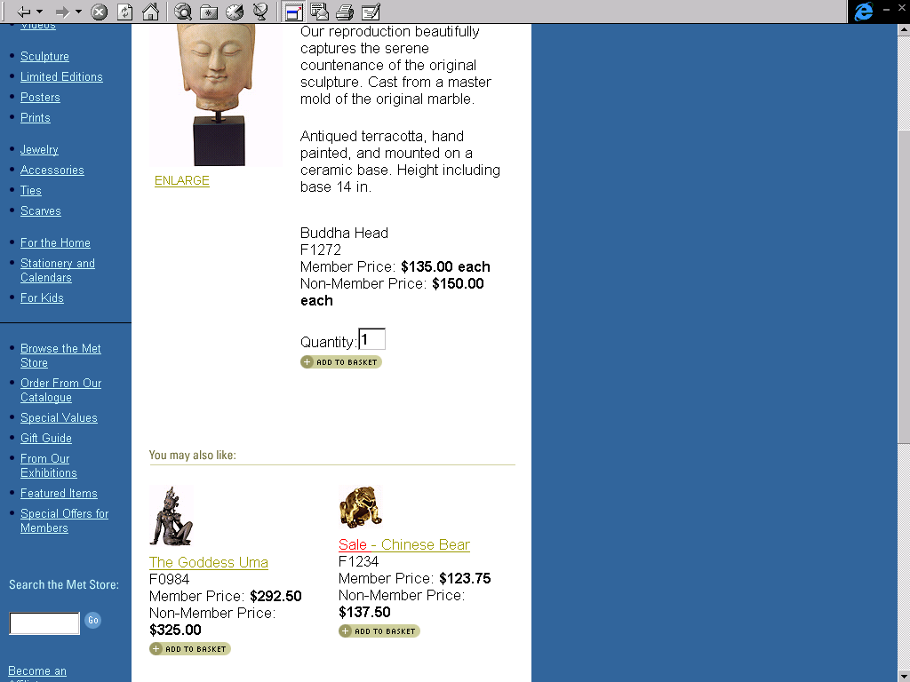
- Is item at the moment available? If not when will there be a new supply.
Example: http://www.britishmuseum.co.uk/frameset.htm

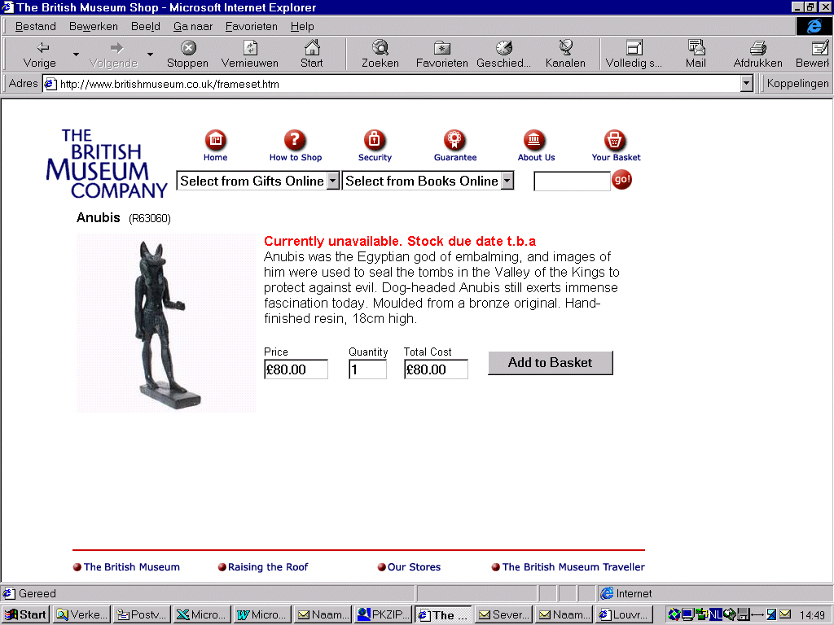

- B2B entrance: a clear entry should be present for enterprises which want to cooperate with museums as to introduce new products for the REGNET-shop
Example: www.museumshop.com

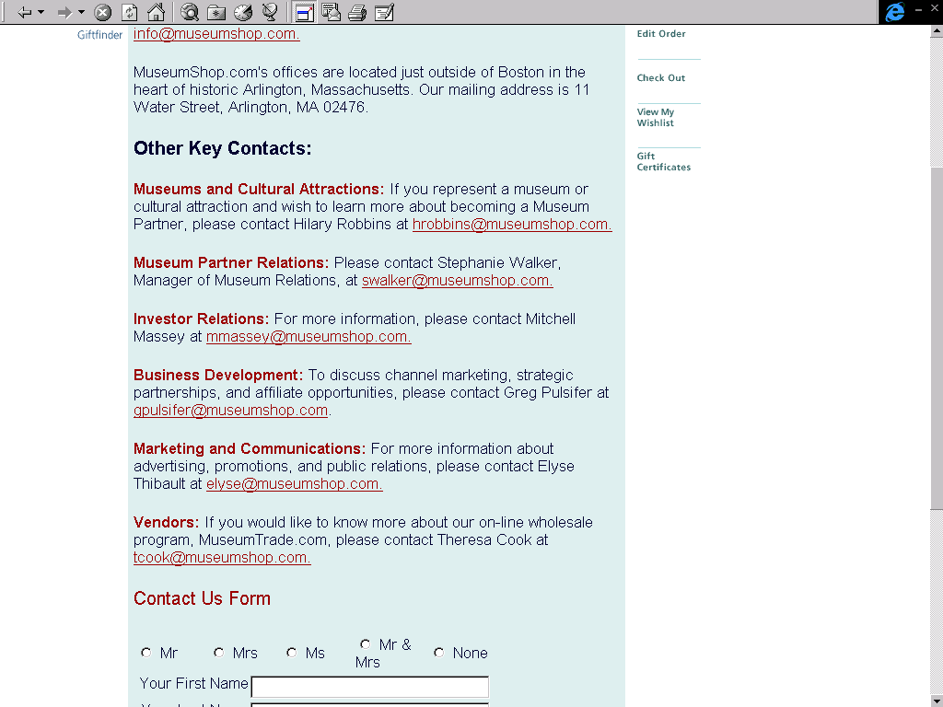

- Become an affiliate
Example: www.museumshop.com

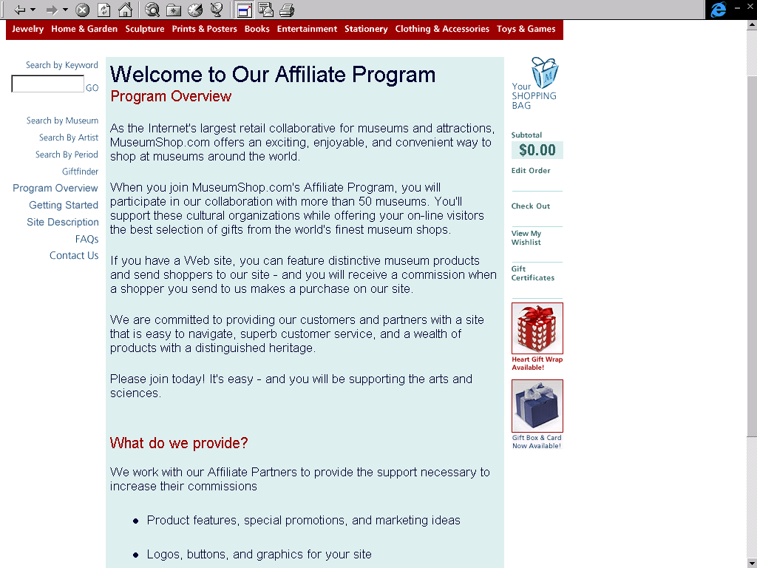

3 SUMMARY MUSEUM SHOPS STUDIED

This overview only highlights the most striking aspects of the sites.

www.rijksmuseum.nl

Positive features
- Most sites have the items ordered only by type of product: Jewelry, sculpture etc. This site also has the items sorted by theme: e.g. marriage. Depicted by a scrollable picture gallery.

Negative features
- The site has a limited number of other features. E.g. Customer services, gift ideas, etc.

www.louvre.fr ***

Positive features
- 3D pictures
- Click here to browse some pages of the book
- Click here to get the original painting
- Multimedia: Click here to get a video sample
- guided search is possible
- Apart from the categories on the starting page there is also a (for most part overlapping) division with a more pictorial approach
- Track your order
- Payment possible both by creditcard and cheque

Negative features
- The website design is not optimal: The background is not filled in in most pages this does not give it a professional appearance
- The possibility to become a member is hard to find and no advertisements for member benefits are to be found on the site except when checking out
- The site is a little slow

www.britishmuseum.co.uk ***

Positive features
- visual hierarchical system tree (VHST): this is a partial site map of the categories and subcategories
- Fast site

Negative features
- The website design is not optimal: The background shows too much white to give it a more professional appearance

www.bmashop.com ***

Positive
- Beautiful webdesign
- Mail to a friend
- All products have beside the standard price also the reduced price for museum members depicted

Negative features
- Delete item from basket by changing number of items to zero
- Need to update basket when number of the same item has increased or decreased
- It is not possible to order from outside the US due to the compulsory data entry for the shipping sheet

http://www.metmuseum.org/store/index.asp ***
Positive
- Gift guide
- best-sellers
- Track your order
- Become an affiliate
- For several products more than one type is available e.g. different sizes for rings or T-shirts
- All products have beside the standard price also the reduced price for museum members depicted
- Payment possible both by creditcard and cheque

Negative features
- Startpage has too much text and items, it should be more clearly structured

www.museumshop.com ****

Positive
- Startpage is very well structured, eventhough it has many functions available
- Create a wishlist
- Gift certificate
- Become an affiliate
- Search by museum
- Search by artist
- Search by period
- 3D exhibitionroom
- Gift finder
- bestsellers= fabulous features
- For several products more than one type is available e.g. different sizes for rings or T-shirts
- All products have beside the standard price also the reduced price for museum members depicted

Negative features
- For PC´s with a slow connection the 3D presentation is not something to enjoy
- site is somewhat slow
- E-Showcase; if you have started this feature and your connection is not fast it is not It is not clear how to disable the “E-Showcase” view and return to the normal presentation.
- Delete item from basket by changing number of items to zero
- Need to update basket when number of the same item you want to buy has increased or decreased

http://www.smithsonianstore.com/asp/root/default.asp ****

Positive
- Startpage is very well structured, eventhough it has many functions available
- Site is fast
- Become an affiliate
- Gift finder
- bestsellers= World favourites
- Email this item to a friend
- For several products more than one type is available e.g. different sizes for rings or T-shirts
- All products have beside the standard price also the reduced price for museum members depicted

Negative features
- Delete item from basket by changing number of items to zero
- Need to update basket when number of the same item you want to buy has increased or decreased
- It is not possible to order from outside the US due to the compulsory data entry in the shipping sheet

