

REGNET-IST-2000-26336
Worksheet Audit Summary

Project acronym | REGNET |  | Contract nr. |  | IST-2000-26336
Type and Number | Worksheet Audit Summary
Work package | WP 1 Analysis of the State of the Art and Development of Concepts
Task | 1.1 Description of collections and definition of user requirements
Date of delivery | Contractual | 2001-06-22 | Actual | 2001-06-29
Code name | RN_T11v01_IMAC_auditsummary |  | Version 01 draft ☑ final 
Objective | Report
Distribution Type
Authors (Partner) | IMAC
Contact Person | Grossmann@imac.de
Abstract
Keywords List
Version log

Worksheet audit summary
„Description of collection and definition of user requirements“

Domain: Artists /Art Galleries

1. General information | GRAN |  |  | ICCS
Owner/Provider | INcivics. Municipal Project of Young Artists |  |  | ICCS/Union of Bulgarian Artists
Name | Young Artists from Granolers |  |  | Works of Bulgarian Artists
Online Version |  |  |  | www3.iccs.bas.bg
Short description | - Works of visual art  - Formed in October 1994  - Awarded with awarded with „Espais a la critica d’art 2000“ for the exhibition „Música per a Camaleons Incivics“ |  |  | The portal of the Union of Bulgarian Artists (UBA) gives access to collections of art objects - stored, exhibited, offered by the artists -members of the UBA (about 2700 in Bulgaria). The art objects are classified according to the Union's administrative organization in 15 chapters: painting; graphics and illustrations; sculpture; critique; caricature; art space design; scenography; restoration; wall painting and monument art; design; ceramics; graphical design; new media and nonconventional forms; wood carving; jewellery; textile.
3. Detailes description of collection
3.1 Size | Work of about 30 artists, no information of total number |  |  | About 500
3.2 Categories of items | Paints, sculptures, installations, photography, etching, videoart, net art |  |  | painting; 200  graphics and illustration 40  sculpture 40  caricature 20  art space design 20  scenography 10  restoration 10  wall painting and monument art 10  design 20  ceramics 20  graphical design 20  new media and  nonconventional forms 30  wood carving 20  jewellery 20  textile 20
3.3 Covered themes / topics | Figurative art, conceptual art, social |  |  | Contemporary Bulgarian Art:  painting; graphics and illustrations; sculpture; critique; caricature; art space design; scenography; restoration; wall painting and monument art; design; ceramics; graphical design; new media and nonconventional forms; wood carving; jewellery; textile
3.4 Temporal coverage of collection | From 1990 to now
3.5 Comments/Further relevant information on the collection | Emerging of representative contemporary visual arts from the end of XX century in Granollers |  |  | The collection consists contemporary artists’ achievements and presentations. It will operate as a permanent virtual gallery for the Union of Bulgarian Artists. As the Union of Bulgarian Artists contains 15 different chapters, representing different specialties of the artists, the collection includes all kinds of contemporary Bulgarian art.  Temporary auctions will be supported through the network to extend the potential auction’s auditory
4. Data Management
4.1 Data Management | - Paper-based system  - Most of the objects of this collection are still not catalogued in any way |  |  | Art objects – in possession of the artists  Type: Art objects  Number of entries: 500  Tool: MySQL for Linux
4.2 Digital storage of objects |  |  |  | Collection is not digitized at all
4.3 Tools
4.4 Comments on technical planning | Intention to implement a database system to catalogue the collection  Intention to design a web site on INcivics as well as the inclusion of the artists and their works on photography and image (video creation and netart) in the Aire F`s website (which belongs to the Alliance Française)  Functions that need to be supported focus on two levels:  - Internal level: Creation of an online community of the emergent artists, the interchange of experiences and work together among the Incivics artist, resources, digitsation  - External level: Cataloguing the Incivic’s artists and works, the dissemination of the Incivics artists and their works, digitisation and education |  |  | The database is operating in environment: Linux, Apache Web Server, PHP module;  My SQL Database; PHP3 based middleware
4.5 Formal Decription |  |  |  | „Own“ data strucutre (Comments/Clarifications: Record Number, Artist, Institution, Keywords, Title of object, Object type, Price)
4.6 Subject Description | Method used for subject description: keywords, image categorisation possible |  |  | Method uses for subject description:  - Category :painting, sculpture, graphics… (according to the UBA’s chapters, p.3.2);  - Exhibitions  - Artist  - Institution  - Title of object  - Object type  - price
5. Output provided by the „system“
5.1 Service for internal users
- Conventional outputs |  |  |  | Artist’s collection on CD  - Including artist’s objects in the system  - Arts postcards
- Online Services and products | Foreseen: searchable database |  |  | Searchable Database  - Reports  - Help Desk
5.2 End user services (external users)
- Conventional Outputs |  |  |  | List of actual exhibitions  List of previous Exhibitions
- Online Services and products | Foreseen: OPAC/searchable catalogue, ordering of items |  |  | Virtual Gallery  - Help Desk  - Auctions  - Searchable Database:  List of artists from a city (Varna)  List of works of determined artist  List of works of determined year  List of thematic works-according
6. User Groups
6.1 Internal User Groups
- Librarians
- Scientific employee
- Registrar |  |  |  | +
- Administration | +
- Others | Incivics Artists, Art Galleries |  |  | Members of UBA
6.2 External User Groups
- Visitors | + |  |  | +
- Students/Academics | + |  |  | +
- School Classes | + |  |  | +
- Others: | Art Galleries, Museums, Collectors, Buyers |  |  | Non-members of the UBA related to CH domain, Public Authorities (Ministry of Culture; Ministry of Education; Municipality Authorities), Private Business representatives
7. Usage of the system/collection (use cases)
7.1 Current usage of the system/collection |  |  |  | - Members of the UBA (in 15 categories) (promotion of the members, permanent authors’ achievements presentations, creation of electronic repository for the UBA members, access through Internet and world wide CH achievements)  - Administration of the UBS (promotion of UBA; support of the public/internal/external relations of UBA with Bulgarian and foreign authorities, impact on the impotance of CH in Bulgaria)
Internal usage | -
- User Group / Use case | -
External Usage | -
- User Group / Use case | - |  |  | - Public Administration (supports relations with UBA, consultaton and expert services, auctions: preparation, support)  - Customers (trade with art goods, request for art catalogue publishing, request for e-publishing (CD creation)  - Students/schools (educational services in art domain; investigations/history/state of developments in art technologies, styles; peculiarities; consultations, help desk)
7.2 Future usage of the system
Internal Usage
- User Group / Use case | - Incivics (promotion of research, creation, communication, exhibitions; creation of an online community of the emergent artists, the exchange of experiences and cooperate among the Incivics artists and resources; Digitisation)  - Administration (Update, Cataloguing, offering ressources and grants)  - Art Galleries (Creative ressources, knowledge of works, participation on cataloguing) |  |  | - University of Art – Sofia (education of high school students in virtual presentation of art goods)  - )
External usage
- User Group / Use case | - Art Galleries (Exhibitions, Acquisition of art works)  - Museums (Exhibition, Acquisition of art works)  - Curators (Exhibition, getting information about new artists)  - Collectors (Acquisition of art works)  - Buyers (Acquisition of art works)  - Visitiors (cultural and leisure interest)  - Students (didactic use)  - Academics (didactic use and research)  - Student classes (didactic use) |  |  | Customers from museums, libraries, research/ development organisations (extension of the content of UBA – virtual repository; inclusion in others CH domains
8. User Requirements
8.1 General Goals | - Use the REGNET portal for multimedia productions  - Easy and thematic access to art services and services  - Use the REGNET portal for disseminating and purchasing contemporary young artists‘ works  - Use the REGNET portal as a tool to acquire art works  - Use the REGNET portal to create an Intranet for INcivics artists Network  - Network for the creation of cultural products together with the other partners |  |  | - Easy and thematic access to cultural data and services  - Network effects (globalization): the regional art achievements to be connected to  world-wide thematic / professional networks of professionals for promotion and  dissemination  To retrieve CH data world-wide from a single portal
8.2. Which functions should be covered by the REGNET system? Which requirements do you have in order to use the REGNET system?
- General and technical requirements  1a. First of all, please describe your existing infrastructure |  | - Hardware: PC  - Network architecture: client – server.  - Operating system: Novell  - File management system: Novell  - Database Enginiering: Oracle  - Databaseprogramming tools: Access  - Geographical Information System: digitalised map associated with a database of streets in MGE plataform  - Ophimatic tools: word 97, access 97, Internet Explorer, Agenda Lotus, Workflow tool: Notes Workflow  - Number of users: 278 | PC based system - M  OS-Windows based - M  Application software browser available - M  Network connectivity - M  Dial up connectivity - S  Response time: satisfactory - S
1b. Please formulate (further) requirements according to general and technical issues! |  | User interface requirements, support of standards, security requirements | new application software: multimedia - S  user interface : Windows based - M  standards support - M  security - S
2. Data management |  | Allow to parameterise, data import and export functions, data exchange issues, formats, sound, good image definition, 3 dimensional images, application to amplify details of an image, links to other web site | See Appendix beneath this table
3. Functional requirements |  | Data input, searchable catalogue, information retrieval ordering capabilities, image retrieval... | Multilingual support - S  discount for members - S  availability for educational purposes S
4. Further requirements |  | online help, support | - Modular differentiation into “free” and “to pay for” information - S  - A bar code label system should be integrated into the program - S
8.3 Try to formulate requirements of your users! |  | M possibility to buy  M simple interface (easy to work with)  M Easy system information retrieval (graphic and textual)  M Allow the interchange experiences  S allow the segmentation of external users  S technological tools should allow different ways of access (mobile, web TV) | - opportunity for putting artist’s object in the e-shop directory/ adding items to e-auction  - information about future auctions  - information about future exhibitions  - information about future events/initiatives/projects related with CH  - ordering collection on CD  - ordering own collection on CD  - ordering postcards of Art  - online order  - submission of prices

Appendix ICCS 8.2 /2
2. Data management
data search - M
standard data structure - M
hierarchical levels of retrieval - M
Standard data structure or data field catalogue for the description of objects - M.
Support of international formats and rules for coverage and structuring of documents (XML, etc.) - M.
The user can define data fields and is supported by the software in doing so - M.
The entire record can be imported (comprising hierarchies, thesaurus etc) - M.
A wide variety of text processing functions (e.g. select, cut, copy, paste, etc.) - M.
A permanent display of the most important record information (e.g. the inventory number) - M.
Partly filled in data records can be stored as hold-files - M.
These files are stored separately and are not taken into account when a search is performed - M.
Abbreviation lists can be defined, and abbreviations can be replaced automatically by an integral information - M.
The deletion of data can be reversed (either on the server and/or the client) - M.

Data validation/Check handlers
Data items can be compared to open or secluded word lists at input or at some later moment.
When saving or leaving a record, the user is prompted to fill in mandatory fields which he has not filled in yet - S.
The different check routines (e.g. date, signature) can be defined individually for every single field - S.
When saving, a check is performed whether there already exists a record (e.g. check of the inventory number) - S.
Data output/Printouts
Data records can be collected in a pool for printing - M.
A free selection of what is to be printed is possible when running the application (e.g. search results or actual document) - S.
Indexing of fields
The saving of a record entails an automatical update of the index - M.
Fields and field combinations for indexing can be selected freely, as well as the index, in which the data will be imported - S.
The form of the index can be chosen freely (word- or phrase-index) - S.

Domain: Museums

1. General information | MECH | LMG | MUS |  | NRM
Owner/Provider | Stedelijke Musea Mechelen | Länsmuseet på Gotland | Museon |  | Swedish Museum of Natural History
Name | Hof van Busleyden  Schepenhuis  Brusselpoort | Museum Shop catalogue |  |  | Museum Shop
Online Version | Under construction | http://www.gotmus.i.se/ | http://www.museon.nl/ |  | http://www.nrm.se/
Short description | - Historical relics, applied art (crafts), visual art | The catalogue for the museum shop is going to be translated to Englis and German.  The Museum shop content has copies /originals from various fields of the museum collection and much more of handicraft stuff.  The museum has a picture archive, too. | Museum (with educational mission)  Collection consists of objects (3D), documentation, images |  | The Museum has around 9 millon items. The shop has around 2000 items
3. Detailes description of collection
3.1 Size | 12000 objects | 40.000 items | 300.000 objects |  | 2.000 000 objects in the museum, arouind 2.000 in the shop
3.2 Categories of items | - Visual art  - Archaeologic items  - Applied art-crafts |  | Objects: 3D mostly.  - Art  - machines  - textiles  - stuffed animals  - minerals  - films  - videos  - images  - documents |  | Books , presents, childrens toys, posters, reproductions, postcards, maps, jewellery
3.3 Covered themes / topics | - Archaeological findings, instruments, utensils, documents, coins  - Applied art: silver, bronze and copper, gilt leather, lace, furniture, tapestry, glass and ceramics, etc.  - Sculptures, paintings, graphics | The collection in this museum is of normal culture-history goods | - Natural History  - Physics and Technology  - History and Archaeology  - Ethnography |  | Natural history:  Botany  Zoology  Geology  Paleonthology  Astronomy
3.4 Temporal coverage of collection |  | 1874-2001 | From Prehistory to present |  | From the start of evolution to 20th century
3.5 Comments/Further relevant information on the collection | The collections are strongly linked with the history of the city of Mechelen and the surrounding regions | The LMG Regnet-project can present things that are achievable from/in the musum shop | For the REGNE-project the Museon will use contributions from the Ethnography, History and the Physics and Technology sections of its collections. Objects to be used will have to fit into the following themes:  - Leather  - Gods and saints  - Measuring and weighing  - Science  - Tour d’Horizon |  | Most of our customers are children and school-classes and therefore we do not have a typical museumshop.  The assortment is based on animals, nature, human beings and space. It is not directly facing what the museum has in it´s collections. We do not have replicants but we have some scanned picture´s of drawings from our botanical collection. We have made some postcards and eventually there will be some posters.  The shop sells books, both for children and adults, dissertations, textiles, fashion and accessoires, stones and minerals, CD´s, posters, postcards, calendars, paperworks, t-shirts, ties, hats, umbrellas, a lot of softtoys, pens, keyrings, plastictoys , puzzles, games, spacetoys, sometimes handicraft and, everydayobjects for adults.  We change some of our assortment all the time depending on actual exhibitions, taxcosts etc. We buy our goods from Sweden, Europe and USA. 95% of our assortment can be bought in other shops.
4. Data Management
4.1 Data Management
- Paper-based Systems | 7000 catalogue cards |  | +
- Database | ADLIB: a few hundred museum objects | MS Access file  40.000 records  5000 images (JPEG) | 60.000 objects are searchable by an automated collection management system: the Museum System (Gallery System) |  | Electronic listing of items  According to article number and product groups  Books: titel and ISBN
- Others | 10 000 addresses in:  40 WP-files  120 Word-files
4.2 Digital storage of objects | Collection is not digitized at all | 40.000 records, 5000 images (JPEG) (MS Access) | 60.000 objects are searchable by an automated collection management system: the Museum System (Gallery System)  2200 digital images (JPEG)
4.3 Tools | - |  | No other tools
4.4 Comments on technical planning | - Deployment of the collection management system ADLIB Museum (on going)  - Digitising of the first series of objects (within one year)  - Start with museum shop, also via e-commerce (within one year)  - Installation of kiosks at several locations in the museums (within 2 years) |  | REGNET system is incorporated in this project  Open Heritage is also under development  See Appendix for details!
4.5 Formal Decription
Standards in use | - Adlib support standards  - Following the de facto standards | - PC-Windows 98-access  - JPEG-standard for images | - Windows NT access  - JPEG for images |  | Own system  Article number  Product groups
„Own“ data structure | - Thematic approach (starting) | About 10-50 data fields – varying for different purposes
4.6 Subject Description
- Thesaurus | AAT | - | - AAT  - TGN
- Keywords |  | -
- Classifications |  | - |  |  | SAB – Swedish Classification system
5. Output provided by the „system“
5.1 Service for internal users |  | - |  |  | Not applicable
- Conventional outputs | Paper catalogue cards | - | Printed reports (Content depending on information wanted)
- Online Services and products | - ADLIB collection management system  - Reports on specific themes | Searchable database  Reports | - Various search entries  - various reports facilities  - Image gallery  - work set creation  - user profiling facility  - data entry monitoring system  - data editing monitoring system
5.2 End user services (external users)
- Conventional Outputs | Content for guiding purposes | - New items in the library  - Actual exhibitions  - Museum shop catalogue | In principle all features for internal users can be given to the external users! What is most important is to have a sophisticated facility to make any profile you want of any combination of fields. This to guard and thus withhold access to information which is sensible or not useful in the opinion of the institute who controls the database system. Or (looking at it from a more positive respect) making available that information which is most tailored for the users you have in mind. |  | Selling of products
- Online Services and products | - | -
6. User Groups
6.1 Internal User Groups
Librarians | - | + | +
Scientific employee | + | + | +
Registrar | + | + | + |  | +
Administration | + |  | + |  | +
Others |  |  | - Restoration employees  - Photographer  - Taxidermist |  | staff
6.2 External User Groups
Visitors | + | + |  |  | +
Students/Academics | + | + |  |  | +
School Classes | + | + |  |  | +
Others: | Scientific institutions, artists, craftsmen |  |  |  | Students  Academics  Tourists  Children  visitors
7. Usage of the system/collection (use cases)
7.1 Current usage of the system/collection
- Internal usage |  |  | In general: the results of most the use cases shortly described hereunder, should be easily transferable to the colleagues/internal “client” who will use the result as a basis for further products.
User Group / Use case | - Scientific employee (study new item or item to restore; gather information; prepare content or restoration dossier)  - Registrar (input of data prepared by the scientific employee into the collection management system; design leaflets and brochures)  - Administration (handling of purchases, loans, insurances and communications) | - Students / New finds from excavations  - Archaeologists / Search the database  - Visitors / Visitors can search the Museum Shop catalogue | - Librarian (data entry: journals, books etc.)  - Scientific employee (study: (new) item; add more data; validate data (records) entered by others; gather information: prepare content for publication or exhibition; link object records with library module records)  - Registrar (input of basic data; Add digital thumbnail image; contact scientific employee to add more information or validate existing info; add information on loan status etc.)  - Educational employee (gather information for: museum lessons, workshops, lectures, brochures etc., gather basic info for press releases)  - Storage employee = curator (edit location changes of the objects etc.)  - restoration employee (make status reports, add images of restoration process, add information of restoration material and methods used)  - Photographer/Picture-archive employee (add digital pictures and add/link information about picture-archive) |  | Librarian (conversion, exhibitions)  Visitors (buying of products)  Researchers
External Usage
- User Group / Use case | All user groups (search for objects and/or ad hoc information via visits, telephne calls, fax transmission, paper mail and e-mail) | - Visitors / Online search for products from the museum shop | - No direct access to the collection management system at this moment
7.2 Future usage of the system
Internal Usage | Internal and external usage  - Visitors (kiosks at specific locations within the museum treating the exposed themes in the surrounding area)  - Students, academics (scientific space within the museum with multimedial infrastructure) |  | - Marketing (search for images; search to reply to simple question made by phone)  - Management (monitoring progress)  - Exhibition producing dept. (search for objects (size, colour, etc.) to be incorporated in an exhibition this to facilitate the design concept. In case of 3D image in data base a preview tour of the exhibition can be made) | Staff (possibility of visiting and purchasing on the web, better control of stock)
- User Group / Use case |  | Scientists / Search and print images
External usage
- User Group / Use case |  | Visitors / Search and print | - Visitors kiosk (in-depth information about objects and/or themes in exhibition, objects/themes related to the objects seen in exhibition etc.; print services of object information selected.; construct your own tour around the museum by selecting, through theme-search or key-word search, in exhibition object database those objects you do not want to miss) | Academics /Visitors (possibuility of visting and purchasing the web)  E-commerce on selected items
 | - Schools (Collection navigation via game scenarios)  - Artists (capturing of the process of the creation of pieces of art which can be displayed later on  - Craftsmen (computer based presentation and simulation of old an new techniques) |  | - Visitors schools (tailor made selections of the object data base or themes on request. This on the kiosks at the time of the visit)
8. User Requirements
8.1 General Goals |  | Portal for our museum shop.  Easy to find us on the www. | More exposure to both the general public en commerce  Facilitating the goals of the Museum through funds generated by the sales of items through the REGNET portal.  Stimulate and exchange services between other (museum)Regnet partners | The Regnet website must be immediately reachable from, and by, all major search engines
8.2. Which functions should be covered by the REGNET system? Which requirements do you have in order to use the REGNET system?
2. General and technical requirements |  |  | .
1a. First of all, please describe your existing infrastructure | Normal PC standard with Microsoft 98 system and MS Office 2000 pro.  Network standard: ethernet with RJ45 connections. | 60 users | Hardware: 4 servers, PC‘s (mostly 1 Gigabite hard disk; 64 MB); Museum network: 100- 10 bit; Software: Windows NT; Office 97/2000; SQL; Access; Collection management system: TMS Users: 100, about 90 workstations.
1b. Please formulate (further) requirements according to general and technical issues! |  |  |  | M Userfriendly interface.  M Security requirements.  M Support of Standards  M Easily handled Shopping system
2. Data management |  | Define own database structures in standard formats. .mdb .txt and so on.. |  | M Field Searching  M Free text searching  S Z39.50 protocol  S Dublin Core or Marc format
3. Functional requirements |  | dynamic search possibility on our site/homepage within the access databases. |  | M Both import and export of data  M Posibility of local registration of data  M Ordering functions  M Financial transactions via card etc.
4. Further requirements |  | Bigger harddrives (!) |  | M Good help support
8.3 Try to formulate requirements of your users! |  | M Microsoft Explorer or similar to. | Define and provide the systems and methodologies to carry out the digitising  Systems should be easy to handle also for none-experienced persons  An easy access and overview of the nearest by (REGNET?)institutes providing digitising services should be in the REGNET B2B section for those institutes not able to buy one for themselves  An automated transfer tool should be available to adjust format of the images from the Image-Data base into formats directly to be used for webpublicatiton (72 dpi) or Wap, etc.  Define a standard format for the images, preferably 300 dpi  Provide the rules and interfaces for an easy migration of (parts of) the digitised items into the REGNET-system.  Content approach  Object information should be approachable by at least two different concepts:  The database access  The data base concept is the standard mostly used when giving access to a repository. Search criteria ➔separate, none contextually linked, set of objects  the context access  The context access will create added value to the objects, since it will place each object in relation to several others. This will be done by the additional development of a structure of texts based on themes. For more details see APPENDIX 1.  A facility to set up different presentation levels for the same item. This is needed because we will distribute through different channels: e.g. Internet, Wap etc. Therefor the texts should be present in for example three levels: A short comprehensive title-like phrase (also author?); a summary, giving more information and a full text. For the Image-levels the same approach should be taken: thumbnail, screen resolution and high resolution.  No strongly predefined hierarchical structure. But a extendable format in which new content contributors can add new content threads with the possibility to link (web them up) with already existing content.  Strong focus on edutainment (education and entertainment) and scientific use.  Access  Define the standards to be used to open the full catalogue of cultural heritage objects (CHOs) to a broad range of users (occasional visitor till scientist) and devices (handheld till personal workstations and kiosks).  Wireless access is a high priority.  Device-, user- and region-dependent content schemes for storage, search and retrieval and consultation.  Mechanism through which thematic text contributions by third parties can be handled: draft reception, editing and approval, publishing.  Consultation and navigation  Multi-lingual navigation with switch over possibility: native language and English to start with.  Multilingual helpfunction  a clear data entry system: mandatory fields and optional fields  a flexible object number entry field  Thesaurus facilities  Possibility to store content in different languages with switch over possibility during consultation.  Constant awareness of the current context on the screen during navigation (notions “session” and “context”)  Personalised navigation and possibility to recall the consulted information (profiling and storyboard)  Zooming possibility on images with high resolution (rules for resolution and formats)  Clear dimension reference for the displayed objects (also at zooming)  Operations  Automated upload of new data from the distributed repositories  System availability: 7/24  Reasonable response times (to be specified)  Sound recovery procedures and fallback scenarios  Hosting and/or back up facility for the collection management system of the museums  Logging mechanisms for the REGNET system-use (technical and content statistics)  Setting up of Service Level Agreement (SLA)  Setting up of coherent pricing schemes  E-business  Intellectual Property Rights-mechanisms for texts and images (identification, authentication, digital object numbering, watermarking, …)  Modular differentiation into “free” and “to pay for” information  For further requirement see: Best practise Museum shops  Search and retrieval  Full search  Prelisted search: categories, theme search, key words etc.  Boolean operators | M Easy to use  M Searchable through many search engines  M High quality images  M Security  M Shopping system easily managable

Domain: Archives

1. General information | Alinari | ONB
Owner/Provider | Fratelli Alinari I.D.E.A., archive | Austrian National Library
Name | Alinari | Picture Archive
Online Version | http://www.alinari.it/ | http://www.onb.ac.at/
Short description | photo archive museum, restoring, commerce | Picture archive catalogue: digital image catalogue based on the typewritten card catalogue developed in the 1930s
3. Detailes description of collection
3.1 Size | 3 500 000 pictures owned by alinar  7 500 000 pictures kept / managed by Alinari  Number of photographers: 2.500 | 1 207 305 catalogue cards
3.2 Categories of items | Daguerreotypes  Ambrotypes  Ferrotypes  total_____________2.600  Album 4.800  Calotypes 140  Vintage prints 110.000  b/n films 330.000  Coloured films 30.000  Prove prints 60.000  Slides b/n 12.000  Slides col. 20.400  Autochrome 2.000  Postcards 3.000  Pictures 1.000  Else 380.000 | Images
3.3 Covered themes / topics | art  architecture  travelling  agriculture  industry  history  movie  fashion  theatre  science  technology  ... | Main topics  - The Habsburgs, especially the Emperor Franz Joseph, Elisabeth and other members of the imperial family  - Topographical and architectural photographies: with special focus on Austria and Vienna  - Contemporary history: e.g. the photo archive of the United States Service 1946-1955  - Portrait photography of artists, politicians, scientists, celebrities and outstanding persons  - Theater photography of artists, politicians, scientists, celebrities and outstanding persons  - Theater photography: e.g. the salzburg festival  - Special collections of individual photographers (focussing on architecture, landscapes, foreign countries, theater, celebrities, portraits, reportage)
3.4 Temporal coverage of collection | From 1852 to present day | From 1850 (and older, taking into account photographical reproductions of older prints) to present day
3.5 Comments/Further relevant information on the collection | Number of artists represented: 5000
4. Data Management
4.1 Data Management
- Paper-based Systems |  | 1 207 305 pictures / catalogu cards  1 207 305 picutres / KATZOOM
- Database | ISIS (European standard) | 1 207 305 pictures / STAR
- Others | Interface: ISIS
4.2 Digital storage of objects | More than 65.000 images are digitized (JPEG)  Resolution:  Thumbnails: 128x128  Low resolution: 256x256  Low-medium resolution: 480x480  Medium resolution: 800x800 (internal use only)  High resolution: 2000x3000 (on demand)  Chrome channels: RGB/CYMK | 1 207 305 catalogue cars are digitized (JPEG-format, 500x300 dpi)
4.3 Tools | Digital watermarking by Digital Copyright Technologies (Image Bridge Pro)  Adobe Photoshop 6 for picture enhancement  Barco Reference Calibrator monitor for colour accuracy  X-RITE and ICC Color profiles for color calibration  Specific sw for db management (EasyWeb, EasyCat and in-house software for e-commerce) | None so far
4.4 Comments on technical planning | The system is already on line: the business web site is already reaching its full functionality, the educational web site is in test phase. Alinari is considering now to enrich the system on the top of the current state of the art “watermarking on the fly” service, with wavelet compression display, Jpeg 2000 file format, and XML pages. In the near future the company might enhance the online data retrieval with the pattern recognition/image similarity picture finder tool  There are continuous improvements on image management, tools, web functionality administrative tools… | The Austrian National Library is actually working on a project „Digital Image Archive“ (duration: 1999-2001). The project's main target is to create an efficient model for a "Digital Image Archive", which is based on the existing organizational structures of our collection. The traditional services shall be supplemented by new, digital services. Electronic image catalogues and presentations shall increase the availability of the objects of the collection for scientific as well as commercial usage.  STAR will be the new image database of the Austrian National Library. In addition to the library system ALEPH, STAR will cover cataloguing, documentation and customer services for the collections of the Austrian National Library. A test version of this database is already online. An enhanced test version is planned for July 2001
4.5 Formal Description | Proprietary standard created with the collaboration of the University of Florence. The database and the iconographic tree has been created following the remarks, suggestions and revisions from several worldwide museums, libraries, photographers and stock agencies. | STAR is working with SPECTRUM, the ANL is currently using PND (Personal Norm Data)  The ANL intends the future (additional) use of AMICO
4.6 Subject Description
Thesaurus | Thesaurus which is Alinari’s property
Keywords | About 8.000 (chosen in collaboration with the Unicersity of Florence) | The catalogue is built as a dictionary catalogue (combining author and subject heading catalogues)
Classifications | Art, Architecture, Travelling, Agriculture, Industry, History, Movie, Fashion, Theatre, Science, Technology…  Main catalogue fields used (Alinari):  Photographer information:  ID number of the image (archive)  Photographer Surname  Photographer Name  Date of shoot  Complete place location  Work information:  Title (Italian)  Title (English)  Date of work of art  Date ISO (start, end)  Support information:  Colour-B/W  Positive/Negative  Type of object  Technique  Dimensions  Format  Other information:  Key words  Conservation state  Description  Copyright information | The catalogue cards can be divided in 3 types according to their function (header card, index card, pointer card) and in 3 categories according to their content (person, subject, topography) –  Header Card:  - Header Serial Number  - Type (full)  - Type (short: initial letter)  - Index  - Keywords  - Number of keywords  - Number of index cards  - Definition  - Source  - Author  General Subject:  - Description  - Language  - Place  - Time  Persons:  - Date of birth  - Date of death  - Place of birth  - Place of death  - Profession  - Parents  - Marriage  - Children  - Comment  - Person code  Places:  - Country  - Fedral Province  - District  - District Authority  - Area Code  - Employee / Author of Card  - Date  Index Cards  - Index Card Serial number  - Header Card Number  - Inventory Number  - Description of pivture  - Legend  - Collection  - Collection signatory mark  - Volume, Year, Number, Date  - Page (or other def..)  - Series  - Date of birth  - Place of birth  - Date of item  - Technique  - Format (in cm)  - Additional comment  - Comment from collection  - Entry number  - Former inventory number  - Cataloguer (of picture archive)  - Cataloguer (of collection  Date of card creation
5. Output provided by the „system“
5.1 Service for internal users
- Conventional outputs | 1- books.  2- postcards.  3- artistic prints and hi quality reproductions.  4- posters | - Catalogue cards
- Online Services and products | Services:  1-Search in the data base using different engines (specific made engines).  2- On line help .  Products:  1-images; information. | - Searchable database (test version)
5.2 End user services (external users) |  | .
- Conventional Outputs | - “Sculpture and photography” Florence: palazzo Pitti , Italy (still open).  - “Von Gloeden” Florence: Palazzo Vecchio.  - Italy, 100 Years of Photography, traveling exhibitions lent to the major capitals around the world. | Processing of orders for picture reproductions  Man-powered search
- Online Services and products | On line search engines (property: Alinari)  On line watermarking  On line customer service  Remote administration | OPAC / searchable database (test version)
6. User Groups
6.1 Internal User Groups
- Librarians | +
- Scientific employee | + | +
- Registrar
- Administration | +
- Others: | Software engineering, image engineering, archive sear for internal use | Customer Service
6.2 External User Groups
Visitors | +
Students/Academics | + | +
School Classes | +
Others | Editors  Graphic desginers  advertisers | Television  Publishing companies
7. Usage of the system/collection (use cases)
7.1 Current usage of the system/collection
Internal usage
- User Group / Use case | software engineering (management of a large data base, hw memory management, transmission of images, selection of new tools)  image engineering (image compression, digitising process, calibration process, -quality control, preservation of outputs)  archive search (cataloguing new items, process loan) | Scientific employee / Cataloguing new items: research in the catalogue, integration/update of entries (is a specific person/subject already in the catalogue?); research in the catalogue/database for external users: oublications TV, private end user  Customer Service / Research in the catalogue/database for processing picture reproduction orders (Is material available to a specific topic as required by external end user?)
External Usage
- User Group / Use case | Editors (publishing)  Graphic designers (image creations, study and research)  Advertisers (publishing, study and research) | Students/Academics:  - Search for objects in the collection  - what are the fees and the copyrights?  - Formats, quality?  Television  - Search for objects in the collection  - What are the film and broadcasting rights, fees?  Publishing companies  - Search for objects in the collection  - Theme-oriented search  Questions as above concerning reights and fees, formats and quality
7.2 Future usage of the system
Internal Usage
- User Group / Use case | Image research (file formats, compression formats, database search tools, wartermark tools and test) | Employees of other collections:  E.g. comparison between different graphics/drawings or photographs using the bigger information pool provided by the regnet portal
External usage
- User Group / Use case | Architects, writers, archivists, archaologsits (study&research, virtual archiving or remote archiving, documentation, publishin of books about history of arts)  Restoring companies (documentation  Police department (documentation)  Art and Cultural Department (documentation)  Artists (creative productions)  Web designer (page editing esources, web publishing) | Business  - Fast and easy access to high qualiy items and professional customer care, whether for general or specific interests  Employes of other institutions  Research, taking advantage of the bigger database
8. User Requirements
8.1 General Goals | Use the REGNET portal for multimedia productions  -Easy and thematic access to cultural data and services  -Documentation services  -Quality | Easy and fast access to a variety of geographically distributed information  better cooperation with other institutions  wider presentation of our archive, better access to our collection, establishing contacts to new user groups
8.2. Which functions should be covered by the REGNET system? Which requirements do you have in order to use the REGNET system?
- General and technical requirements  1a. First of all, please describe your existing infrastructure | M- no duplication of the existing data.  M- modularity.  M- high quality .  S- homogeneous technology (formats,…).  S- integration with the existing systems | OS: WindowsNT 4.0, Windows 95, 2000 (partly Linux: in the Central Informatics Service);  FMS: STAR (to be integrated);  Application software: MS Office, Filemaker, Allegro  Network: yes / client-server  Users and workstations general: about 200 each, 30 in the picture archive
1b. Please formulate (further) requirements according to general and technical issues! | - transmission of images (speed).  - watermark on the fly.  - zooming utilities.  - security. | M fast and easy migration of data;  M Support of Z39/50, XML  M Use of TCP/IP as network protocol  M Software must be based on a Server/Client-architecture, platform-independent and scalable  M Encryption methods for data transmission  M Database and server-software (application) works on all UNIX-systems in use, especially SUN-Solaris  M The Client-software integrates state-of-the-art GUI-standards and is compatible with WindowsNT 4.0 /Windows 2000  M The system supports a plurality of variably tuned and parametered databases (catalogues).
2. Data management |  | M Standard data structure or data field catalogue for the description of objects.  M The user can define data fields (supported by the software).  M The system supports hierarchical and networked structures for the accession of complex objects and group of objects (ensembles, e.g. a tryptichon).  M Support of intern. formats & rules for the coverage & structuring of documents (XML etc).
3. Functional requirements |  | M searchable database / catalogue  M gallery, thematic exhibitions  M data input  S ordering  S Editing of a personal profile for news & alerts  S personal office providing e-mail, chat-rooms, calenders , to-do-lists .....  S public notice board for requests and questions
4. Further requirements |  | S variably parametered access permissions (users/data-fields)  S support of HSM (Hierarchical Storage Management) for high-res. Images  S portal with different user profiles (B2B, B2C, C2C)  M online qualified help desk (rights, fees, cooperations and partnerships)  S portal in different languages versions
8.3 Try to formulate requirements of your users! | M- subscription to user list.  M- help and information.  M- information the remaining credits.  S- navigation tools. | M Fast access to information / picture (e.g. phonetic search etc.)  M well structured, simple, user friendly information on web-site  S Easy ordering via internet  C Payment via online tools (credit card, pay safe card or other)  M general support by customer service unit  M precise search by qualified employees  M capacity for the integration of the integral data base (more than 1.4 mio items)  S forum for end users, personal settings & profile, discussion groups, news & alerts...  S continual, regularly updated content servicing on portal

Domain: Libraries

1. General information |  | SUL/KVA
Owner/Provider |  | Stockholm University Library/ Royal Academy of Sciences
Name |  | The Rare Book Collection
Online Version |  | http://www.sub.su.se/
Short description |  | Card catalogue (an online catalogue will be completed during 2001)
3. Detailes description of collection
3.1 Size |  | Ca. 10 000
3.2 Categories of items |  | Books, manuscripts, maps
3.3 Covered themes / topics |  | Natural history, zoology, travels, physics, astronomy
3.4 Temporal coverage of collection |  | 15th-19th century
3.5 Comments/Further relevant information on the collection |  | Collection owned by KVA, but placed and maintained at SUL
4. Data Management
4.1 Data Management
- Paper-Based Systems |  | Card catalogue with entry on author on the first noun in nominative (Prussian rules)
- Database(s) |  | Libris (current conversion of card catalogue)
- Others
4.2 Digital storage of objects
4.3 Tools
4.4 Comments on technical planning |  | Libris Marc will be converted into Marc 21 (conversion completed by January 1, 2002. Copy for protection purposes – system not yet decided upon.
4.5 Formal Decription
- Standards in use |  | MARC format  Libris MARC format / Marc 21
- „Own“ data structure
4.6 Subject Description
- Thesaurus
- Keywords
- Classification(s) |  | SAB – Swedish Classification System
- Other
5. Output provided by the „system“
5.1 Service for internal users
- Conventional outputs |  | Catalogue cards
- Online Services and products |  | OPAC (Voyager Systems)
5.2 End user services (external users)
- Conventional Outputs
- Online Services and products |  | OPAC (Voyager System)  Online ordering
6. User Groups
6.1 Internal User Groups
Librarians
Scientific employee
Registrar
Others
6.2 External User Groups
Visitors
Students/Academics
School classes
Others
7. Usage of the system/collection (use cases)
7.1 Current usage of the system/collection
Internal usage
User Group / Use case |  | Librarian / Conversions, exhibitions  Students / Loan of books  Researchers / at present they have to visit the library to have access to the collection
External Usage
- User Group / Use case
7.2 Future usage of the system
Internal Usage
- User Group / Use case |  | Librarians / better access, better security
External usage
- User Group / Use case |  | Academics / Scanning on demand for the national and international research community  Others / E-commerce on selected items
8. User Requirements
8.1 General Goals | The Regnet website must be immediately reachable from, and by, all major search engines
8.2. Which functions should be covered by the REGNET system? Which requirements do you have in order to use the REGNET system?
- General and technical requirements  1a. First of all, please describe your existing infrastructure | Sun, PC, Oracle, Voyager, Network. Ca 250 simultaneous users
1b. Please formulate (further) requirements according to general and technical issues! | M Userfriendly interface.  M Security requirements.  M Support of Standards  M Easily handled Shopping system
2. Data management | M Free text searching  S Z39.50 protocol  S Dublin Core or Marc format
3. Functional requirements | M Both import and export of data  M Posibility of local registration of data  M Ordering functions  M Financial transactions via card etc
4. Further requirements | Good help support
8.3 Try to formulate requirements of your users! | M Easy to use  M Searchable through many search engines  M High quality images  M Security  M Shopping system easily managable

APPENDIX 1
Museon: 4.4 Comments on technical planning

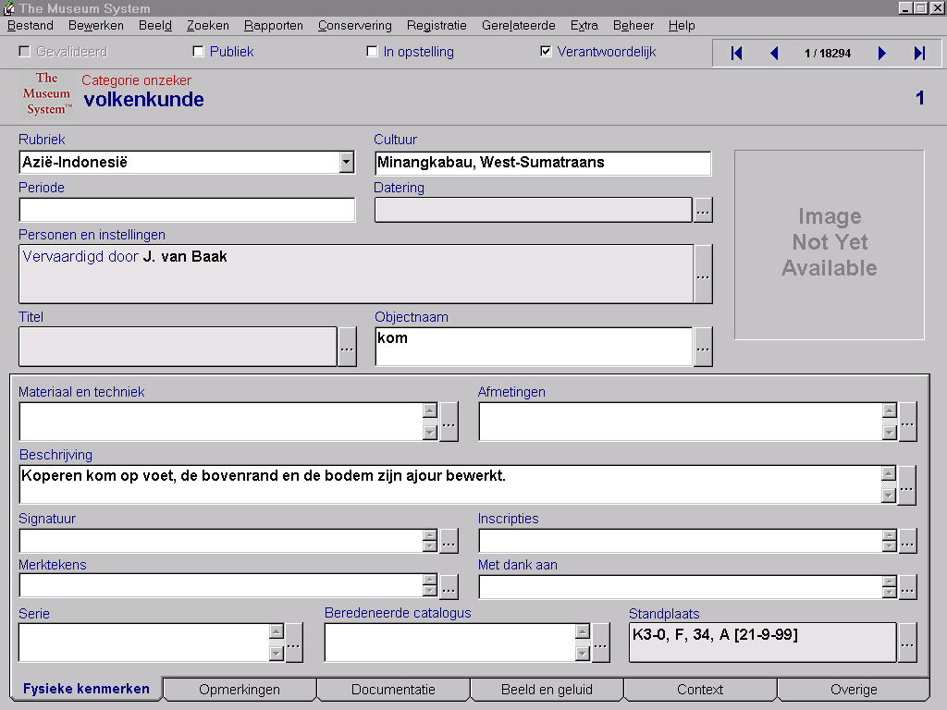
On this catalogue card you find the following tab card:
Fysical features (= displayed tab); Remarks; Documentation; Visual and Audio aspects; Context; Others.

Fields on Tab Fysical features (on image depicted in blue, translation made from left to right and then downward):
Category; Culture
Period; Dating
Persons and Institutes
Title; Object name
Material and Technic; Dimentions
Description
Signature; Inscriptions
Marks; Thanks are due to…
Series; Self constructed Classification; Object location

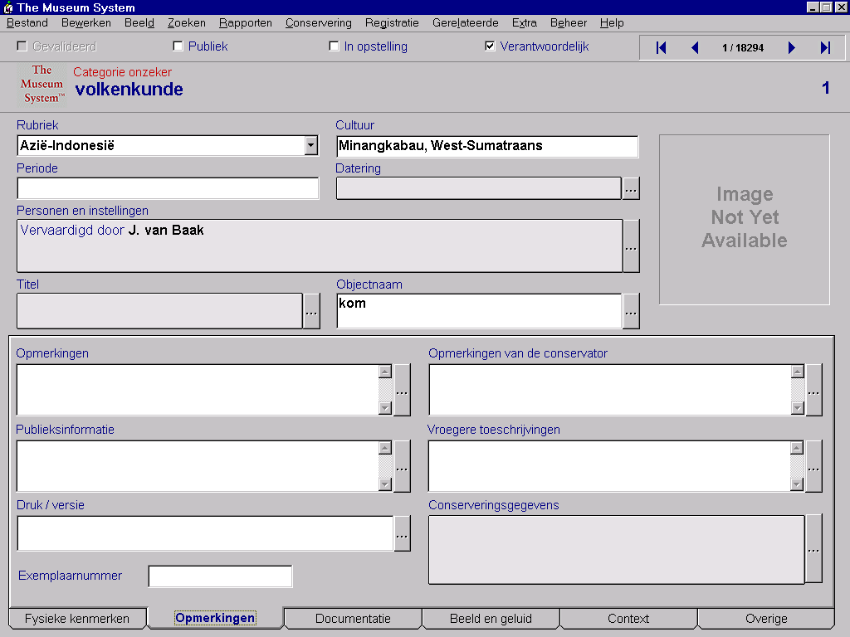
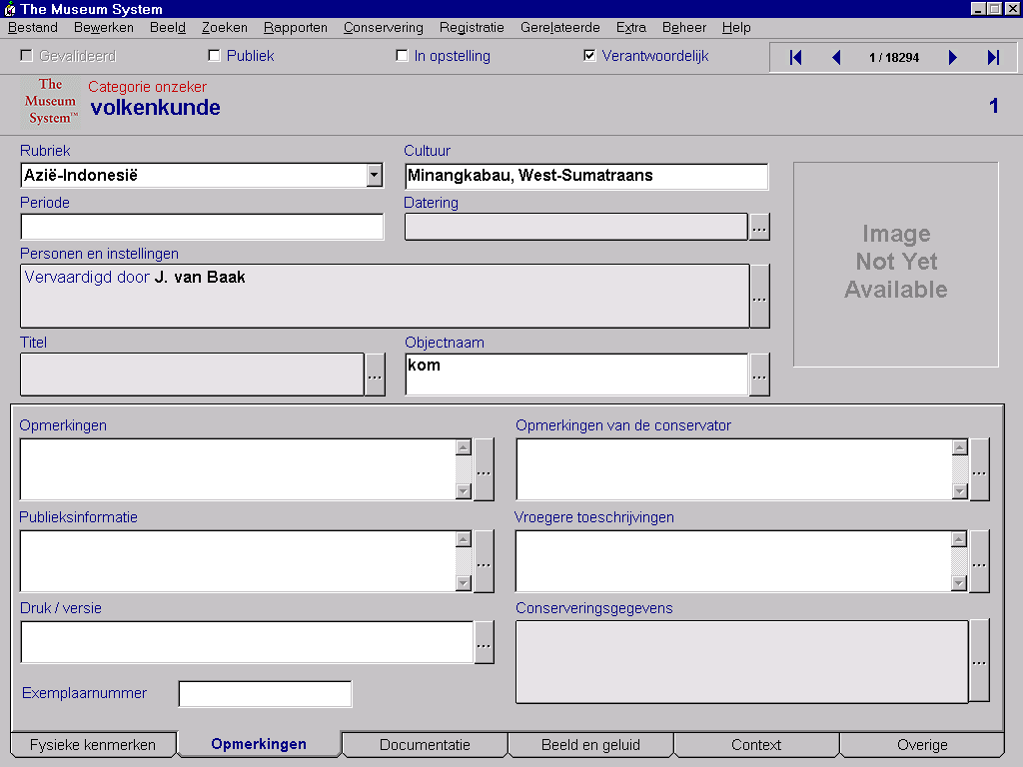

On this catalogue card you find the following tab card:
Fysical features; Remarks (= displayed tab); Documentation; Visual and Audio aspects; Context; Others.

Fields on Tab Remarks (on image depicted in blue, translation made from left to right and then downward):

Category; Culture
Period; Dating
Persons and Institutes
Title; Object name
Remarks; Remarks by the scientific employee (expert)
Information for the Public; Previous descriptions
Issue/version; Conservation data
Number

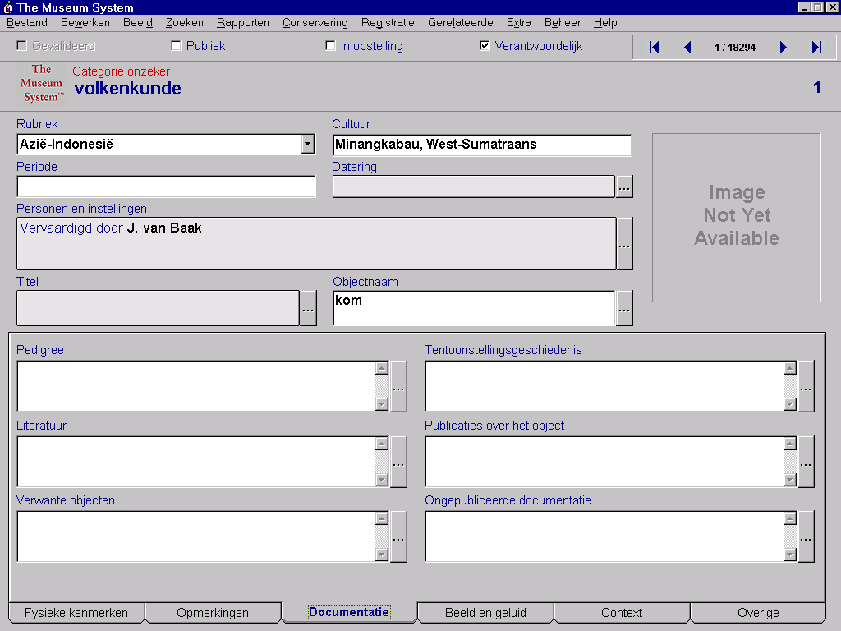
On this catalogue card you find the following tab card:
Fysical features; Remarks (= displayed tab); Documentation; Visual and Audio aspects; Context; Others.

Fields on Tab Remarks (on image depicted in blue, translation made from left to right and then downward):

Category; Culture
Period; Dating
Persons and Institutes
Title; Object name
Pedigree; Exhibition history
Literature; Publications about this object
Related objects; unpubliced documentation

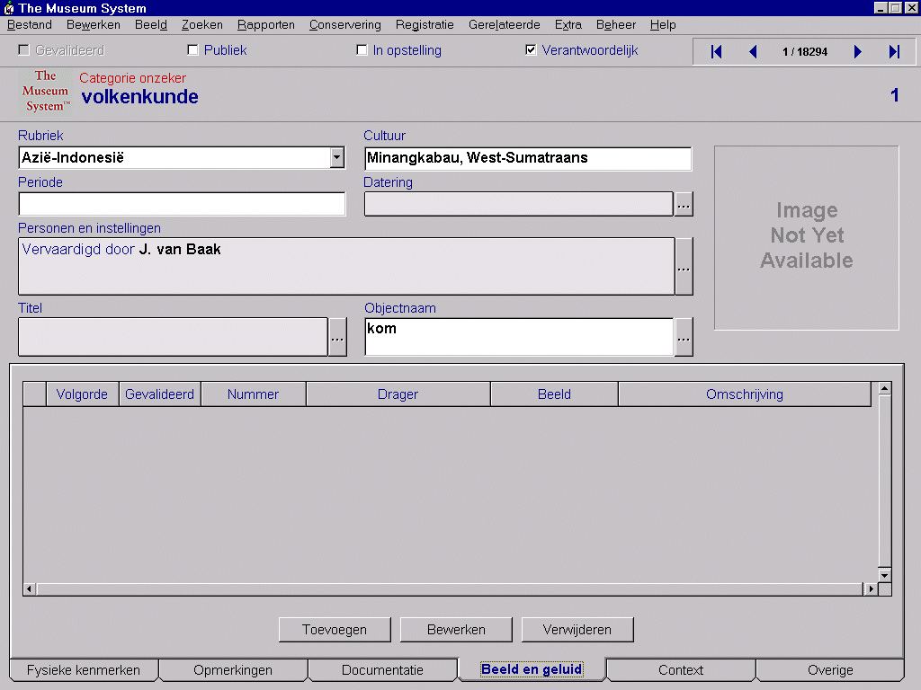On this catalogue card you find the following tab card:
Fysical features; Remarks; Documentation; Visual and Audio aspects(= displayed tab); Context; Others.

Fields on Tab Visual and Audio aspects (on image depicted in blue, translation made from left to right and then downward):

Category; Culture
Period; Dating
Persons and Institutes
Title; Object name
Ranking order; Validated; number; Type of medium; Description

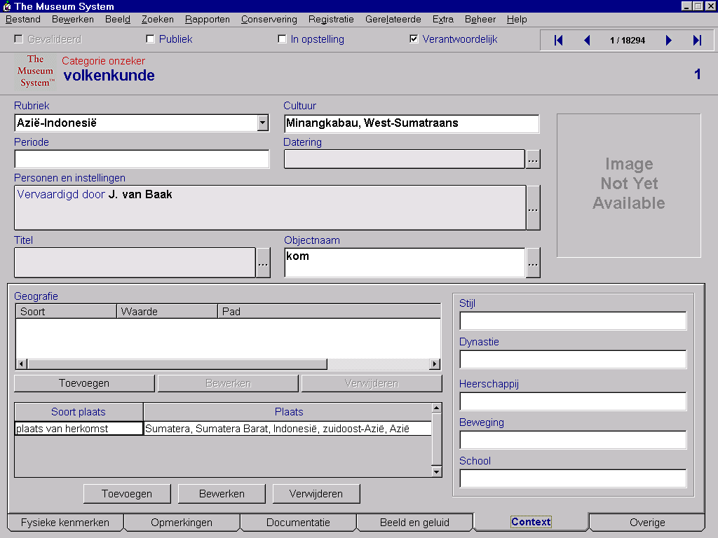

On this catalogue card you find the following tab card:
Fysical features; Remarks; Documentation; Visual and Audio aspects; Context (= displayed tab); Others.

Fields on Tab Context (on image depicted in blue, translation made from left to right and then downward):

Category; Culture
Period; Dating
Persons and Institutes
Title; Object name
Geography; Style; Dynasty; Dominion; Movement; School
Type of Locality; Locality

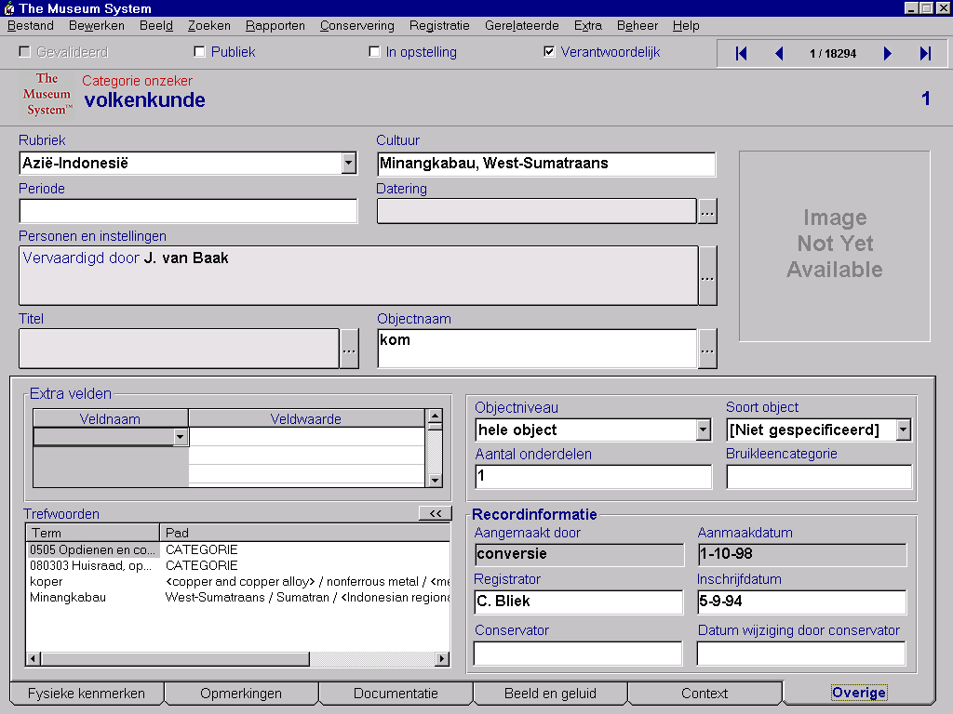

On this catalogue card you find the following tab card:
Fysical features; Remarks; Documentation; Visual and Audio aspects; Context; Others (= displayed tab).

Fields on Tab Others (on image depicted in blue, translation made from left to right and then downward):

Category; Culture
Period; Dating
Persons and Institutes
Title; Object name

Extra fields
Field name; Field value; Object level; Type of object
Number of components; Loan category
Key words; Record Information
Made by; Date of production
Registrar; Date of entry (as part of Museum collection)
Scientific employee (expert); Date of editing by Scientific employee (expert)

