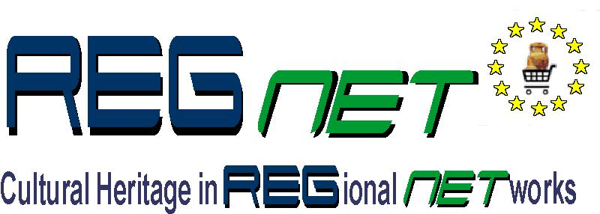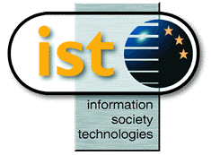

REGNET-IST-2000-26336
Interim Report
Project acronym | REGNET |  | Contract nr. |  | IST-2000-26336
Type and Number | Interim Report no. 1.2
Work package | WP1 Analysis of the State of the Art and Development of Concepts
Task | T 1.2 Development of a documentation and digitisation plan
Date of delivery | Contractual | 2001-09-15 | Actual | 2001-09-25
Code name | input.doc |  | Version 2 draft ☑ final 
Objective | Report
Distribution Type | Public
Authors (Partner) | AIT
Contact Person | Gerda Koch kochg@ait.co.at
Abstract | This is a second version of the AIT contribution to T1.2, the description of models
Keywords List
Version log | Version 2 (2001-09-25)

Table of Contents

1 Introduction to models 3
1.1 Object Type –Type of Description – Type of Digitisation 3
1.1.1 Textual description 3
1.1.2 2D surrogates of originals 3
1.1.3 3D surrogates of originals 3
1.1.4 Electronic texts 4
1.1.5 Electronic video, audio 4
1.1.6 Automatic recognition of image/video contents 4
1.2 Levels of Digitisation 5
2 Integration of Digitisation into RegNet System 6
2.1 Complete new digitisation into REGNET system 6
2.2 Migration of existing digitisation into REGNET system 6
2.3 Co-existence between existing digitisation in different systems 7

Introduction to models

Object Type –Type of Description – Type of Digitisation

Objects stored in museums, libraries, archives and art galleries represent a wide range of types, size, material, quality and quantity. First of all each object has to be described and recorded in a digital catalogue. The appropriate processes and techniques for converting the original to digital form is mainly depending on the type, size and condition of objects.

Textual description

Object type | Type of digitisation
real objects (artefacts, objects of everyday life, maps, etc. ) | textual description of objects in accordance to international standards e.g.:  CIDOC, MDA Spectrum in Museums  EAD, ISAD (G) in Archives  ISBD (G), MARC in Libraries  CDWA in Art Galleries
bibliographic objects (books, journals, newspapers…)
media objects (films, photographs, sound storage medium, digital data)
archival objects (charters, files, letters, manuscripts etc.)

2D surrogates of originals

Object type | Type of digitisation
real objects | create digital 2D images of objects,  scanning bibliographic objects is mainly an intermediate step for final OCR
media objects: photographs, slides
archival objects, handwritten manuscripts
bibliographic objects
card catalogues, microfilm etc.

3D surrogates of originals

Object type | Type of digitisation
real objects (artefacts and objects of everyday life, etc.) | produce digital 3D models of objects:  overlapping scans from multiple points of view over the complete surface are made. Once scanned, data modelling and display software is used to merge or integrate the multiple view data sets into a high resolution 3D digital model of the object. e.g. object description with VRML/X3D

Electronic texts

Object types | Type of digitisation
images of bibliographic objects, typewritten manuscripts | produce digital texts with OCR Software
images of card catalogues, microfiches, microfilm | produce digital texts with OCR Software

Electronic video, audio

Object type | Type of digitisation
media objects: audio tapes, gramophone record, videos, films | digitise audio/visual material in the traditional analogue format using data capturing software

Automatic recognition of image/video contents

Object type | Type of digitisation
media objects: digital images, video | capture the content of images/videos with automatic recognition of image/video contents  software

This scheme also takes intermediate steps of digitisation into account, e.g. digitisation of card catalogues, microfilms or microfiche. This procedure will be important for retrospective digitisation.

One additional point concerning digital material has to be mentioned:
There is an increasing amount of primary digital data (administration, research) stored by Cultural Heritage Institutions, especially by archives. Digital preservation is in the future one of the most important issues in Cultural Heritage Institutions (e.g. knowledge about long-term digital preservation). Description of digital assets should also be based on international standards.

Levels of Digitisation

Three levels of digitisation can be outlined:

- Describing objects and recording them in a digital catalogue. This first step of digitisation is the most important one. The database containing the textual description of objects is the basis for creating metadata and enabling search and retrieval.
- Creating an electronic surrogate of originals. Electronic surrogates are as well important for preservation as for providing an access version of objects. This access version can be used for commercial, scientific or presentation purposes.
- Further electronic processing of digital versions/surrogates, e.g.: search and retrieval via (in some cases) automatic image/video content recognition

Object Type Textual Electronic Further Electronic
Description Surrogates Processing

real Objects
textual description
2D/3D images

bibliographic objects
textual description
2D images, OCR software

text retrieval

archival objects
textual description
2D images

analog media objects
textual description
2D images/ digital audio/video
automatic content recognition
digital media objects
digital admini-stration data
textual description
textual description

automatic content recognition

text retrieval

Integration of Digitisation into RegNet System

Complete new digitisation into REGNET system

Standards are the key to effective sharing of resources and system interoperability. Guidelines and standards have to be defined for complete new digitisation into RegNet system.
Data processed by the RegNet system has to comply with a known resource description method, which could serve as a ‘switching language’ between individual database record. For this purpose we propose to use the Dublin Core Metadata Element Set.

Metadata is most often divided into three conceptual types:
- Descriptive metadata: - standards for creating descriptive metadata of originals are defined as in Dublin Core standards.
- Structural metadata:- information used to display and navigate digital resources; also including information on the internal organization of the digital resource.
- Administrative metadata: – represents the management information for the object (information needed for access and display, rights). Administrative metadata might include the resolution the image was scanned at, the hardware and software used in producing the image, compression information, pixel dimensions, etc. (Dublin Core Metadata A-Core).

Digital textual description of objects

Direct digitisation into RegNet system can be done via a (configurable) data entry facility loaded into the user’s browser. This data entry form enables RegNet partners to enter directly metadata of their collections into the system. It is also possible to provide a less-complicated form or template to partners, who are not plenary familiar with a metadata standard. That will be rendered in the proper format by a data manager or cataloguer, who is familiar with the subject and well-versed in the metadata standard. The metadata data base is comprised in the Reference System.

Digital surrogate of objects

Digital contents such as electronic documents, images, audio/video will be stored in the RegNet Repository Management. Each object in the Repository Management has to be linked to its meta data description in the Reference System.

Migration of existing digitisation into REGNET system

Which standard an institution adopts depends on a variety of factors, including the type of materials to be digitised, the potential user, the knowledge and expertise of project staff and the technical infrastructure available. The level of details provided also varies from institution to institution.

Structure and content of various catalogue systems will not suit international standards. So export of these heterogeneous data to a standardized target system needs to establish special rules. It is necessary to choose an appropriate strategy to develop a joint database record profile, so individual fields in each original database will be mapped to this common profile.

- Semantic data transformation– various databases use different terms for data fields containing in fact the same matter (domain specific vocabulary). These field names are converted to metadata standard subject terminology. A matrix will be specified with semantically equivalent elements in the target metadata standard to each element of the source database.
- Content transformation- a converter is added which will convert files into a format which can be handled by the RegNet Ontology. Conversion rules are based on the defining properties of the source and target metadata element, and also on the content of source metadata elements (particular data type, range of values, controlled vocabulary, etc. ).

Integrity of data and document types will be controlled by RegNet Ontology system (XML schema or DTD).

RegNet Data generation

RegNet Data generation enables the automatic generation of meta data. Advanced tools are able to extract aspects of the metadata self-acting from the data bases. This harvester module visits a document, reads it and returns back resource description.

External tools

RegNet partners extract the relevant fields from their databases by their own. This can be done by a special software or by the internal professionals itself. The metadata produced by the Cultural Heritage Institution is sent to the RegNet System.

Co-existence between existing digitisation in different systems

It should be possible that heterogeneous local catalogue systems participate to RegNet System. The aim is to support cross-database searching on web-based systems. The RegNet system will have to be able to load records from various metadata standard-based records.

An Interface is to be implemented which will retrieve data directly from the local collection management system and is able to convert access version of digital data “on the fly”.

