

REGNET-IST-2000-26336
Interim Report
Project acronym | REGNET |  | Contract nr. |  | IST-2000-26336
Type and Number | Interim Report no. 1.2
Work package | WP1 Analysis of the State of the Art and Development of Concepts
Task | T 1.2 Development of a documentation and digitisation plan
Date of delivery | Contractual | 2001-09-20 | Actual | 2001-09-20
Code name | input.doc |  | Version 01 draft ☑ final 
Objective | Report
Distribution Type | Public
Authors (Partner) | ICCS
Contact Person | K.Stoilova k.stoilova@hsh.iccs.bas.bg
Abstract | This is a first version of the ICCS contribution to T1.2, the description of models
Keywords List
Version log | Version 1 (2001-09-20)

Table of Contents

1 Introduction to models 3
1.1 Object types of the REGNET System 3
1.1.1 Textual description 34
1.2 Object types of the Union of Bulgarian Artists 4
1.3 Digitisation Process 6
1.4 Customized Digitisation Plan for the Union of Bulgarian Artists 8

Introduction to models

Object types of the REGNET System
The main feature of the objects which will be presented in the REGNET system is their variety. They have different
• type
• size
• quality
• quantity
The objects of the REGNET system could be grouped in some main chapters like in Fig.1.

REGNET Objects

Bibliographic Objects

Books, Archives, Illustrations

Real Objects
Paintings, Sculptures, Graphics,
Museum’s exhibits
Media Objects
Images
Films

Figure 1. The variety of REGNET Objects

Textual description

Object type | Type of digitisation
real objects  Artists objects: paintings, graphics, sculptures, textile’s object, wood-carving object, etc. | Categories for the Description of Works of Art  ( CDWA )  Dublin Core for Metadata presentation

Object types of the Union of Bulgarian Artists
The Union of Bulgarian Artists is a professional association of 2700 members - artists and critics from all generations. They are included in 16 specialized sections
- painting,
- graphic arts and illustration,
- sculpture,
- criticism,
- caricature,
- artistic spatial design,
- stage design,
- restoration,
- monumental arts,
- design,
- ceramics,
- graphic design,
- "13" - new forms of expression,
- wood-carving,
- artistic processing of metals and leather,
- textiles.

In the REGNET system will be included objects of nearly all of these 16 sections. As the number of the different section objects is expected to be different - with a dominant role of painting, graphic art and illustration, sculpture and design, these 16 topics could be combined for the REGNET system in a more convenient manner. For instance these objects could be organized in a more common scheme like this presented in Fig.2.
This scheme could be used for all artists, participated in the REGNET system as it includes all types of the artists’ skills.

One of the paintings from Bulgarian artist (presented in the web site of the Union of Bulgarian Artists, which is in a process of Internet connection), is shown in Fig.3.

REGNET A R T GALLERY

BULGARIAN A R T GALLERY

painting

graphic &

illustration

sculpture

design
design
graphic design
art spatial design
stage design

others
Caricature
restoration
monumental art
ceramics
“13” new forms
wood-carving
textiles
artistic processing of metal and leather
criticism

Figure 2. Expected objects of the Union of Bulgarian Artists

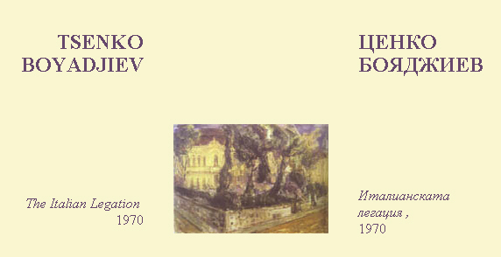

Fig.3. A view of a painting of Art Gallery of the UBA

Digitisation Process

The objects of the REGNET system are situated in different places like geographical tterm and like a kind of place. As it was shown in Fig.1 they are mainly books and archives in libraries and museums, real objects in museums, art galleries and artists and video and film materials in different institutions. All these objects have to be digitised for including in the REGNET system. The process of digitisation is quite different for the different objects and the different partners of the REGNET system. The particular institutions have different equipment, human resources and skills for the digitizing.

- Equipment
- Financial
- Human

CRITERIA :
* efficiency
* cost effectiveness

Fig. 4. Scheme of Digitisation Process

The Digitisation process has to be performed according to two main criteria like efficiency (the digitised objects have to have good quality) and cost effectiveness (the digitised process can not exceed determined limits).

1.3.1. Digitisation process for the artists

For the digitisation process for the artists’ objects can be used some standards for the description process and later for the presenting the object in INTERNET. For the description process the CDWA standards is appropriate for the artists’ objects. Below is shown a part of Intermediate Report 1.3 where this standard is recommended for the Artists’ area.
“Categories for the Description of Works of Art (CDWA, http://www.getty.edu/research/institute/standards/cdwa/) is a product of the Art Information Task Force (AITF) from Getty Research Institute (http://www.getty.edu/research/institute/standards.html). CDWA articulates an intellectual structure for the content of object and image descriptions. The Categories are intended to enhance compatibility between diverse systems wishing to share art information.
CDWA was created to be able to address art works and material culture from all periods and geographic areas and their visual surrogates (slides, photographs, digital images.) The categories range from general to specific with a small number of core elements required. Object information is entered into a consistent template that groups categories and subcategories. There are 31 broad categories with nine essential areas and 225 subcategories that allow information to be specifically recorded. “

For the Internet presentation of the artists’ objects the Dublin Core is suitable standard for metadata presenting. Dublin Core has 15 Meta Data elements:
- Title
- Creator
- Subject
- Description
- Publisher
- Contribution
- Date
- Type
- Format
- Identifier
- Source
- Language
- Relation
- Coverage
- Rights

These elements are necessary and sufficient for describing the artists’ objects through Internet.

Customized Digitisation Plan for the Union of Bulgarian Artists

The process of digitization of the artists’ objects for the Union of Bulgarian Artists has begun for few months and till now are scanned about 80 objects. The artists present their photo of the objects at the Union of Bulgarian Artists where the photo objects are scanned. The artists fill a list, shown at point 3 for the digitization process of their work. More detailed description of the digitization process in the Union of Bulgarian Artists is presented bellow.

1.4.1. Levels of Digitisation

- Preparing the object (painting, graphic, …)
As an individual artist or Art Gallery, which intend to present theirselves in the REGNET system have many objects, there is a kind of making decision which of the number of objects to be included in the REGNET Art Gallery.

- Preparing a Photo of the object.
At this step it is necessary to determine the environment of the object. For instance the object (painting, sculpture etc.) has to be putted on a fundament, and the light, photo and photograph process require special skills typical for the professional photographers. This and previous points are executed with the artists’ choice and possibilities. The photo picture of their object is presented at the Union of Bulgarian Artists where the next two steps are performed.

- Filling a data list :
 name,
 title of the object,
 year of creation the object
 technique
 size
 price /min – max /
 artistic pseudonym
 e-mail of the artist
 URL of the artist
 Specialty of the artist
 Year of birth
 Living place

This data is necessary for the describing the object and preparing for the Internet presentation.
As the REGNET standard has not been established in the beginning of the digitization process in the Union of Bulgarian Artists, after it’s determining it has to be included some more fields according to it.
Dublin Core standard is proposed for the Artists’ objects. The list of fields (shown above) satisfies the requirements of Dublin Core. For more completeness and preciseness it is better to include three fields more:
• Description of the object according to Description DC Element
• Rights of the object according to Rights DC Element
• Relation of the object according to Relation DC Element
Now the last field can be particularly filled with the existing data, using the URL and e-mail of the artist and the type of his work (painting, graphic, sculpture, etc.). The Relation option shall be filled from the artist, too - to be satisfied his requirements.

- Scanning the photo in high quality.
The scanning process is executed at the Union of Bulgarian Artists. Here is performed also the process of review scanned images (using Photoshop) and put the images on the shelf.
The next steps are performed at the ICCS.
- Preparing two kinds of objects:
128 x 128 pixels
300 x 300 pixels
These two kinds of scanned objects are necessary for the Internet presentation of the artist’s object. At the step of researching “State of the Art “ for the artists in Internet it was established the existence of these two kinds of presentations. The “little” picture is in the site of the Gallery and if it is necessary, by clicking it could be seen as a “large” picture in a new window. This is the common practice in the Internet Art Galleries and many examples could be seen at the previous reports regarding “state of the Art”. The “little” picture is put in the Gallery site not only for the better view of the page but mainly for faster loading the site.

- Preparing the necessary text of the objects
- Around the artist’s image at the REGNET site has to be shown text, consisting some mandatory fields (which have to be determined and standardized) like
Artist
Title
Medium
Year
More Art

Here could be used the example shown bellow from
http://www.art-gallery-online.org
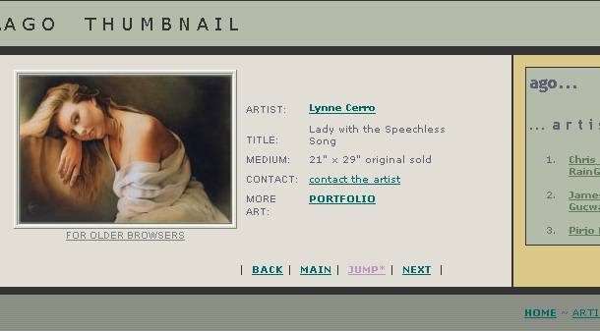

- the text has to be marked up for every object

- Process text into final form
- Archive text in repository

- Beginning the process of combining the image with text.
As the text is on a paper it must be inserted in the REGNET system in English and in Bulgarian. It has to be established correspondence between the image and the both kind of texts using code numbers.

- Audio files (if they will present in a future)
- Determine sample rate and resolution
- Select digital audio file format
- Analyze storage requirements
- Perform analog to digital conversion

- Check the sufficient of the filled data according to the determined standard.

As in the beginning are not used all data, necessary for the CDWA and Dublin Core, some artists have to add their data to be included in the REGNET system.

- Filling the necessary fields according to the standards.

- Filling the CDWA fields
- Filling the Metadata fields according to Dublin Core
- Filling the Fragments’ Table, necessary for REGNET

Here are included
- Incorporation of basic-level links
- Adding enhanced –access links or subject terms

- Store in Digital Archive
- store files in directories as specified by naming scheme
- register items in REGNET server
- deposit items in digital repository (when in use)
- all items stored

- Create Framework
- Develop and insert hypertext links
- Coordinate search engine link with the REGNET server
- Add graphic enhancement to HTML pages
- Review framework for accuracy and completeness

- Assemble Digital Collection
- store access aids in directories as specified by naming scheme
- register document style access aids in REGNET server (when in use)
- deposit document-style access aids in digital repository (when in use)
- generate indices for related CDWA records
- prepare customized scripts associated with searching indices and displaying results
- add relevant viewers to supported configuration for www access

- Test and refine
- review assembled collection for accuracy and completeness
- test links
- make any necessary changes
- testing completed

- Release collection
- move HTML pages to production area of the REGNET server
- provide links to new collection from appropriate points in the REGNET structure
- add collection level CDWA record to Dublin Core
- release digital collection to public

16. Update

