DIGITISATION PROCESS

Before starting any digitisation process it is necessary to establish the urgency of the digitisation request, the quality of the digital image needed, the complexity of the objects regarding their photographical aspects (e.g. highly shining object or paintings are more difficult to photograph than other objects), the fragility of the objects concerned, the internal facilities present in the organisation and the claims on these facilities made by others in reference to their priority.

- Determine use-type of digitised objects
  - Exhibition
  - Website
  - Museum PR
  - Internal publication
  - External publication
  - Restoration documentation
  - Collection research project
  - Collection management system

- Determine digitisation quality needed
  - Standard 72 dpi
  - Up to A-4 130 dpi
  - Higher quality

- Determine urgency of digitisation
  - Within one day – one week
  - Within one month
  - Within one year
  - Long-term project

- Object complexity
  - Standard (not highly glossy or extremely large, or microscopic)
  - Complex: highly shining object, paintings etc.

- Fragility
  - Normal
  - Highly fragile

- Internal facilities
  - None
  - Photographer
    - Analogue camera
    - Digital camera simple
    - Digital camera A-4 130 dpi
    - Digital camera > A-4 130 dpi
    - Scanner simple
    - Scanner advanced
  - Volunteer
    - Analogue camera
    - Scanner simple

- Claims for other projects on organisation facilities
  - None
  - Some
  - All

It is possible to construct a grid to accommodate all the factor mentioned here. It is better to keep these facets in mind and at the same time follow a general approach.

One can determine a basic set of workflows:
We presume that a museum has at least a basic set of facilities: simple digital camera, simple scanner.

External digitisation
Factors contributing towards this procedure:
- High digitisation quality needed
- Urgency is not high
- Large quantities of digitised images needed
E.g. Internal or external publications: posters or photo´s used in exhibitions or images (large numbers) used in the collection managementsystem.

Internal digitisation
Factors contributing towards this procedure:
- Images needed quickly
- Images needed of low or medium quality
E.g. Images for websites, restauration documentation, images for the collection management system.

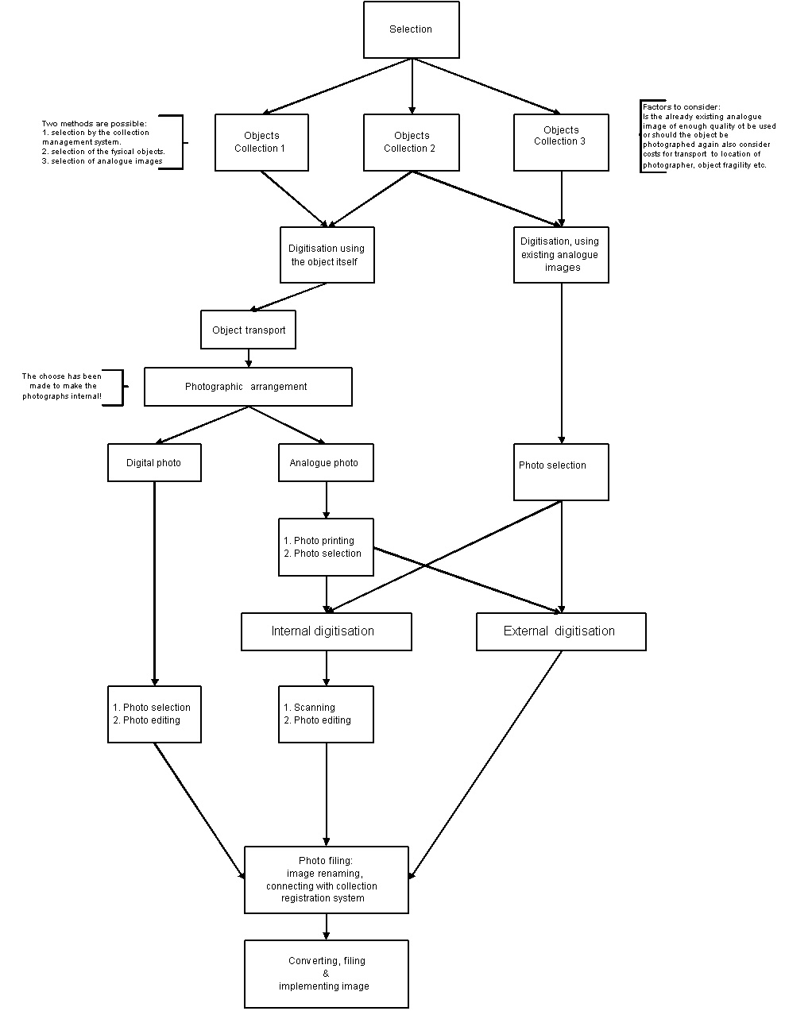

Decision-Digitisation Scheme

TIME CALCULATIONS

Several institutes have made calculations regarding the time investment for each phase in a digitisation proces. Here under are some of the results. Source : SIMIN-bundel nr. 18, Author J. v.d. Starre.
Care must be taken not to forget that a large object takes much more time and a complex object is more time consuming than a simple one. To go short : the durations mentioned are averages.

Digital photography
Activity | Number of mintes per object
Selection object collection | 1,00
Selection object | 4,00
Object transport | 5,00
Photographic arrangement | 5,00
Making digital photo | 2,00
Photo selection | 2,00
Photo editing | 1,00
Photo filing | 0,50
Photo convertion | 0,50
Photo filing | 0,50
TOTAL | 21,50

Analogue photography
Activity | Number of mintes per object
Selection object collection | 1,00
Selection object | 4,00
Object transport | 5,00
Photographic arrangement | 5,00
Making photo | 2,00
Photo printing | 9,50
Photo selection | 2,00
Photo scanning | 5,00
Photo editing | 2.00
Photo filing | 0,50
Photo convertion | 0,50
Photo filing | 0,50
TOTAL | 27,50

Existing analogue Images
Activity | Number of mintes per object
Selection object collection | 1,00
Selection object | 4,00
Photo selecting | 1,00
Photo scanning | 5,00
Photo editing | 2.00
Photo filing | 0,50
Photo convertion | 0,50
Photo filing | 0,50
TOTAL | 14,50

