

REGNET-IST-2000-26336
Work Sheet
Project acronym | REGNET |  | Contract nr. |  | IST-2000-26336
Type and Number | Digitisation Process & Best Practice
Work package | WP 1 Analysis of the State of the Art and Development of Concepts
Task | 1.2 Definition of Content
Date of delivery | Contractual | 2001-08-31 | Actual | 2001-08-31
Code name | RN_T12v01_ONB_digitproc-bestpr |  | Version 01 draft ☑ final
Distribution Type | Restricted (Content Providers)
Authors (Partner) | ONB
Contact Person | christian.recht@onb.ac.at
Abstract
Keywords List | Digitisation Process and Best Practice
Version log

Description of digitisation process & Best Practice

The study “DigiCult”, mandated by the European Commission and conducted by the independend experts of “Salzburg Research” (http://www.salzburgresearch.at ) identified the digitisation concept & process of the Austrian National Library as a leading example for digitisation in the field of cultural heritage in Europe. The Austrian National Library therefore takes the liberty to present one of it’s own projects:

The project "Digital Image Archive"

The project "Digital Image Archive" of the Austrian National Library (sponsored by the Federal Ministry of Education, Science and Culture and the Austrian Industrial Research Promotion Fund) aims at restructuring the "Collection of Portraits, Picture Archive and Fidei Commissa Library", Austria's largest picture documentation center. This division of the Austrian National Library holds more than 1.5 million pictures focussing on historical portraits, architecture, topography and history of Austria.
The project's main target is to create an efficient model for a "Digital Image Archive", which is based on the existing organizational structures of the collection. Traditional services shall be supplemented by new, digital services. Electronic image catalogues and presentations shall increase the availability of the objects of the collection for scientific as well as commercial usage.
For the Austrian National Library the "Digital Image Archive" project represents a decisive step towards cataloguing and stock exploitation of all kinds of pictural objects in all collections of the library. Digital services will open new opportunities of cooperation with the economy (publishing companies, printing trade and multimedia industry).

The Basis: the typewritten card catalogue

The new digital image catalogue is based on the typewritten card catalogue (developed in the 1930s) of the Picture Archive of the Austrian National Library.
This card catalogue comprises a central catalogue of 1,110.782 cards and an additional catalogue of 96.568 cards listing localities of Vienna which are arranged according to both districts and motives. Further, a catalogue in book form of about 10.000 pages summarizes comprehensive topics.
All cards of the card catalogue would amount to a length of about 291 meters.
The catalogue is built as a dictionary catalogue (combining author and subject heading catalogues). The cards can be divided in 3 types according to their function (header card, index card, pointer card) and in 3 categories according to their content (person, subject, topography).

Example 1: header card (person)
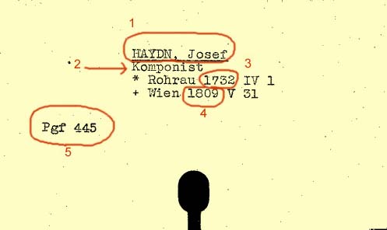
1: main heading
2: profession
3: date of birth
4: date of death
5: persons' index code

Example 2: index card (subject)
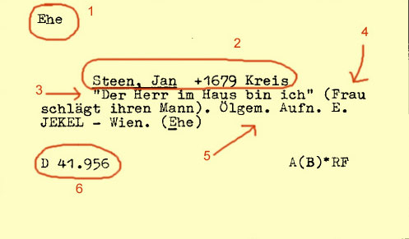
1: first heading
2: second heading
3: legend
4: description
5: technique
6: signature mark

Example 3: pointer card (subject)
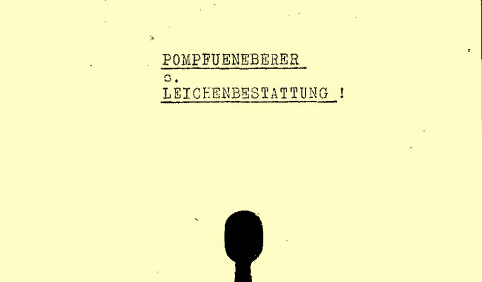

Example 4: header card (topography)
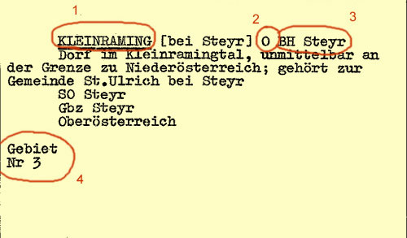
1: place name
2: federal province
3: district authority
4: geographical area codes

Example 5.: index card (topography)
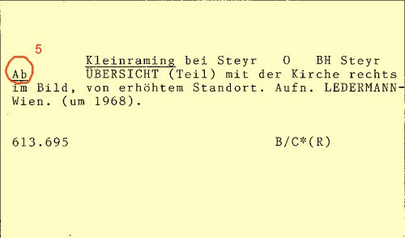
5: classification scheme

Thorough analysis & the digitisation of the card catalogue

More than 6 million catalogue cards of the Austrian National Library were digitised between 1998 and 1999 and a specific software was developed to make them available via the World Wide Web.
This software is called “KatZoom”. It was developed by Wilhelm Dikovich, a staff member of the Austrian National Library. “KatZoom” is based on the digitised card catalogue (GIFs) and structures the cards hierarchically according to their order in the alphabet. It enables the fast reproduction of searchable card catalogues of any size in the Internet, once the card catalogue is digitised. The user can browse through the cards by first choosing the initial letter in which he/she wants to browse in and subsequently narrow the range of cards in which he is interested in. “Katzoom” is a very simple tool easily understood by any user. Some of Austrian National Library’s catalogues may still be consulted via “KatZoom” ( http://katzoom.onb.ac.at/cgi-bin/katzoom/katzoom.pl?katalog=2 , http://katzoom.onb.ac.at/cgi-bin/katzoom/katzoom.pl?katalog=3 ).
A thorough analysis of the archive's structures led to the development of a concept for the Image Database. From August 1999 to October 1999 all catalogues of the Picture Archive were digitised.

The development of a cataloguing software & indexing

In cooperation with the Central Informatics Service of the Austrian National Library and based on the indepth structural analysis of the card catalogue, a cataloguing software was developed, which enables the indexing of millions of catalogue cards via web-interface in very short time. After having started with preliminary analyses as soon as fall 1999, the indexing software was programmed in spring 2000 by Wilhelm Dikovich. On the 27th of March 2000, at 15:15 in the afternoon, the first catalogue record was created: (the island) "Oahu", card-picture no. 726246. The final decision concerning the input fields and their structures was taken on the 3rd of March 2000, and the developing of the software for the indexing process was finished by the 24th of March 2000.
The result is an extension of the "KatZoom" software, developed by the Austrian National Library for the electronical reproduction of card catalogues in the internet. The extended solution "KatZoom plus" allows the creation of an index for the card catalogue, processed by automatic methods. In the case of the Picture Archive catalogue, an index was developed according to its documentary structure, dividing people, places and subject keywords.
In April 2000 an indexing team consisting of five people began with the indexation of the scanned integral catalogue. First, the type of card was determined for each new keyword appearing in the alphabetical order of the cards.

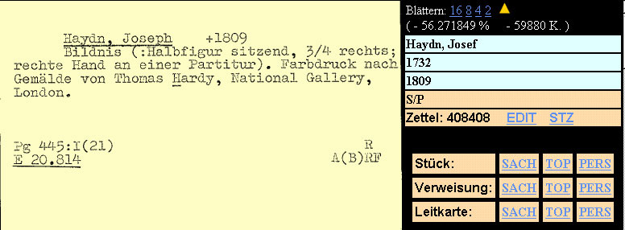

By a simple click on the corresponding card category the input mask was opened and the correct type of card was already marked. Then the input fields were filled in. In the case of persons, dates of birth and death were indexed in addition to names. Where topographics were concerned, area codes and classifications were indexed, too. This system of marking and dividing enabled an efficient processing of the cards for the import into the image database (separating header and index cards, creating a topographical thesaurus as well as an index for people and subject keywords, and removing pointless pointer cards etc.).

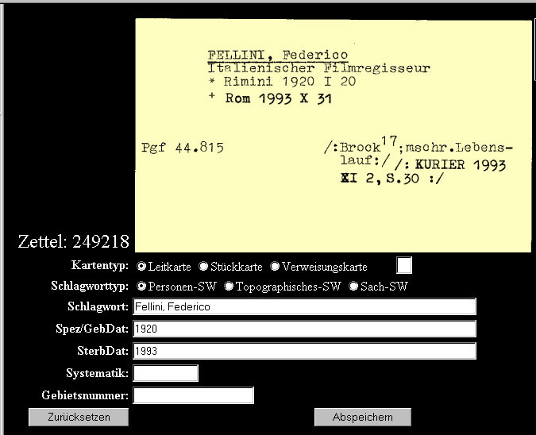

After completing the form of the input mask, the indexing person would close the input mask window. As the index keywords would then be automatically attributed to the following cards, as long as no new index keyword was written into the input field of the input mask, not every single card but only the cards with different keywords had to be worked on. A second index level was built in where there were more than 400 index cards in a row.
During the input process, there was no automatic spell-check or any control, whether the cards were appearing in the right order. Misplaced or faulty cards were marked with special codes during the indexing process, which enabled a direct accession to the record in question in a correctional phase. These check-routines and protocols were performed during the night or at week-ends.
The project team started indexing the Picture Archive catalogue (about 1.2 million catalogue records) at April 3rd, 2000. Everyone managed to increase the average daily indexing rate from about 800 cards per day to about 3500 cards per day. On August 10th, 2000 the indexing team celebrated the indexation of the one millionth catalogue card and on November 10th, 2000 all catalogues of the Picture Archive had been indexed, corrected and prepared for the import into the Image Database.

The installation of the Image Database

The selection committee of the Library's Directorate General elected STAR (online information: http://www.cuadra.com ) as the new image database of the Austrian National Library. In addition to the library system ALEPH, STAR covers cataloguing, documentation and customer services for the collections of the Austrian National Library. It was installed at the Austrian National Library at the 13th of February 2001.
Subsequently, the database had to be adapted to the needs and data structures of the Picture Archive. This is where the STAR Software’s flexibility (which was one of the main reasons why it was elected) proved to be a major asset.

Going online

On July 12th 2001 the Austrian National Library presented the new online version of the Picture Archive: http://www.bildarchiv.at . It’s design and storyboard has been realized by the Internet- and Web Design Experts “Pixelwings Medien AG” in close cooperation with the Picture Archive of the Austrian National Library. It is a test version and aims at gaining first experiences in new communication forms and consumer relations. Even as a test version, it already attracted thousands of users and earned wide recognition among professionals.
One of the prize winning features of this website is the fact, that the user actually furthers the indexation of the catalogue by ordering an item. As he orders a reproduction of a certain picture, he/she is prompted to fill in the signature of the specific picture, which can be read of the catalogue card. The signature of the picture was not indexed during the indexation phase, as it would have been much to time consuming and expensive. This way, the user contributes to the building up of information: not only concerning the signatures of pictures, but also concerning the items which are of the greatest interest for the users. The quality control consists in the ordering process: giving the wrong signatures automatically entails the reproduction of the wrong picture. As the filling in of this signature field is mandatory, every order is also a service rendered to the Picture Archive.
Besides the mandatory signature field, the user is also asked to help the Archive by copying the legend. This field is not mandatory. Still, it has been filled out by a small percentage of users.

