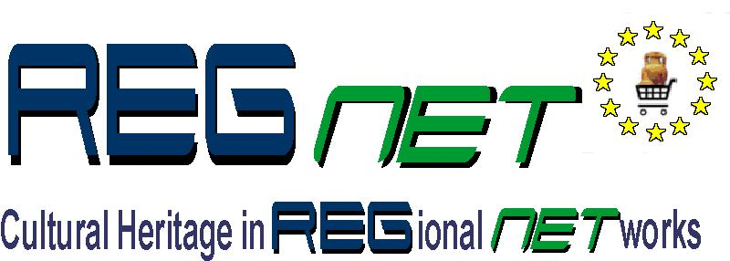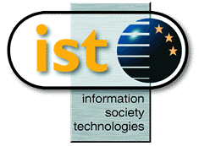

REGNET-IST-2000-26336
Interim Report
Project acronym | REGNET |  | Contract nr. |  | IST-2000-26336
Type and Number | Interim Report no. 1.4.1
Work package | WP1: Analysis of the State of the Art and Development of Concepts
Task | T1.4: Development of the System Specifications
Date of delivery | Contractual | YYYY-MM-DD | Actual | 2001-06-30
Code name | RN_IR141v01_Space_Contribute |  | Version NN draft ☑ final 
Objective | Report
Distribution Type | Restricted / Public
Authors (Partner) | Space
Contact Person | Alongi Paolo
Abstract
Keywords List
Version log

Uses cases
- G1 – Data generation

To be discussed…

Functional architecture

Data generation

Metadata advantages
With increasing amounts of data being created and stored (but often not well organised) there is a real need to document the data for future use - to be as accessible as possible to as wide a "public" as possible.
Data without context are not as valuable as documented data, for this reason its very important to add the context use to data. Data plus context become information (documentation + metadata = information).
There are significant benefits to such approach:
Metadata helps organise, maintains an organisation's investment in data, and provides information about an organisation's data holdings in catalogue form. Coordinated metadata development avoids duplication of effort by ensuring the organisation is aware of the existence of data sets. Users can locate all available items and associated data relevant to an area of interest.

fig. 1 - Metadata collection in REGNET Scenario

Collection of metadata enhances the data management procedures of the REGNET community.
Content providers are able to advertise and promote the availability of their data and potentially link to REGNET on line services (e.g. text reports, images, multimedia productions, CD-ROM, catalogues and e-commerce) that relate to their specific data sets.

Metadata levels
There are different levels into the REGNET structure that metadata may be used for:

- Discovery – metadata describes the sort of data, user is interested in. This enable REGNET content provider to know and publicise what data holdings they have. In other terms, this level is the minimum amount of information that needs to be provided to ensure to the inquirer the nature and content of the data resource.
This falls into REGNET’s broad categories to answer the ”what, why when who, where and how” questions.
The level of metadata detail that will be documented is dependent on the type of data held and the methods that it is being accessed and used.

- Exploration – metadata have to identify if data sets contain sufficient information to enable a sensible analysis to be made for users purposes.

- Exploitation – metadata have to establish the process of obtaining and using the data that are required. This helps end users and provider organisations to effectively store, reuse, maintain and archive their data holdings.

Each of these purposes, while complementary, requires different levels of information. As such organisations should look at their overall needs and requirements before developing their metadata systems. The important aspect is for agencies to establish their business requirements first, the content specifications second and the technology and implementation methods third.

Cultural Heritage Data Management
The goal of the Cultural Heritage Data Management (REGNET Node 2) is to supply and promote an application-independent interoperability framework that can be used by a variety of partners who are engaged in publishing digital content on the Web.

REGNET is composed of an arbitrary number of repositories (data storage), containing digital contents (electronic documents, images, audio files, video streams, etc.) coming from REGNET content providers such as museum collection, photograph library catalogue and any kind of interesting archives.

The distruibuted repositories of REGNET are network accessible, filtered by Portal subsystem, to which user’s requests can be submitted. Is expected that Cultural Heritage Data Management (Node-2) will be able to return a record about each object held in the content’s provider database.

Searching various databases concurrently is a complicated matter for several reasons: their records differ, covered fields differ, the syntax in the fields differ and access protocols differ (if network accessible overall).
The Cultural Heritage Data Management aim is to choose an appropriate strategy to develop a joint database record profile, so individual fields in each original database will be mapped to this common profile.
As the next step each partner will extract the relevant fields from their database and expose their data to a common REGNET front end, containing similar resource descriptions (but describing different material).
To create the initial common record profile, the REGNET partners need a known resource description method, which could serve as a "switching language" between individual database records. For this purpose we propose to use the Dublin Core Metadata Element Set

Technical architecture

Data generation

REGNET partners have to select a supported international standard: the Dublin Core is a metadata element set intended to facilitate discovery of electronic resources. Originally conceived for author-generated description of Web resources, it has attracted the attention of formal resource description communities such as museums, libraries, government agencies, and commercial organisations, finding a great international consensus. The advise is to stay within Dublin Core constructs. Subtle changes may be cost in terms of exchangeable and parser(by software) behaviour.

The ability to differentiate the contents of the meta-database from its presentation allows Content creator to consider more flexibly how to present what information. There are typically three forms of metadata that should be recognized and supported in systems:

- the implementation form: within a database or software system
- the export or encoding format: a machine-readable form designed for transfer of metadata between computers
- the presentation form : a format suitable to viewing by humans.

By recognizing the connections between these dispositions of metadata, one can build systems that support mission requirements, standard encoding for exchange, and permit many “report” views of the metadata to satisfy the needs and experience of different user constituencies.

The Extensible Markup Language (XML) provides solutions to metadata problem:
- Includes a capable markup language with structural rules enforced through a control file to validate document structure.
- Through a companion standard (XML Style Language, or XSL), an XML document may be used along with a style sheet to produce standardised presentations of content, allowing the user to shuffle field order, change tag names, or show only certain fields of information. Used together XML and style sheets allow for a structured exchange format and for flexible presentation. Thus, a metadata entry can be rendered in many ways from the same, single structured encoding. XML is a widely accepted encoding methodology with international software support. It is supported by a lot of software, both free and commercial. However, the metadata-producing community doesn't have much experience using it to solve problems yet.

Metadata generation
The Data Generation (subsystem-4) is a sub-module belong to REGNET Portal. Like others entry point of the REGNET’s Portal its aimed at support REGNET’s metadata contributor.
Subsystem-4 have to ensure that there is good communication between the metadata producer and the data producer (usually working in the same organization); the former may have to ask questions of the latter to collaboratively develop adequate documentation.
Creating correct metadata is like library cataloguing, except the creator needs to know more of the technical information behind the data in order to properly document them.

The form for maintaining metadata will depend on a number of factors:
- the size of the data holdings
- the size of an organisation
- the patterns of data management within an organisation

fig. – CH Data Management Technical architecture

Probably REGNET partners who produce contents to be treated in the system, not be worth their time to fully learn a metadata standard. Instead, they might be asked to fill out a less-complicated form or template (Data Entry Form) that will be rendered in the proper format by a data manager or cataloguer who is familiar with the subject and well-versed in the metadata standard.
Following term lists and recommendations, the Data Entry Form permits the creation of high quality metadata (Dublin Core) to carry into XML documents.

The Data Entry Form displays a specific set of metadata elements with the available metadata values. Some mandatory elements could include Identifier, Title, Description and Subject. Where metadata is not present, values for these elements will be obtained according to the default rules that will be establish. The Thesaurus module connected to the Metadata Editor enables keywords selected from a list of resources to be mapped to a selected thesaurus and then inserted into the metadata element as controlled vocabulary. This module permits users to view data from a number of different thesauri.

The Metadata Manager provides the administrator of REGNET system with the facility to build/update the Thesaurus, to select resources and to view its metadata with the option of editing or creating metadata using the editor module.
The Metadata contributor is able to update element through the Metadata Manager across the existing resources .

As the data holdings become larger and the access to the data becomes distributed, then organisations would look at more advanced methods for maintaining metadata of their data holdings. These advanced tools may consist of commercial or self-developed systems that may extract aspects of the metadata automatically from the data itself: this is the approach of most of the various harvesters such as AltaVista and the like. The harvester module visits a document, reads it, and returns back resource description, such as every weeks or months, to look for changes.
The resource description continuum represents compromises among cost, ease of creation and maintenance, and utility.
At one end there is the virtue of simplicity: harvesting is done with no concern for the domain, the structure, or the purpose.
The scale of the collection and delivery of the information is challenging, but the description model is simplistic: word-level indexing. Search result sets are generally very large; high recall, but typically very low precision. Even with such coarse-grained retrieval, the harvester results can be useful.

Cultural Heritage Data Management

To encourage the interoperability of the REGNET Node-2 data flow, it will be possible to implement a database without affecting how the data are stored. The Content’s provider are not restricted in how they implement their database so long as the interface they present to the ZClient conforms to the Z39.50 Profile.

Protocol Z39.50
In order to make all databases accessible from a single interface, they are all connected to the Internet through Z39.50. This is a standard client/server search and retrieve protocol. Since it was originally proposed in 1984 it has increased in popularity in the library community, becoming one of the most used standards to achieve interoperability in search and retrieval.
As Z39.50 is supposed to cover all possible needs for searches in bibliographic databases, its design is quite flexible, allowing the implementor to choose which features of the protocol to implement and how to use these to achieve the desired functionality.
In order to make it easier to create software that can work with several databases, some sub-standards to Z39.50 have been developed. These standards determine what features a Z39.50 server should support and how it should respond to certain requests.

The gateway approach, described on CIMI Profile (including Z39.50 protocol) provides the capability to convert dynamically between the Z39.50 protocol and the native query and retrieval facilities of the host database. In other word it maps the host database's searching and retrieval capability on to the Z39.50 Profile as well as it can, rather than augmenting it in any fundamental way. The "underlying database" is accessible according to the mapping implemented by the Z39.50 protocol.

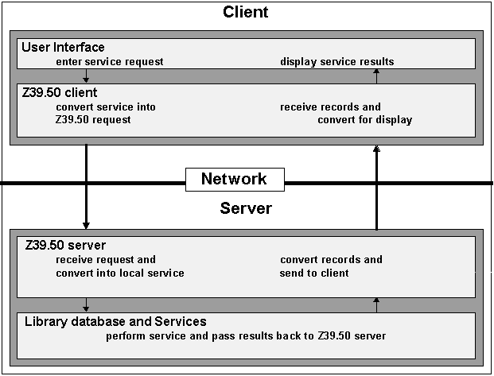

The Reference System of REGNET acts as a proxy for the "underlying database" which is not directly accessible to Z39.50 clients.

System architecture and tools [VALT]
This part detail necessary tools for each module.

Web acquisition client
JavaTM Web Start is a new application-deployment technology gives the power to launch full-featured applications with a single click from the Web browser. User can now download and launch applications, such as a complete spreadsheet program or an Internet chat client, without going through complicated installation procedures.

Data generation
Modules could be developed using C/C++ or PHP or Java languages.
For what concern tools implementing the Harvest module we could adopt the Combine Harvesting robot (http://www.lub.lu.se/combine/ ): Combine is an open system for harvesting and indexing Internet resources. The Combine was initially developed as a part of the Development of a European Service for Information on Research and Education (DESIRE) project, which was funded by the European Commission within Telematics for Science Program.
The Combine Robot was released only in 1998, and is currently used whithin the nordic NWI services in Sweden and Denmark. It is also used in other contexts like the research information system Safari. Combine its useful for regional web indexing in general.

Cultural Heritage Data Management
Modules could be developed using C/C++ or PHP or Java languages.

For what concern tools implementing the Z39.50 protocol there exist various kits, all available for free at http://www.indexdata.dk/software:
SimpleServer is a simple Perl module for implementing Z39.50 servers over own database. It handles the complexity of network and session management, Z39.50 protocol exchanges, and allows to concentrate on the task of searching database.
YAZ (Yet Another Z39.50 Toolkit) is a "toolkit" for implementing the Z39.50-1995 standard and protocol. Both the Origin (client) and Target (server) roles of the protocol are supported. The toolkit is written in C. YAZ is freeware.
PHP/YAZ is an extension for PHP that implements a Z39.50 origin. The software allows you to build web gateways that searches Z39.50 targets in parallel.
ZAP! : Easy-to-use Apache module for WWW/Z39.50 development. You develop WWW-based user interfaces in ZAP! by providing a template of HTML-bits to be output in specific situations. It's easy to make simple gateways in ZAP!, but it also makes it possible to develop quite complex systems

