

REGNET-IST-2000-26336
Task Brief
WP Number and Title |  |  |  |  | WP 1 | Analysis of the State of the Art and Development of Concepts
Task Number and Title |  |  |  |  | T 1.4 | Development of the System Specifications:
Sub-Task Number and Title |  |  |  |  | T 1.4.1.1 | Node-1: Portal – Data Generation
Task Leader and Contact |  |  |  |  | MOT | roberto.cicci@motorola.com
Deliverable Number and Title |  |  |  |  | D 2 | Report: “The REGNET – System: Specification and State of the Art”
Interm. Report Number and Title |  |  |  |  | IR 1.4.1 | REGNET Node-1: Portal – Data Generation (2001-06-30)
Start Date: |  |  | 2001.05.02 |  |  | End Date: | 2001.09.30
Version | Date |  |  | Log
01 | 2001-06-01 |  |  | First Version
Objectives:
Description of Work:
Metadata advantages
With increasing amounts of data being created and stored (but often not well organised) there is a real need to document the data for future use - to be as accessible as possible to as wide a "public" as possible.
Data without context are not as valuable as documented data, for this reason its very important to add the context use to data. Data plus context become information (documentation + metadata = information).

There are significant benefits to such approach:
Metadata helps organise, maintains an organisation's investment in data, and provides information about an organisation's data holdings in catalogue form. Coordinated metadata development avoids duplication of effort by ensuring the organisation is aware of the existence of data sets. Users can locate all available items and associated data relevant to an area of interest.
Collection of metadata enhances the data management procedures of the REGNET community.
Content providers are able to advertise and promote the availability of their data and potentially link to REGNET on line services (e.g. text reports, images, multimedia productions, CD-ROM, catalogues and e-commerce) that relate to their specific data sets.

Metadata levels
There are different levels into the REGNET structure that metadata may be used for:

- Discovery – metadata describes the sort of data, user is interested in. This enable REGNET content provider to know and publicise what data holdings they have. In other terms, this level is the minimum amount of information that needs to be provided to ensure to the inquirer the nature and content of the data resource.
This falls into REGNET’s broad categories to answer the ”what, why when who, where and how” questions.
The level of metadata detail that will be documented is dependent on the type of data held and the methods that it is being accessed and used.

- Exploration – metadata have to identify if data sets contain sufficient information to enable a sensible analysis to be made for users purposes.

- Exploitation – metadata have to establish the process of obtaining and using the data that are required. This helps end users and provider organisations to effectively store, reuse, maintain and archive their data holdings.

Each of these purposes, while complementary, requires different levels of information. As such organisations should look at their overall needs and requirements before developing their metadata systems. The important aspect is for agencies to establish their business requirements first, the content specifications second and the technology and implementation methods third.

Description of Sub-Component: Data Generation (node-1/subsystem-4):
This subsystem (component) enables the generation of meta data either via a (configurable) data entry facility (loaded into the user's browser) or by sending a harvester to repositories included in Subsystem-1. Meta data are either stored in Subsystem-1 or -2. Data entry and harvester processes can be triggered by document type definitions (residing in Subsystem-3) according to the needs of the end user (librarian, archivist, curator). The client connected to this subsystem might even support multimedia and 2/3D data input of digital content.
Methodology:
The subsystem-4 is a sub-module belong to REGNET Portal. Like others entry point of the REGNET’s Portal its aimed at support REGNET’s metadata contributor (as included in the T 1.4.3.1 Task brief delivered by ZEUS).
Subsystem-4 have to ensure that there is good communication between the metadata producer and the data producer (usually working in the same organization); the former may have to ask questions of the latter to collaboratively develop adequate documentation.
Creating correct metadata is like library cataloguing, except the creator needs to know more of the technical information behind the data in order to properly document them.

[1] Subsystem-4 (Data Generation) into the REGNET Architecture

The form for maintaining metadata will depend on a number of factors:
- the size of the data holdings
- the size of an organisation
- the patterns of data management within an organisation

Probably REGNET partners who produce contents to be treated in the system, not be worth their time to fully learn a metadata standard. Instead, they might be asked to fill out a less-complicated form or template (Data Entry Form of subsystem-4) that will be rendered in the proper format by a data manager or cataloguer who is familiar with the subject and well-versed in the metadata standard.
To example title, a similar service is provided by the Nordic Metadata Project (Library of Lunds University in Sweden) in order to assure good support for the creation of Dublin Core metadata to the Nordic "Net-publisher" community.
Following term lists and recommendations, the form permits the creation of high quality metadata (Dublin Core) to carry into HTML documents.
As the data holdings become larger and the access to the data becomes distributed, then organisations would look at more advanced methods for maintaining metadata of their data holdings. These advanced tools may consist of commercial or self-developed systems that may extract aspects of the metadata automatically from the data itself: this is the approach of most of the various harvesters such as AltaVista and the like. The harvester module visits a document, reads it, and returns back resource description, such as every weeks or months, to look for changes.
The resource description continuum represents compromises among cost, ease of creation and maintenance, and utility.
At one end there is the virtue of simplicity: harvesting is done with no concern for the domain, the structure, or the purpose.
The scale of the collection and delivery of the information is challenging, but the description model is simplistic: word-level indexing. Search result sets are generally very large; high recall, but typically very low precision. Even with such coarse-grained retrieval, the harvester results can be useful.
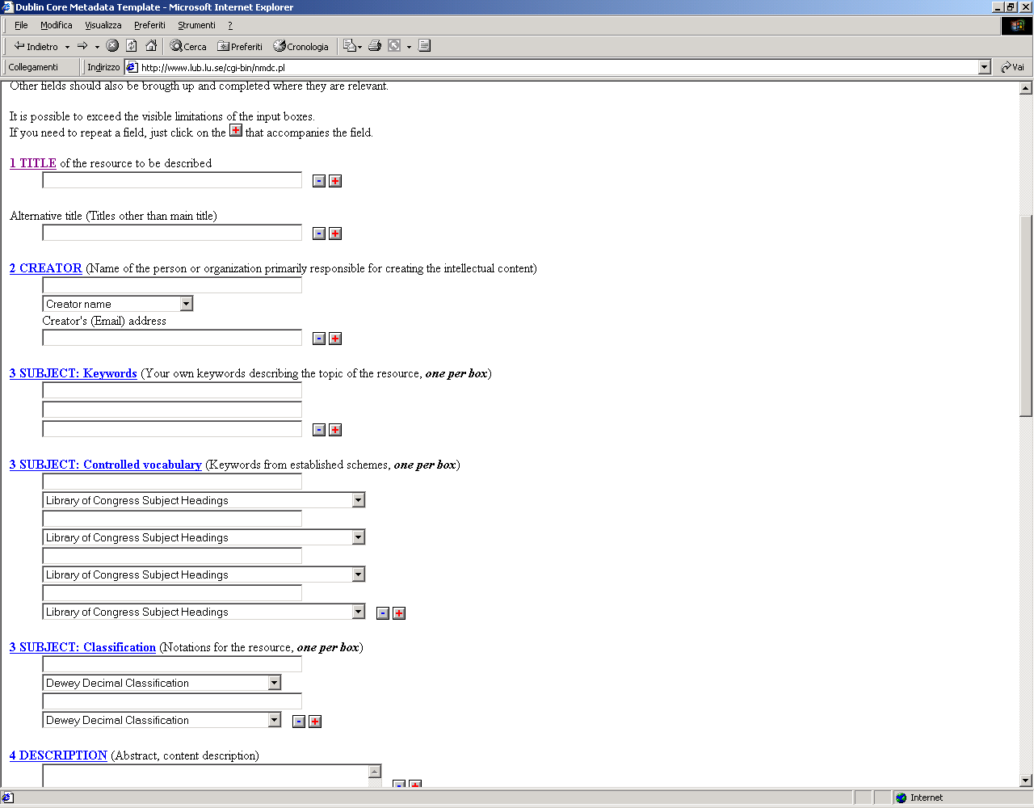

[2] Dublin Core Metadata Template (http://www.lub.lu.se/cgi-bin/nmdc.pl)

Expected results

- REGNET partners have to select a supported international standard: the Dublin Core is a metadata element set intended to facilitate discovery of electronic resources. Originally conceived for author-generated description of Web resources, it has attracted the attention of formal resource description communities such as museums, libraries, government agencies, and commercial organisations, finding a great international consensus. The advise is to stay within Dublin Core constructs. Subtle changes may be cost in terms of exchangeable and parser(by software) behaviour.

- The ability to differentiate the contents of the metadatabase from its presentation allows Content creator to consider more flexibly how to present what information. There are typically three forms of metadata that should be recognized and supported in systems:

  - the implementation form: within a database or software system
  - the export or encoding format: a machine-readable form designed for transfer of metadata between computers
  - the presentation form : a format suitable to viewing by humans.

By recognizing the connections between these dispositions of metadata, one can build systems that support mission requirements, standard encoding for exchange, and permit many “report” views of the metadata to satisfy the needs and experience of different user constituencies.

- The Extensible Markup Language (XML) provides solutions to metadata problem:
- Includes a capable markup language with structural rules enforced through a control file to validate document structure.
- Through a companion standard (XML Style Language, or XSL), an XML document may be used along with a style sheet to produce standardised presentations of content, allowing the user to shuffle field order, change tag names, or show only certain fields of information. Used together XML and style sheets allow for a structured exchange format and for flexible presentation. Thus, a metadata entry can be rendered in many ways from the same, single structured encoding. XML is a widely accepted encoding methodology with international software support. It is supported by a lot of software, both free and commercial. However, the metadata-producing community doesn't have much experience using it to solve problems yet.

Partner |  | PM | Contact (email) |  |  | Obligation
- AIT |  | 0,3 | bogenspergerm@ait.co.at |  |  | Contribution to IR 1.4.1
- IMAC |  | 1 | grossmann@imac.de |  |  | Contribution to IR 1.4.1
- MOT |  | 2 | roberto.cicci@motorola.com |  |  | Task Management and Contribution to IR 1.4.1
- SPAC |  | 1 | paolo.alongi@spacespa.it |  |  | Baseline for this sub-chapter of Interim Report IR 1.4.1
Total Effort |  | 4,3 | Comment

