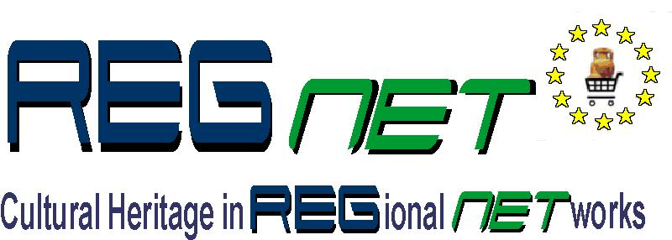

REGNET-IST-2000-26336
Task Brief
WP Number and Title |  |  | WP 1 | Analysis of the State of the Art and Development of Concepts
Task Number and Title |  |  | T 1.4 | Development of the System Specifications
Sub-Task Number and Title |  |  | T 1.4.2.2 | Node-2: Cultural Heritage Data Management Reference System
Task Leader and Contact |  |  | SPAC | Stefano.cuomo@spacespa.it
Deliverable Number and Title |  |  | D 2 | Report: “The REGNET – System: Specification and State of the Art”
Interm. Report Number and Title |  |  | IR 1.4.1 | REGNET Node-2: Cultural Heritage Data Management – Reference System (2001-06-30)
Start Date: | 2001.05.02 |  |  | End Date: | 2001.09.30
Objectives: as specified
Description of Work:
Cultural Heritage Data Management is one of the five main – server side – components located on Node-2. It should be considered that the REGNET technical infrastructure should be portable to different locations and by no means proprietary or dependent on a few vendors. That’s why the system should be scalable.
Node-2 facilitates the management of data related to scientific and cultural heritage. The connected repositories contain electronic documents as well as surrogates of ‘real objects’. This node type consists of two components:
Subsystem-2 contains meta-data related to the Repositories included in ‘Repository Management’ or ‘Product Catalogue Management’ and allows distributed searches over those repositories. The meta-data database stored in ‘Reference System’, could also be populated by meta-data generation done within subsystem-4 (Data Generation).
After, the generation of meta data either via a configurable data entry facility loaded into the user's web browser or by sending a harvester to repositories included in Subsystem-1, meta-data are stored in the Reference System.
Description of Component: Reference System (node-2/subsystem-2)
- Reference System (subsystem-2)
This subsystem contains meta data related to the Repositories included in Subsystem-1 or Subsystem-7. It allows distributed searches over those repositories. The metadata data base is populated by uploads of Subsystem-1 or Subsystem-7, or meta data generation done within Subsystem-4 (data entry, harvesting).
-Protocol
The usage of low cost software and reuse of available components is a priority. Especially, for data related to the storage and exchange of cultural heritage, CIMI profile is the most appropriate one.
This set of technical specifications govern the interaction of clients and servers for information retrieval from one or more distributed repositories. The CIMI Profile defines specifications for searching a database, selecting information to be retrieved from the database, and structuring and packaging of the information to transfer from the server to the client. The Profile contains sections that detail the way Z39.50 protocol is used for:
Search: Specifications that allow a client and a server to share an understanding of access points available for searching databases containing, for example, museum object records and images with associated text. This is accomplished by specifying a standard list of access points represented by an Attribute Set (e.g. CIMI–1) along with semantics for those access points. The client and the server share an understanding of CIMI–1 and other Z39.50 attribute sets. The functionality provided by these specifications enables a client to express searches on specific concepts (e.g., the title of an object, the provenance of an object, the material or medium of the object) in a standard way that can be understood by a server.
Retrieval: Specifications cover both Selection and Transfer. Selection specifications allow a client and a server to share an understanding of database records for retrieving the entire record or specific units of information (e.g., one or more groups of database fields). This is accomplished by specifying a standard list of elements in the Abstract Record Structure for the Retrieval Record along with semantics for those elements. The client and the server share an understanding of this Abstract Record Structure. The functionality provided by these specifications enables a client to ask for groups of elements and enables the server to deliver those elements and label each element in a standard way for client processing. Transfer specifications allow a client and a server to exchange a record in an understandable format
According to the users requirements the CIMI profile could be enriched with additional tags and composite one big schema, stored in subsystem-2 which could be used as a linkage between the distributed repositories including the subsystem-7 (referred to e-Business).
-Metadata System
Data exchange will be based on different XML data management tools already available. In the field of Cultural Heritage we propose the use of ‘XML/Dublin Core’ and in the field of e-Business the use of ‘ebXML’. A description of both tools follows:
Dublin Core:
Metadata is used to supplement existing methods for searching and indexing Web-based metadata, regardless of whether the corresponding resource is an electronic document or a "real" physical object. The characteristics of the Dublin Core that distinguish it, are:
Simplicity: The Dublin Core is intended to be usable by non-catalogers as well as resource description specialists. Most of the elements have a commonly understood semantics of roughly the complexity of a library catalog card.
Semantic Interoperability: In the Internet Commons, disparate description models interfere with the ability to search across discipline boundaries. Promoting a commonly understood set of descriptors that helps to unify other data content standards increases the possibility of semantic interoperability across disciplines.
International Consensus: Recognition of the international scope of resource discovery on the Web is critical to the development of effective discovery infrastructure. The Dublin Core benefits from active participation and promotion in some 20 countries in North America, Europe, Australia, and Asia.
Extensibility: The Dublin Core provides an economical alternative to more elaborate description models such as the full MARC cataloging of the library world. Additionally, it includes sufficient flexibility and extensibility to encode the structure and more elaborate semantics inherent in richer description standards.
ebXML:
ebXML is a set of specifications that together enable a modular electronic business framework. The vision of ebXML is to enable a global electronic marketplace where enterprises of any size and in any geographical location can meet and conduct business with each other through the exchange of XML based messages. The ebXML architecture provides:
- A way to define business processes and their associated messages and content.
- A way to register and discover business process sequences with related message exchanges.
- A way to define company profiles.
- A way to define trading partner agreements.
- A uniform message transport layer.

The following figure shows schematically how the ebXML works:
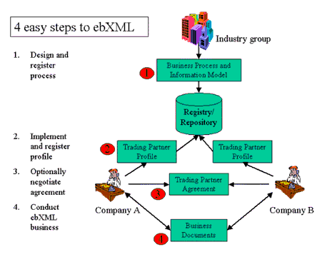
In our point of view, subsystem-2 (Reference System) relies on ‘Registry/Repository’ module of ebXML.
Methodology:
Partner | PM | Contact (email) |  | Obligation
- AIT | 1 | bogenspergm@ait.co.at |  | Baseline for this sub-chapter of Interim Report IR 1.4.1
- CERT | 2 | Dimitrios.Tzovaras@iti.gr |  | Contribution to IR 1.4.1
Total Effort | 3

