

REGNET-IST-2000-26336
Task Brief
WP Number and Title |  |  | WP 1 | Analysis of the State of the Art and Development of Concepts
Task Number and Title |  |  | T 1.4 | Development of the System Specifications:
Sub-Task Number and Title |  |  | T 1.4.3.1 | Node-3: eBusiness Data Management - Product Catalogue Management
Task Leader and Contact |  |  | ZEUS | kgiotop@zeusnet.gr
Deliverable Number and Title |  |  | D 2 | Report: “The REGNET – System: Specification and State of the Art”
Interim. Report Number and Title |  |  | IR 1.4.1 | REGNET Node-3: eBusiness Data Management - Product Catalogue Management (2001-06-30)
Start Date: |  | 2001.05.02 |  | End Date: |  | 2001.09.30
Objectives: System specifications will be elaborated using state of the art and well-proofed methods. The method used within REGNET is outlined in the annex. There will be five main – server side - components (REGNET-Portal, REGNET-Cultural Heritage Data Management, REGNET-eBusiness Data Management, REGNET-Ontology Checker, REGNET-Electronic Publisher) located on different nodes. This will imply an n–tier architecture with interoperable components like protocol gateways, (multi media) data management, data exchange facilities, etc. An outline of the methodologies used is given in the annex. Standard notations (e.g. UML) will be used as applicable.
Description of Sub-Component: Product Catalogue Management (node-3/subsystem-7)
This subsystem includes meta data describing products (real or digital) offered by content providers up to services offered by service providers (e.g. consultancy, digitisation projects, etc). REGNET allows also search and retrieval of distributed product (and service) catalogues (as included in the ebXML specifications). Doing this, the user will be able to compare products, which supports his/her buying decision.

Description of Work:
The Product Catalogue Management will consist the basis for the description of the products using meta data.
The concept of the operation of the specific sub-system will be based on the following architecture:
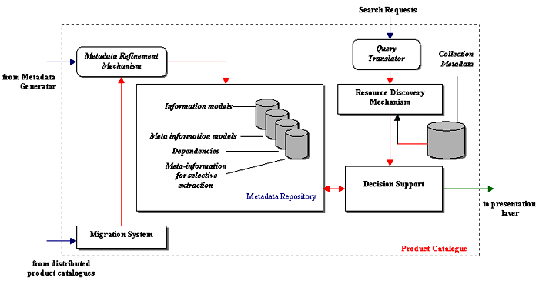
The components of the Product Catalogue Management are the following:
- Metadata Refinement Mechanism:
Since the current feature extraction methods are not perfect, the initial subject clustering of the database images clustering may be inaccurate. In addition, new images and new subject domains may be added into the database. Thus, metadata must be dynamically updated. The metadata refinement involves two aspects:
- Updating existing metadata based on database updates. (Input from Migration System)
- Updating existing metadata based on query feedback
The metadata refinement process is often time-consuming and should be performed off-line.
- Resource Discovery Mechanism:
The goal of the RDM is to find the best collections for a query that an end-user has made to the system. This is really important and efficient for the systems performance, because the end users have a large variety of searchable collections available to them. Accessing all these collections for each query is not practical and the response time in too many collections will vary. Besides that, only few collections will contain useful items for a given query. Therefore, the demand for a tool that assists users in discovering the useful resources for their queries is great. This process will be covered by the RDM.
- Query translator:
The queries that are given to the system by the user need correspond directly to requirements on our metadata architecture.
- Migration System:
The Migration system will reflect all changes of a product features (i.e. price etc.) to the Product Catalogue Management. Therefore it will provide the input to the metadata refinement mechanism to update existing metadata based on database updates.
- Decision Support
The Decision Support mechanism will provide the decision for the output of the results of the queries into a necessary format in the presentation layer.
- Metadata Repository
The model correspondences in the modelling phase separate the different kinds of metainformation. Following the same strategy these different kinds of metainformation are stored into different repositories. So, there are different sub-repositories, in order to store the information models, the metainformation models and the dependencies of the above two. The last sub-repository stores the metainformation for the selective extraction of the query results.
The above components consist the operational and functional features of the Product Catalogue Management and the basis of the E-business system.
Furthermore, the inputs of the PCM are three:
- The query from the user.
- The metadata from the metadata generator
- The changes of the feature of a product in order to update the already stored metadata.
The output of the system is one and concerns the presentation of the results of a query in the presentation layer of the portal.

Methodology:
Partner | PM | Contact (email) |  |  | Obligation
- VALT | 2 | jean-pierre.Lorre@toulouse.valtech.fr |  |  | Metadata Refinement Mechanism  Resource Discovery Mechanism
- ZEUS | 5 | kgiotop@zeusnet.gr |  |  | Baseline for this sub-chapter of Interim Report IR 1.4.1  Task Management and Contribution to IR 1.4.1  Query translator  Migration System  Decision Support  Metadata Repository
Total Effort | 7 | Comment

