

REGNET-IST-2000-26336
Task Brief
WP Number and Title |  |  | WP 1 | Analysis of the State of the Art and Development of Concepts
Task Number and Title |  |  | T 1.4 | Development of the System Specifications:
Sub-Task Number and Title |  |  | T 1.4.3.2 | Node-3: eBusiness Data Management - Procurement, Delivery Invocation
Task Leader and Contact |  |  | ZEUS | kgiotop@zeusnet.gr
Deliverable Number and Title |  |  | D 2 | Report: “The REGNET – System: Specification and State of the Art”
Interm. Report Number and Title |  |  | IR 1.4.1 | REGNET Node-3: eBusiness Data Management - Procurement, Delivery Invocation (2001-06-30)
Start Date: |  | 2001.05.02 |  | End Date: | 2001.09.30
Objectives:
System specifications will be elaborated using state of the art and well-proofed methods. The method used within REGNET is outlined in the annex. There will be five main – server side - components (REGNET-Portal, REGNET-Cultural Heritage Data Management, REGNET-eBusiness Data Management, REGNET-Ontology Checker, REGNET-Electronic Publisher) located on different nodes. This will imply an n–tier architecture with interoperable components like protocol gateways, (multi media) data management, data exchange facilities, etc. An outline of the methodologies used is given in the annex. Standard notations (e.g. UML) will be used as applicable.
Description of Work:
Internet-based e-procurement solutions are proving to be one possible answer by providing an open infrastructure that allows companies to automate the procurement process.
It can transform manually driven communication processes into electronic exchanges that keep all parties involved on the same page. Using a network such as the Internet as the communication medium and connecting applications across companies, e-procurement solutions make purchasing goods simpler and more efficient than the proprietary systems of the past.
The specific procurement delivery invocation subsystem must operate in a specific way like the following flowchart of decisions:
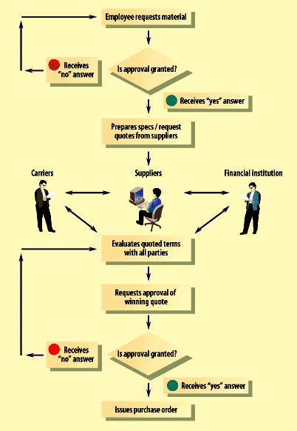
The above schema describes and defines in detail the potential requests to the procurement, delivery and invocation subsystem.

Description of Sub-Component: Procurement, Delivery Invocation (node-3/subsystem-9)

This subsystem provides access to products and services and transforms requests into real orders or logistic processes. Contractual matters and partnerships among the different stakeholders in the REGNET-System (Content Provider, Service Centres, Added Value Generator, Dealer, etc) are dealt with by this subsystem.
Methodology:
The methodology that it will be used is described in great detail by the task brief 1.4.3
Partner | PM | Contact (email) |  | Obligation
- IMAC | 1 | <name@organisation> |  | Baseline for this sub-chapter of Interim Report IR 1.4.1
- MOT | 3 | <name@organisation> |  | Contribution to IR 1.4.1
Total Effort | 4 | Comment

