

REGNET-IST-2000-26336
Task Brief
WP Number and Title |  |  |  | WP 1 | Analysis of the State of the Art and Development of Concepts
Task Number and Title |  |  |  | T 1.4 | Development of the System Specifications:
Sub-Task Number and Title |  |  |  | T 1.4.5.1 | Node-5: Electronic Publisher - Electronic Publishing
Task Leader and Contact |  |  |  | SR | <erich.gams@salzburgresearch.at>
Deliverable Number and Title |  |  |  | D 2 | Report: “The REGNET – System: Specification and State of the Art”
Interm. Report Number and Title |  |  |  | IR 1.4.1 | Node-5: Electronic Publisher - Electronic Publishing (2001-06-30)
Start Date: |  |  | 2001.05.02 |  | End Date: |  | 2001.09.30
Objectives:
The three main objectives of T 1.4.5 are:
- B2B functionality
- Reuse of modules
- Show benefits of database publishing
The ‘REGNET-Electronic Publisher node’ will demonstrate the B2B functionality, i.e. support for the production of CD-ROMs, WWW sites, etc. Furthermore it should reuse contents in different formats and demonstrate the usage of other REGNET modules like the search and query functionality, user profiling or the ontology subsystem.

Description of Work:
The ‘REGNET-Electronic Publisher node’ supports the creation of prototype publications of digital products such as CD-ROMS, WWW-sites, etc. This node consists of one component: Electronic Publishing (subsystem-8). Since this is the only component of the node, it will be described within this document without going into further detail at the task brief level.

Electronic Publishing (node-5/subsystem-8):
Using the search system of REGNET users are able to query for the artefacts they want to be collected for publishing. Preferences such as type of collection and/or artefact or personal interests are also considered. These results are collected and ranked.
By using the ontology subsystem query results could be improved or extended by taking into account other data such as sales data, current exhibitions, popular items, etc. This depends on the power of the ontology subsystem and can be of arbitrary complexity.
The ranked and filtered query results are then passed on - together with a storyboard, e.g. based on location/geography or time - to an XML/XSLT style sheet engine that converts them to
- XHTML
- SMIL
- PDF
The figure below describes the publishing process that will be used in REGNET. Core material stored in a fixed format in the REGNET database will be taken for a base publication. This will be done by query sent to the search system. Together with the ontology subsystem the selection can be more specific. Finally, adding a storyboard and choosing the output media automatically refines the publishing prototype. Now this prototype can be manually refined as often as needed, e.g.,by adding pictures, or by refining the design, to fit individual requirements.
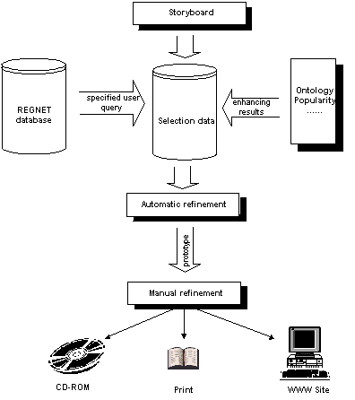

Methodology: Database publishing based on XML and XML/XSLT style sheet engines will be used.

Partner |  | PM | Contact (email) |  |  | Obligation
- SR |  | 5 | <erich.gams@salzburgresearch.at> |  |  | Baseline for this chapter of Interim Report IR 1.4.1  Task Management and Contribution to IR 1.4.1
- SI |  | 3 | <nikos.karatzoulis@systema.gr > |  |  | Contribution to IR 1.4.1
- UNIVIE |  |  | wolfgang.klas@univie.ac.at |  |  | Subcontracted for a state-of-the-art analysis of multimedia document formats.
Total Effort |  | 8 | Comment

Task outline and keywords to be discussed and observed in future development of this task

XML-Development
From TA1-AT, p. A-17: For XML development Apache Fundation sofware is an option (http://xml.apache.org/ ) that is:
- Xerces: an XML parsers in Java, C++ (with Perl and COM bindings)
- Xalan: an XSLT stylesheet processors, in Java and C++
- Cocoon: an XML-based web publishing, in Java and so on.

EU-Policies
From TA1-AT, p. A-19: This will be addressed by several 'building blocks' of the REGNET system: the (distributed) search system, the electronic publishing subsystem, and both connected to the e-business component.

Innovative aspects
From TA1-AT, p. A-29:To demonstrate the benefit of business to business (B2B) relationships the process of generating an electronic publication (e.g. CD-ROM) will be modelled and implemented.

D2 specification
From TA1-AT, p. A-31: The potential of the whole “infrastructure” will be evaluated based on the assumption that the REGNET-Publishing component can be considered as a kernel of a “media production centre”.

Comparison with OpenHeritage
From TA1-AT, p. A-61: REGNET has made concrete technical specifications what functions will be implemented (e.g. B2B workflows related to electronic publishing, integration of an ontology subsystem, query subsystem, etc).

SIE share
The coordinator sent out a paper on the consequences of SIE leaving the consortium. “System specifications will be elaborated using state of the art and well proofed methods.” This paper states that the SIE-contribution ( 8 PM) in Task 1.4 would have been:
- Contribution to the overall design of the component: 2 PM
- Analysis of printed products in the Cultural Heritage domain: 2 PM
- Contribution to the design of the sub-component supporting
The generation of printed products: 3 PM
- Contribution to the Deliverable D2 (report) 1 PM
This results in a less detailed analysis of the print production area in the Electronic Publishing component.

