

REGNET-IST-2000-26336
Work Sheet
Project acronym | REGNET |  | Contract nr. |  | IST-2000-26336
Type and Number | Library Online Services & ONB Web statistics
Work package | WP 1 Analysis of the State of the Art and Development of Concepts
Task | 1.7 Identification of Market (segments) and User Groups
Date of delivery | Contractual |  | Actual | 2001-09-20
Code name | RN_T17v01_ONB_services-statistics |  | Version 01 draft ☑ final
Distribution Type | Restricted (Content Providers)
Authors (Partner) | ONB
Contact Person | christian.recht@onb.ac.at
Abstract
Keywords List | Library online services, ONB web statistics
Version log

Library: online services

The best source and starting point for research on online services provided by European Libraries is the Gabriel server, http://www.ddb.de/gabriel/en/sources.html . It contains not only links to online services maintained by the European National Libraries, but also links to a choice of other services of international interest. It’s structure is an alphabetical list of country names, listing the relevant institutions and the links to their OPAC, WWW-Services etc. and the languages used for instruction.
Typical online services besides the OPAC, National bibliographies, Union Catalogues and Indexes to Periodicals are www-services differing very much in range and depth, such as

the www-services of the British Library ( http://www.bl.uk/ )
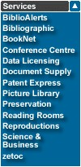
(The BookNet Service offers second hand books for sale within the United Kingdom and to anyone worldwide.
zetoc provides access to the British Library Electronic Table of Contents (ETOC) database, a vast research resource of 16 million journal articles and conference papers, to which 10,000 are added daily. It is a free service for the UK Higher and Further Education Communities.)

or the www-services of the Bibliothèque Nationale de France ( http://www.bnf.fr ).
For researchers and readers
ON-LINE
On-line catalogues
Reserve a place (research library)
Gallica : on-line digital material
Internet Resources
IN THE LIBRARY
Copying document
Reprographic services
Visits in the BnF

For publishers and librarians
Bibliographic products
The National bibliographic agency
The international library network : IFLA

The services of the Austrian National Library cover ( http://www.onb.ac.at/services/index.htm )
● Online mail Ordering of Books for the study in the reading rooms
● Information services: research service (partly free of charge), help in using electronic media, training in online research methods, training in using online databases and harvesting internet resources; tutorials & manuals, web-adresses, ...
● Reproduction Services: Xero-Copy, Microfiche, Photographic and Digitized reproduction; Birthday’s Journal Edition
● Help in using the Library’s resources
● Guided tours in the Library
● Special Services for people working at the Library
and online access to it’s catalogues and databases.
(An english version of the Library’s website will be available soon)

Further Information is available via the above mentioned Gabriel server ( http://www.ddb.de/gabriel/en/sources.html ).

USER SURVEYS: (information supplied by Ingrid Cantwell, SUL)
As an example for library collaboration and a user survey of research library, http://www.library.dmu.ac.uk/Research/CORSALL is a useful link.
(It is a research project on three research libraries within the Leicester aerea.)

The British Library has a user report under the heading "Consultation exercise", http://www.bl.uk/information/strat-bs.pdf. The study is at the end of the report.
Reports on User Needs in the visual arts domain (digital resources) are to be found at http://vads.ahds.ac.uk/reports/index.html . However, they are three years old.

Economic models of the digital libraries were the subject of a vast study conducted by Leah Halliday and Charles Oppenheim of Loughborough University, available at http://www.ukoln.ac.uk/services/elib/papers/ukoln/emod-diglib/final-report . This study was concluded in April 1999.

Web-Statistics

ONB: www.onb.ac.at
Summary Period: Last 12 Months
Generated 01-Sep-2001 04:45 CEST

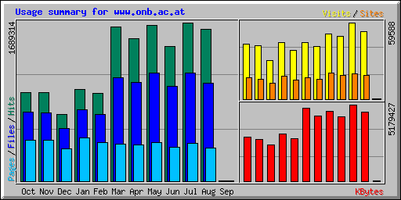

Summary by Month
Month | Daily Avg |  |  |  | Monthly Totals
Month | Hits | Files | Pages | Visits | Sites | KBytes | Visits | Pages | Files | Hits
Sep 2001 | 1070 | 812 | 400 | 214 | 144 | 3862 | 214 | 400 | 812 | 1070
Aug 2001 | 52202 | 33714 | 11375 | 1691 | 18841 | 4667427 | 52445 | 352630 | 1045138 | 1618271
Jul 2001 | 54494 | 37228 | 13134 | 1922 | 19960 | 5179427 | 59588 | 407164 | 1154081 | 1689314
Jun 2001 | 47830 | 33655 | 11943 | 1637 | 18714 | 4352626 | 49124 | 358298 | 1009655 | 1434914
May 2001 | 53626 | 37081 | 13395 | 1636 | 20077 | 4704478 | 50737 | 415257 | 1149513 | 1662415
Apr 2001 | 50714 | 35052 | 12939 | 1373 | 15506 | 4399044 | 41190 | 388184 | 1051579 | 1521436
Mar 2001 | 53140 | 35549 | 12760 | 1427 | 16515 | 4936718 | 44237 | 395580 | 1102042 | 1647361
Feb 2001 | 33342 | 25449 | 14758 | 1358 | 14828 | 2902801 | 38037 | 413228 | 712589 | 933589
Jan 2001 | 31519 | 24618 | 14877 | 1427 | 18038 | 3204259 | 44248 | 461190 | 763167 | 977119
Dec 2000 | 22892 | 18074 | 11217 | 974 | 12601 | 2438517 | 30196 | 347734 | 560323 | 709671
Nov 2000 | 31611 | 24294 | 14572 | 1383 | 15417 | 2838337 | 41509 | 437161 | 728838 | 948332
Oct 2000 | 30505 | 23881 | 14040 | 1381 | 16827 | 2975876 | 42830 | 435258 | 740341 | 945679
Totals |  |  |  |  |  | 42603372 | 494355 | 4412084 | 10018078 | 14089171
Top 10 of 82 Total Countries
# | Hits |  | Files |  | KBytes |  | Country
1 | 1214022 | 71.86% | 778811 | 67.48% | 3339526 | 64.48% | Austria
2 | 170052 | 10.07% | 122372 | 10.60% | 526699 | 10.17% | Unresolved/Unknown
3 | 83944 | 4.97% | 63408 | 5.49% | 327045 | 6.31% | Network
4 | 60634 | 3.59% | 52370 | 4.54% | 406423 | 7.85% | US Commercial
5 | 51625 | 3.06% | 44778 | 3.88% | 230227 | 4.45% | Germany
6 | 18908 | 1.12% | 18086 | 1.57% | 39568 | 0.76% | United Kingdom
7 | 17022 | 1.01% | 13929 | 1.21% | 61482 | 1.19% | Italy
8 | 9645 | 0.57% | 7824 | 0.68% | 39063 | 0.75% | Switzerland
9 | 6915 | 0.41% | 6117 | 0.53% | 28465 | 0.55% | US Educational
10 | 5805 | 0.34% | 4160 | 0.36% | 13071 | 0.25% | Czech Republic

2.2 Picture Archive: www.bildarchiv.at
The peak in july reflects the internet-launch of the picture database on july 12th 2001. Although declared a “test version”, the vivid interest in the “digital image archive” is quite plain. Of course the average use of the database later on is less abundant than in the first month. The statistic data for september is not available yet.

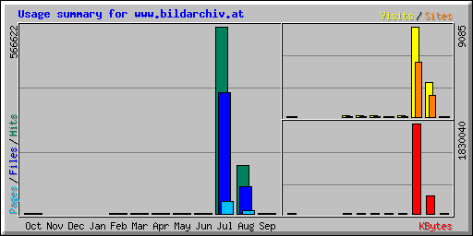

Summary Period: July 2001

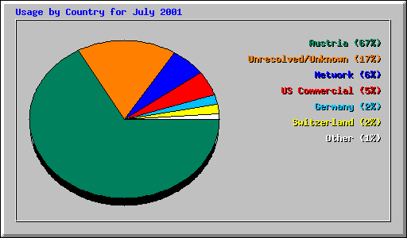

Top 10 of 42 Total Countries
# | Hits |  | Files |  | KBytes |  | Country
1 | 379185 | 66.92% | 245589 | 66.74% | 1219393 | 66.63% | Austria
2 | 97274 | 17.17% | 60010 | 16.31% | 294054 | 16.07% | Unresolved/Unknown
3 | 36100 | 6.37% | 23362 | 6.35% | 120164 | 6.57% | Network
4 | 26314 | 4.64% | 17570 | 4.77% | 95908 | 5.24% | US Commercial
5 | 10906 | 1.92% | 8068 | 2.19% | 38348 | 2.10% | Germany
6 | 8566 | 1.51% | 6769 | 1.84% | 32997 | 1.80% | Switzerland
7 | 1102 | 0.19% | 808 | 0.22% | 3519 | 0.19% | Netherlands
8 | 820 | 0.14% | 541 | 0.15% | 2392 | 0.13% | Non-Profit Organization
9 | 748 | 0.13% | 576 | 0.16% | 2471 | 0.14% | Hungary
10 | 668 | 0.12% | 420 | 0.11% | 1425 | 0.08% | Italy

Summary by Month
Month | Daily Avg |  |  |  | Monthly Totals
Month | Hits | Files | Pages | Visits | Sites | KBytes | Visits | Pages | Files | Hits
Sep 2001 | 56 | 46 | 4 | 7 | 7 | 184 | 7 | 4 | 46 | 56
Aug 2001 | 4724 | 2644 | 295 | 112 | 2167 | 368212 | 3479 | 9171 | 81972 | 146471
Jul 2001 | 18278 | 11870 | 1212 | 293 | 5557 | 1830040 | 9085 | 37596 | 367991 | 566622
Jun 2001 | 5 | 3 | 5 | 4 | 69 | 49 | 134 | 166 | 99 | 177
May 2001 | 3 | 2 | 2 | 2 | 58 | 39 | 89 | 91 | 79 | 95
Apr 2001 | 4 | 4 | 4 | 4 | 55 | 64 | 140 | 145 | 132 | 148
Mar 2001 | 5 | 4 | 5 | 4 | 55 | 73 | 150 | 158 | 147 | 168
Feb 2001 | 5 | 3 | 4 | 3 | 37 | 60 | 101 | 128 | 108 | 141
Oct 2000 | 234 | 87 | 166 | 6 | 2 | 159 | 6 | 166 | 87 | 234
Totals |  |  |  |  |  | 2198880 | 13191 | 47625 | 450661 | 714112

Top 10 of 96 Total Entry Pages
# | Hits |  | Visits |  | URL
1 | 12414 | 2.19% | 7534 | 86.15% | /
2 | 3658 | 0.65% | 354 | 4.05% | /archiv/index3.html
3 | 2253 | 0.40% | 149 | 1.70% | /praesentationen/index4.html
4 | 1845 | 0.33% | 140 | 1.60% | /anfragen/index1.html
5 | 2038 | 0.36% | 109 | 1.25% | /praesentationen/themen/themen.html
6 | 843 | 0.15% | 81 | 0.93% | /informationen/preisfoto.html
7 | 896 | 0.16% | 54 | 0.62% | /archiv/projekt/digital.html
8 | 407 | 0.07% | 46 | 0.53% | /praesentationen/ausstellungen/elisabeth/elisabeth-katalog.html
9 | 504 | 0.09% | 22 | 0.25% | /praesentationen/ausstellungen/elisabeth/elisabeth.html
10 | 89 | 0.02% | 21 | 0.24% | /archiv/projekt/digital-abort.html

