

REGNET-IST-2000-26336
CVS-Server for REGNET development
Project acronym | REGNET |  |  | Contract nr. |  | IST-2000-26336
Type and number | CVS Server
Work package | WP2: Implementation of the System
Task
Covered period | From | - | To |  | -
Code name | input.doc |  | Version 01 draft ☑ final 
Contact Person | Martin Bogensperger bogenspergerm@ait.co.at
Objective | Set up a CVS system for REGNET development.
Distribution Type | Technical Group
Keywords List
Version log | Version 01: 2001-11-14 by AIT

Table of Contents

1 Machine 2
2 CVS System 2
3 Useful Web-Links: 4

Machine
IP-Address: 193.80.249.123 (This computer doesn’t have a DNS-entry)

CVS System
Root directory of the repository: /home/cvsroot
Project-Name: regnet

Login to the server:
- Password-Authentification is done on the server. The Login name is “rn_<company_acronym>” in lowercase, e.g. rn_ait or rn_sr.
- The following names/passwords are available for partner –logins:
Partner | User | Password
AIT | rn_ait | mPwz0k
ONB | rn_onb | ef4dq9
SR | rn_sr | OxC5m5
IMAC | rn_imac | 0pG7KX
SUL | rn_sul | iVwHK1
TARX | rn_tarx | adGPee
MECH | rn_mech | mnSVk2
MUS | rn_mus | qrUrQs
MOT | rn_mot | mz2flD
SPAC | rn_spac | ghyfCO
ALI | rn_ali | sJo74P
CC | rn_cc | cru7is
IAT | rn_iat | gxcN2A
ICCS | rn_iccs | 8vAfyC
ZEUS | rn_zeus | g1crwh
SI | rn_si | w5cvYO
CERT | rn_cert | ejeh4t
VALT | rn_valt | EFQ3wY

- Wincvs (http://www.wincvs.org/) can be used as client-Application for Windows.
Settings for Wincvs:
  - Preferences for login-configuration (Admin->Preferences).
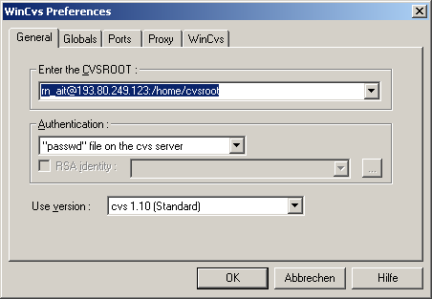
Note: “rn_ait” has to be changed to the right name according the above table.

  - Checking out for the first time (Create->Checkout Modules…)
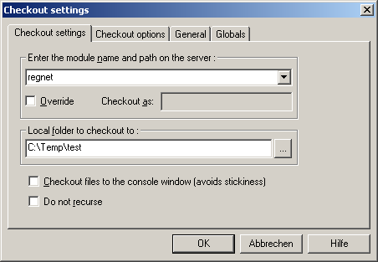
if you want to checkout a specific revision you must specify this in the next tap. Till now there are two tags available. If you don’t specify a tag, the most recent files are checked-out.

- Committing changes: You should add/update files without a tag. If the project reaches a stable version (after each iteration), we will add a new tag name.

Useful Web-Links:
CVS-Sever Download: http://www.cvshome.org/
Documentation of all cvs commands: http://cvsbook.red-bean.com/cvsbook.html
Wincvs-Client: http://www.wincvs.org/
Wincvs-Gui documentation: http://www.wincvs.org/doc.html

