4. Target Market
4.1. Market Potential: Art domain
The goal of this market research is to gather information, helping the analysis of the art market and to make possible to forecast the market trends. In general the art market information is diversified between the category “time” (art domain is established in parallel with the human existence) and the category “space” (art is present to all over the world). These prerequisites define the difficulties, which one can meet in assessing the market trends in the Art domain. Several well-established Art references and encyclopedias may help in highlighting the market state of the Art objects. These sources are:
- Sound View Press (USA);
- Van Wilder publishing (France);
- the Caplan Monograms and Signature;
- the dictionary of 18-thand 19-th century auction records;
- the Rare books auction records;
- the Bayer data bank of English auction records (1700-1913);
- Art Price Annual – a price guide, created in 1987 and now sold in 84 countries;
- Data acquisition of the American Falk’s Art Price index, created in 1998.
Following these editions and dealing with this information art market analyzers estimate the trends and the dynamics of the market and evaluate the commercial characteristics of the trade with art objects. This interim report doesn’t claim wide experience in the art market domain but here an estimation of this market is presented. This estimation is aiming to assess the importance and respectively the potential of the system Regnet, when it will be active on the market. Particularly Regnet system will offer IT services addressing the art market and the tasks related to CH objects.
The analysis below is performed, based on available data from the world leader in art market information Art price (http://art-market.net.searchartprice.com).

4.1.1. Categories used for assessment of the art market state
The auction results for art objects for the last 10 years are analyzed. The index of the price of art objects for 1992 is set to 100%. The deviation of the index is given in the chart index (t), t = 1992 – 2001 year. Five art categories are presented: painting drawing, print-multiple, sculpture, photography. Each category is estimated in relation with the object size: very small formats, small, medium, large, very large, monumental. The dynamic of the business transaction per quarter/per year is given in reference to the index value. The market dynamics is presented per every art category. An integral assessment of the market, performed as average evolution for all art categories for the period of 10 years is presented in table 1.
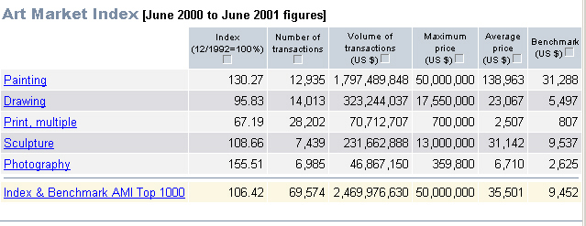
Table 1. Art Market index, total, 1992-2001

It is evident from Table1 that for the time period of 10 years the relevant importance of photography increases to 155,51, for painting - 130,27 and sculpture 108,66. Respectively the market importance of drawing is approximately kept on the same level (95,83) but the print art object index is considerably decreased (67,19). As an integral result, the art market index is 106.42 over the basis of 100 assumed for 1992 year. The tabl.1 gives information about the volume of transactions, maximum and overage price, number of transactions (sells) for the 10 years period 1992-2001. The dynamics of the index, evaluated of the most 1000 successful market transactions per year are given in Fig. 1.
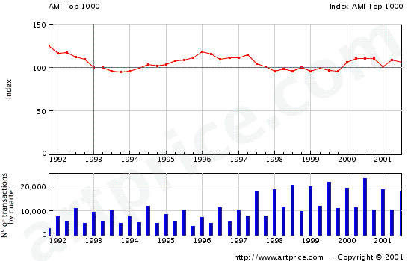

Fig.1 Index value for the top 1000 transactions, 1992-2001

This figure proves the fact that the relative importance and the worth of the art objects are kept relatively constant through the years. Hence the investments in art objects preserve their value nevertheless the inflation rate. The behavior of the market state differs per art category. Here is few estimates of the art market.

Painting
The average values of the painting index, related to the size formats are given on Table 2.

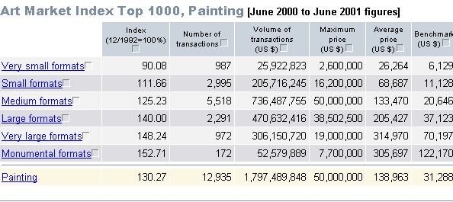
Table 2. Painting. Art market index

Five formats of the paintings are considered:
Very small format: dimensions below 500 cm² (20x25cm)
Small formats: between 500 cm² - 1600 cm² (40x40cm)
Medium formats: between 1600 cm² - 5000 cm²(60x80cm)
Large formats: between 5000 cm² - 12000 cm²(100x120cm)
Very large formats: between 12000 cm² - 40000 cm²(200x200cm)
Monumental: above 40000 cm² (e. g. above 200x300cm )
Table 2 shows the relative dynamics. The market importance of all painting formats increase. The only exception is the case of very small format, which record a decrease of 10% (90,80) in comparison with the level of 1992. In general the art objects, related to painting support an increasing trend of the market sells. The dynamic of the index for painting is presented in Figure 2
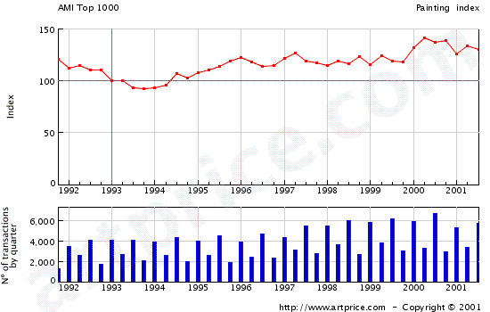
Figure 2. Painting index, top 1000, 1992 – 2001

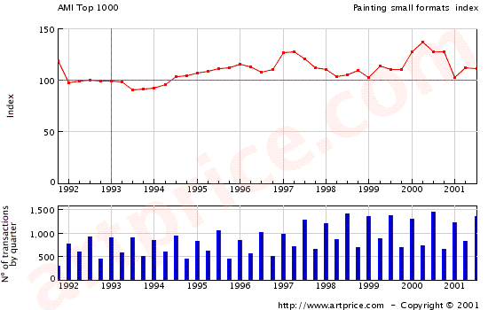
Figure 3 Painting: index dynamics, very small formats.

It’s easy to estimate sequential trend in increasing the market index. The relative importance of the paintings in different dimension are presented in Figures 3-8.

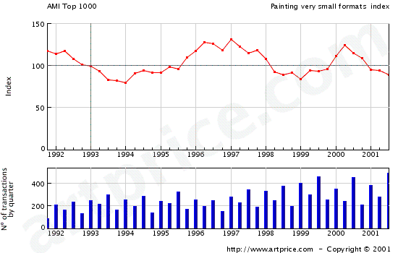

Figure 4 Painting: index dynamics, small format

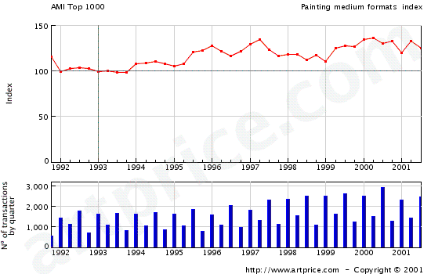
Figure 5 Painting : index dynamics, medium format

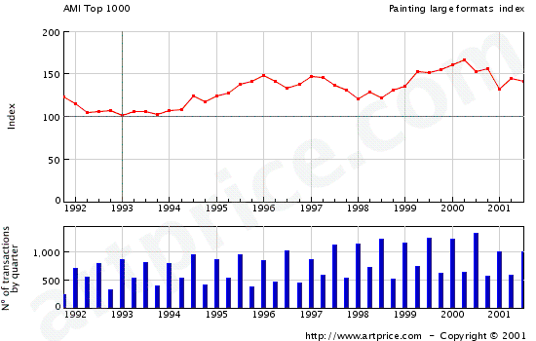
Figure 6. Painting: index dynamics, large formats

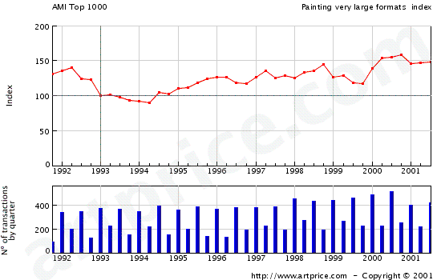

Figure 7 Painting: index dynamics, very large formats

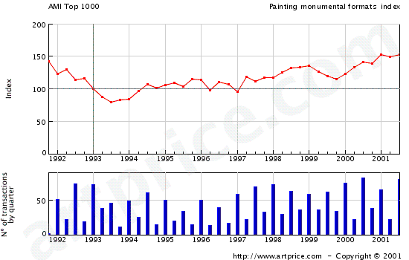

Figure 8 Painting: index dynamics, monumental formats

This comparison defines a non expected conclusion, that the most market sells are generated by the drawings with monumental formats. But the sells are most intensive per year for medium and small painting objects, which proves the importance of these art objects for the “art market”

Drawing

The importance of the art objects for the market are presented integrally in Table 3

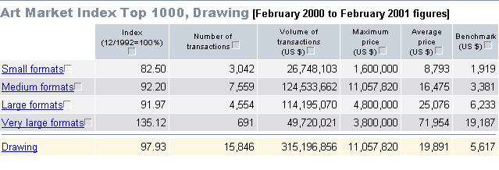
Table 3 Drawing: art market index

Four formats of the drawings are under consideration.
- small formats;
- medium formats;
- large formats;
- very large formats;
The results on table 3 show that only the importance of the very large formats of drawing is market increased (value of the index is 135,12). All others three categories record a decreasing market interest. Respectively the small formats of drawing are not well presented goods for trade. The dynamics of the index of drawings for different drawing forms are given on Fig.9 – 12.

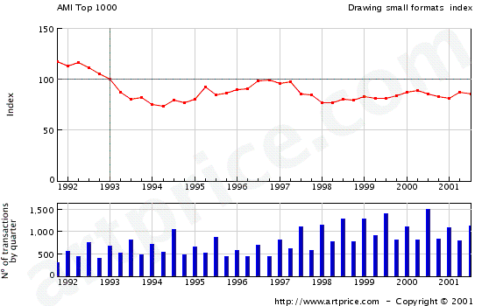
Fig.9. Drawing: index dynamics, small formats

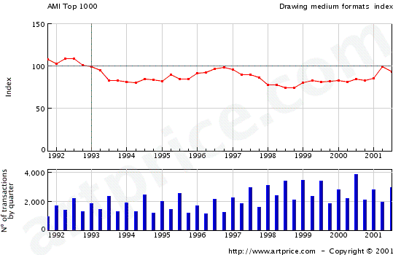

Fig.10. Drawing: index dynamics, medium formats

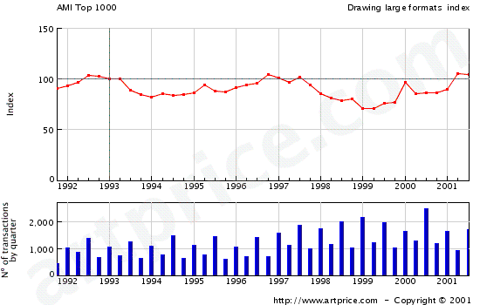
Fig.11. Drawing: index dynamics, large formats

Fig.12. Drawing: index dynamics, very large formats

The figures prove the relatively negative trend of the market importance for drawings.

Print, multiple

The printed objects, related to the art market meet considerable decrease in the market importance for the last 10 years, table 4.
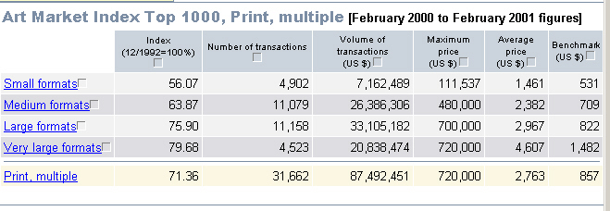
Table 4. Print, multiple: art market index

Four formats of the prints are under consideration:
- small formats;
- medium formats;
- large formats;
- very large formats;
The leader in the negative market importance is the art object with small formats. The decrease of the market index is till 56,07. All other print formats also keep this negative market tendency. Respectively the dynamics of the print indexes for 10 years, related for the corresponding format are presented on fig.13 – 16.

Fig.13. Prints: index dynamics, small formats
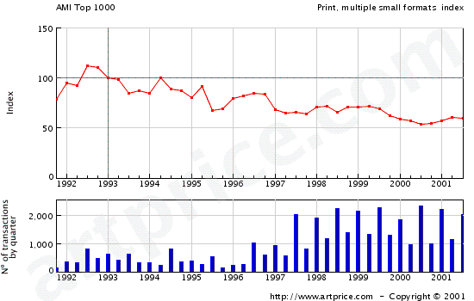

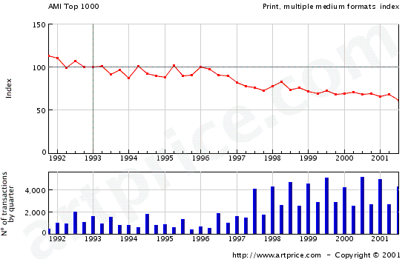
Fig.14. Prints: index dynamics, medium formats

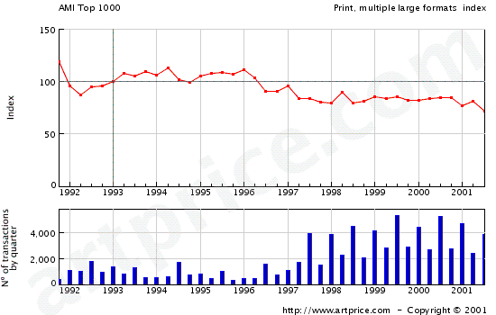

Fig. 15. Prints: index dynamics, large formats

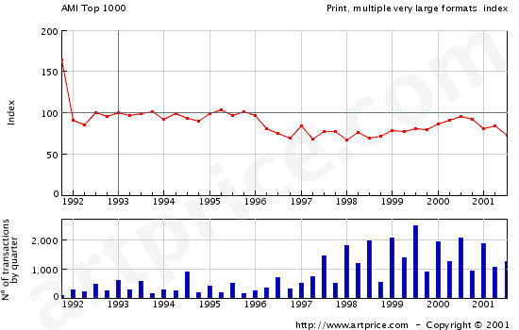
Fig. 16. Prints: index dynamics, very large formats

These figures prove that the prints as art objects are not perspective for the art market.

Sculpture
The art objects, related to the sculpture sub domain keep a relatively constant place in the market. Table 5.
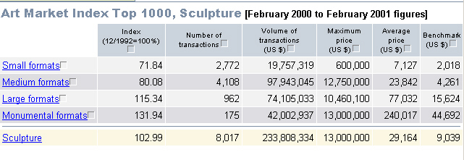
Table 5. Sculpture: art market index.

It is important to notice that the relative market importance of sculpture whit small formats decrease, but the importance of the large sculpture formats records an increasing trend. Four formats of sculptures are under consideration:
- small formats, high and weight below 30cm;
- medium formats, between 30-80cm;
- large formats, between 80-200cm;
- monumental formats, above 200cm;
According to this selective difference in the market indexes of sculpture per formats, the average weight of the sculpture art objects is kept on constant level. The dynamics of the indexes for the sculpture art objectives per formats is given on fig 17-20.

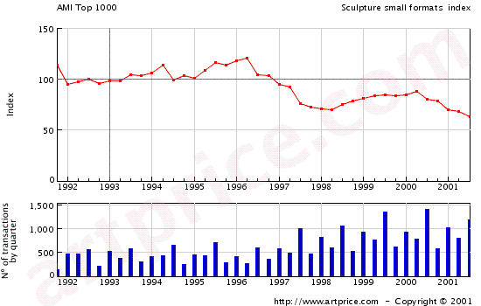
Fig.17. Sculpture: index dynamics, small format

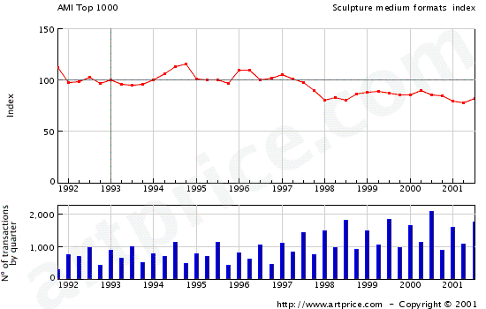

Fig. 18. Sculpture: index dynamics, medium format

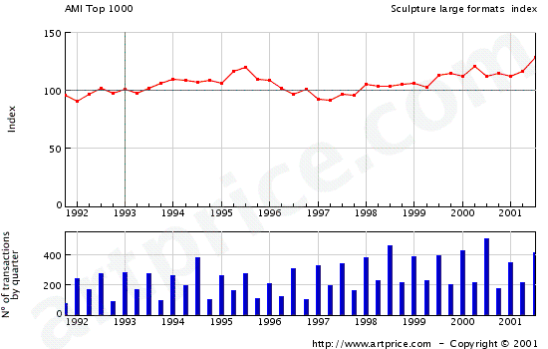
Fig.19. Sculpture: index dynamics, large format

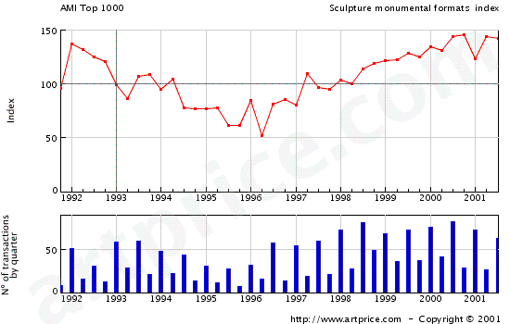
Fig.20. Sculpture: index dynamics, monumental format

The dynamics of the market indexes of the sculptures as art objects show the decrease for the small and medium formats, but describe the increased importance of the largest sculpture objects.

Photography

The art objects, related to photography, has been assessed in table 6.

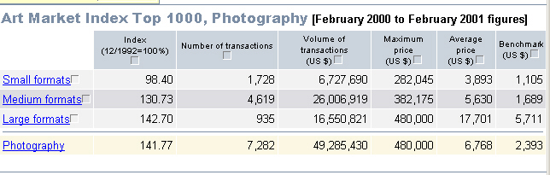

Table 6. Photography: art market index.

This category of art objects records and increased attention on the market. The average market index for 10 years period is 141,77. Thus the photography as art samples are perspective area of investment. Respectively the market trend guarantee the importance of the photography as market object.
Three formats of photography are under consideration:
- small formats;
- medium formats;
- large formats;
The individual dynamics per photography format are given on fig. 21-23.

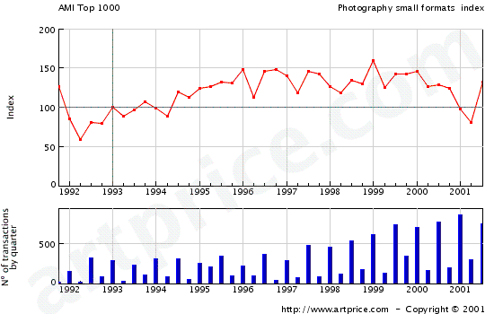
Fig. 21.Photography: index dynamics, small format

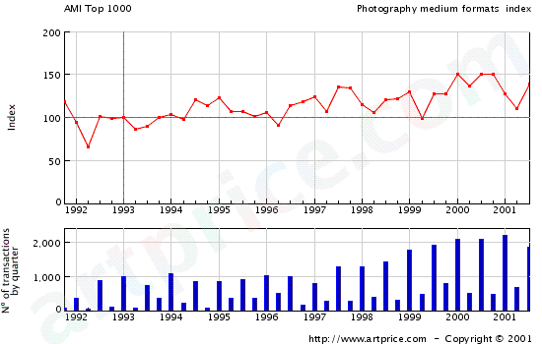
Fig.22. Photography: index dynamics, medium format

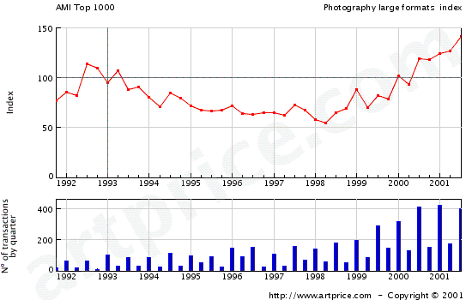

Fig.23. Photography: index dynamics, large format

It is curious to mention that the large format photography’s, are leaders in the market index, but during the period on question they have relatively low market index. The increase arises for the last 2-3 years.
For the case of medium formats photography, the market index keeps relatively constant positives trend and preserve the importance of the photography objects as market goods.

As additional information, related to the art objects and their market value, table 7 and 8 give the top 10 sellers for the art categories painting and drawing. It is easy to estimate that the auction painters and drawing supports the highest market price.

Rank | Artist | Volumeof transactions  (US $) | Maximum price  (US $) | Number of transactions  2000
1 | PICASSO Pablo (1881-1973) | 139,189,706 | 50,000,000 | 34
2 | MONET Claude (1840-1926) | 118,586,390 | 22,000,000 | 25
3 | RENOIR Auguste (1841-1919) | 46,735,065 | 8,000,000 | 79
4 | MODIGLIANI Amedeo (1884-1920) | 37,300,000 | 14,200,000 | 8
5 | CÉZANNE Paul (1839-1906) | 37,094,010 | 16,437,300 | 8
6 | MATISSE Henri (1869-1954) | 31,273,198 | 15,500,000 | 8
7 | WARHOL Andy (1928-1987) | 29,799,138 | 4,200,000 | 82
8 | ROTHKO Mark (1903-1970) | 27,000,000 | 13,000,000 | 4
9 | REMBRANDT (R. van Rijn) (1606-1669) | 26,064,000 | 26,064,000 | 1
10 | CANALETTO Antonio Canal (1697-1768) | 21,686,850 | 10,136,000 | 6
Total : |  | 514,728,357 | 50,000,000 | 255
Rank | Artist | Volume of transactions  (US $) | Maximum price  (US $) | Number of transactions  2000

Table 7. Painting top 10 sellers.

Rank | Artist | Volumeof transactions  (US $) | Maximum price  (US $) | Number of transactions  2000
1 | DEGAS Edgar (1834-1917) | 18,872,570 | 4,800,000 | 40
2 | MICHELANGELO (M.-A. Buonarroti) (1475-1564) | 11,057,820 | 11,057,820 | 1
3 | PICASSO Pablo (1881-1973) | 8,164,772 | 470,000 | 119
4 | MATISSE Henri (1869-1954) | 7,170,054 | 2,450,000 | 46
5 | ZHANG DAQIAN Chang Dai-chien (1899-1983) | 6,376,951 | 706,200 | 96
6 | REMBRANDT (R. van Rijn) (1606-1669) | 5,950,000 | 3,400,000 | 3
7 | WYETH Andrew (1917) | 5,521,350 | 670,000 | 33
8 | ROSSETTI Dante Gabriel (1828-1882) | 4,195,911 | 3,586,320 | 8
9 | KLEE Paul (1879-1940) | 4,039,734 | 600,000 | 33
10 | HOMER Winslow (1836-1910) | 3,940,000 | 1,400,000 | 8
Total : |  | 75,289,162 | 11,057,820 | 387
Rank | Artist | Volume of transactions  (US $) | Maximum price  (US $) | Number of transactions  2000

Table 8. Drawing top 10 sellers.

These tables prove that the art market deals with considerable financial resources. It has a big potential for successful services, related of the application of new IT seditions, which concerns the general task worked out by REGNET project.

4.1.2. Assessment of the art market for Bulgaria.

Different participants contributes to the art market in Bulgaria : individuals; state and private entities; associations, foundations and non profit organizations. During our work, we have not found an organization, which performs continuous research and acquisition of market related information for goods related to the art domain. That is why we tried to estimate the power and the role of the art market in relation with museums and their incomes.
Particularly the state authorities support a chain of national and regional museums. The art galleries have been recorded as a category of specialized museums. The museums have been classified as:
- historical museums;
- specialized museums, including art galleries;
Thus our research targeted the activities and the services offered by museums. When was available explicit data about the art galleries and the art market are presented.
The common attributes, applied for the museum category have been chosen as:
- number for museums/galleries for the region;
- number of visit recorded for 1999.(that was the last available information);
- number of art object, exhibited in the museums/galleries;
- the total income of the museums and art galleries;
- the subsidy of the state and it relative amount to the total income of museums;
- the income, resulted from visits and it relative amount to the total income of museums;
- the income, resulted from sponsorship and it relative amount to the total income of museums;
The total number of museums, supported by the state is 230. The art gallery explicitly supported by the state is 44 or 19% of the entire domain “museums”. The relation between the type of museums, total income and it origin is presented on Table 9.

 | Total | Visits | Objects | Total Incom | State subsidy | % | from Visits | % | Sponsorship | %
MUZEUMS | 230 | 5052854 | 5462556 | 11713439 | 9702432 | 83% | 956726 | 8% | 331851 | 3%
HISTORICAL | 80 | 2209940 | 3864608 | 6599972 | 5625717 | 85% | 483547 | 7% | 213230 | 3%
SPECIALISED | 150 | 2842914 | 1597948 | 5113467 | 4076715 | 80% | 473179 | 9% | 118621 | 2%
incl. ART GALERIES | 44 | 1503382 | 169919 | 1682207 | 1509283 | 90% | 84074 | 5% | 50849 | 3%

Table 9. Museums in Bulgaria for 1999.

Following the information from table 9, it is clear that the general part of the museums and art galleries are supported by the state. An average of 83% of the museums income is recorded. Only few resource come from visits (an average 8% is estimated) an small part of income 3%, origins from sponsorship.
Hence the museums, respectively gallery activities are strongly influenced by the state financial support. Following fig. 24-27, the particular distribution of the museums domain, concerning historical and specialized museums as art galleries are presented on the pie charts.

Figure 24. Museum incomes

Figure 25. Historical museums income

Figure 26. Specialized museum income

Figure 27. Art galleries income

To improve the relationship and the share of the income from different sources, the art galleries have to develop and to deploy new services and user applications. This will result in benefits in two directions:
- increase in the total amount of the museums/art galleries income;
- increase of the relative amount of resource which are not related to the state financial support;
Because the REGNET system targets the development and deployment of new services in the area of culture heritage and estimating the lack of income from new IT services in this domain for Bulgaria, the conclusion follows that it exists real prerequisites for successful REGNET deployment. The general market task will be to disseminate the REGNET potential, to train the museum personal in using new IT services, marketing and advertising REGNET services and products to potential user. The survey, made for 26 countryside regions in Bulgaria gives additional knowledge about the financial behavior of the art galleries. The resulting data are given on Table 10.
 | Total | Total Incom | State subsidy | % | from Visits | % | Sponsorship | %
Burgas | 11 | 379781 | 286280 | 75% | 66315 | 17% | 4616 | 1%
historical | 5 | 287724 | 200950 | 70% | 65867 | 23% | 4616 | 2%
specialised | 6 | 92057 | 85330 | 93% | 448 | 0% |  | 0%
incl. Art Galeries | 2 | 50742 | 50194 | 99% | 448 | 1% |  | 0%
Varna | 8 | 757475 | 694117 | 92% | 54613 | 7% | 6032 | 1%
historical | 3 | 544396 | 495822 | 91% | 42542 | 8% | 6032 | 1%
specialised | 5 | 213079 | 198295 | 93% | 12071 | 6% |  | 0%
incl. Art Galeries | 2 | 94535 | 93415 | 99% |  | 0% |  | 0%
Veliko Tarnovo | 14 | 508710 | 388545 | 76% | 77891 | 15% | 13091 | 3%
historical | 5 | 445646 | 331924 | 74% | 75717 | 17% | 9340 | 2%
specialised | 9 | 63064 | 56621 | 90% | 2174 | 3% | 3751 | 6%
incl. Art Galeries | 3 | 39921 | 37853 | 95% | 1498 | 4% | 52 | 0%
Vidin | 4 | 104257 | 101008 | 97% | 2579 | 2% |  | 0%
historical | 2 | 88924 | 85675 | 96% | 2579 | 3% |  | 0%
specialised | 2 | 15333 | 15333 | 100% |  | 0% |  | 0%
incl. Art Galeries | 2 | 15333 | 15333 | 100% |  | 0% |  | 0%
Vratza | 4 | 188844 | 179404 | 95% | 5339 | 3% | 4101 | 2%
historical | 2 | 131295 | 129054 | 98% | 2140 | 2% | 101 | 0%
specialised | 2 | 57549 | 50350 | 87% | 3199 | 6% | 4000 | 7%
incl. Art Galeries | 1 | 2549 | 2549 | 100% |  | 0% |  | 0%
Gabrovo | 8 | 750081 | 341582 | 46% | 118650 | 16% | 3236 | 0%
historical | 4 | 174132 | 81185 | 47% | 2274 | 1% | 3006 | 2%
specialised | 4 | 575949 | 260397 | 45% | 116376 | 20% | 230 | 0%
incl. Art Galeries | 1 | 13000 | 12000 | 92% |  | 0% |  | 0%
Dobrich | 7 | 250236 | 193820 | 77% | 49440 | 20% | 4827 | 2%
historical | 4 | 190236 | 138177 | 73% | 48401 | 25% | 2009 | 1%
specialised | 3 | 60000 | 55643 | 93% | 1039 | 2% | 2818 | 5%
incl. Art Galeries | 2 | 52056 | 48165 | 93% | 773 | 1% | 2818 | 5%
Kardjali | 2 | 76188 | 75859 | 100% | 237 | 0% |  | 0%
historical | 1 | 14836 | 61023 | 411% | 237 | 2% |  | 0%
specialised | 1 | 61352 | 14836 | 24% |  | 0% |  | 0%
incl. Art Galeries | 1 | 76188 | 14836 | 19% |  | 0% |  | 0%
Kustendil | 5 | 453709 | 352028 | 78% | 98454 | 22% | 3055 | 1%
historical | 3 | 411389 | 309708 | 75% | 98454 | 24% | 3055 | 1%
specialised | 2 | 42320 | 42320 | 100% |  | 0% |  | 0%
incl. Art Galeries | 2 | 42320 | 42320 | 100% |  | 0% |  | 0%
Lovech | 5 | 150464 | 142636 | 95% | 6245 | 4% |  | 0%
historical | 2 | 82881 | 80050 | 97% | 1250 | 2% |  | 0%
specialised | 3 | 67583 | 62586 | 93% | 4995 | 7% |  | 0%
incl. Art Galeries | 1 | 9898 | 9896 | 100% |  | 0% |  | 0%
Montana | 8 | 113176 | 111934 | 99% | 340 | 0% | 400 | 0%
historical | 3 | 80438 | 79241 | 99% | 295 | 0% | 400 | 0%
specialised | 5 | 32738 | 32693 | 100% | 45 | 0% |  | 0%
incl. Art Galeries | 2 | 16073 | 16073 | 100% |  | 0% |  | 0%
Pazardjik | 10 | 305045 | 267199 | 88% | 20246 | 7% | 17600 | 6%
historical | 5 | 225767 | 205156 | 91% | 20011 | 9% | 600 | 0%
specialised | 5 | 79278 | 62043 | 78% | 235 | 0% | 17000 | 21%
incl. Art Galeries | 1 | 28190 | 28190 | 100% |  | 0% |  | 0%
Pernik | 2 | 79798 | 79798 | 100% |  | 0% |  | 0%
historical | 1 | 74649 | 74649 | 100% |  | 0% |  | 0%
specialised | 1 | 5149 | 5149 | 100% |  | 0% |  | 0%
incl. Art Galeries | 1 | 5149 | 5149 | 100% |  | 0% |  | 0%
Pleven | 13 | 561043 | 516868 | 92% | 27157 | 5% | 16706 | 3%
historical | 1 | 179906 | 175801 | 98% | 1293 | 1% | 2500 | 1%
specialised | 12 | 381137 | 341067 | 89% | 25864 | 7% | 14206 | 4%
incl. Art Galeries | 2 | 45067 | 40942 | 91% |  | 0% | 4125 | 9%
Plovdiv | 14 | 544731 | 459947 | 84% | 55372 | 10% | 26336 | 5%
historical | 5 | 145813 | 123991 | 85% | 3674 | 3% | 18114 | 12%
specialised | 9 | 398918 | 335956 | 84% | 51698 | 13% | 8222 | 2%
incl. Art Galeries | 1 | 60898 | 58522 | 96% | 1366 | 2% | 792 | 1%
Razgrad | 3 | 181344 | 160431 | 88% | 1811 | 1% | 12246 | 7%
historical | 2 | 160799 | 140059 | 87% | 1638 | 1% | 12246 | 8%
specialised | 1 | 20545 | 20379 | 99% | 173 | 1% |  | 0%
incl. Art Galeries | 1 | 20545 | 20379 | 99% | 173 | 1% |  | 0%
Russe | 4 | 234151 | 228194 | 97% | 5497 | 2% |  | 0%
historical | 1 | 167142 | 162620 | 97% | 4062 | 2% |  | 0%
specialised | 3 | 67009 | 65574 | 98% | 1435 | 2% |  | 0%
incl. Art Galeries | 1 | 32000 | 31060 | 97% | 940 | 3% |  | 0%
Silistra | 4 | 148850 | 140731 | 95% | 8119 | 5% |  | 0%
historical | 2 | 87172 | 86009 | 99% | 1163 | 1% |  | 0%
specialised | 2 | 61678 | 54722 | 89% | 6956 | 11% |  | 0%
incl. Art Galeries | 1 | 40785 | 40485 | 99% | 300 | 1% |  | 0%
Sliven | 12 | 294415 | 257780 | 88% | 33452 | 11% | 3183 | 1%
historical | 3 | 122666 | 118549 | 97% | 2714 | 2% | 1403 | 1%
specialised | 9 | 171749 | 139231 | 81% | 30738 | 18% | 1780 | 1%
incl. Art Galeries | 2 | 74901 | 69970 | 93% | 3931 | 5% | 1000 | 1%
Smolian | 4 | 122020 | 116238 | 95% | 1591 | 1% |  | 0%
historical | 2 | 72341 | 69996 | 97% | 494 | 1% |  | 0%
specialised | 2 | 49679 | 46242 | 93% | 1097 | 2% |  | 0%
incl. Art Galeries | 1 | 28900 | 28900 | 100% |  | 0% |  | 0%
Sofia | 30 | 3785074 | 3169201 | 84% | 190875 | 5% | 188631 | 5%
historical | 3 | 1976119 | 1667412 | 84% | 48421 | 2% | 134740 | 7%
specialised | 27 | 1808955 | 1501789 | 83% | 142454 | 8% | 53891 | 3%
incl. Art Galeries | 5 | 802188 | 653367 | 81% | 73145 | 9% | 41762 | 5%
Stara Zagora | 14 | 639625 | 505976 | 79% | 23388 | 4% | 1000 | 0%
historical | 3 | 192132 | 169540 | 88% | 21306 | 11% | 1000 | 1%
specialised | 11 | 447493 | 336436 | 75% | 2082 | 0% |  | 0%
incl. Art Galeries | 3 | 87615 | 85286 | 97% | 1500 | 2% |  | 0%
Targovishte | 4 | 96821 | 94172 | 97% | 99 | 0% | 2150 | 2%
historical | 3 | 69742 | 67093 | 96% | 99 | 0% | 2150 | 3%
specialised | 1 | 27079 | 27079 | 100% |  | 0% |  | 0%
incl. Art Galeries | 1 | 27079 | 27079 | 100% |  | 0% |  | 0%
Haskovo | 6 | 105208 | 104908 | 100% |  | 0% | 300 | 0%
historical | 2 | 73730 | 73730 | 100% |  | 0% |  | 0%
specialised | 4 | 31478 | 31178 | 99% |  | 0% | 300 | 1%
incl. Art Galeries | 2 | 17026 | 16726 | 98% |  | 0% | 300 | 2%
Shumen | 9 | 378411 | 282502 | 75% | 82355 | 22% | 2798 | 1%
historical | 1 | 167819 | 139040 | 83% | 28779 | 17% |  | 0%
specialised | 8 | 210592 | 143462 | 68% | 53576 | 25% | 2798 | 1%
incl. Art Galeries | 2 | 24852 | 24852 | 100% |  | 0% |  | 0%
Iambol | 3 | 99321 | 98791 | 99% | 500 | 1% | 30 | 0%
historical | 1 | 50989 | 50489 | 99% | 500 | 1% |  | 0%
specialised | 2 | 48332 | 48302 | 100% |  | 0% | 30 | 0%
incl. Art Galeries | 1 | 35749 | 35749 | 100% |  | 0% |  | 0%

Table 10. Countryside museums in Bulgaria,1999.

As estimated, all 26 countryside regions in Bulgaria have at least one art gallery. The general part of the gallery incomes originates from the state financial subsidy. The relative amount of this support is in the range of 75% till 100%. It exists an exception, which concerns the region of Gabrovo. The relative amount of the state subsidy is 46% from the total museum incomes. It means that this region successfully develops different channels of activities, which result in additional income. Particularly for this region a lot of hand made art goods are produced and offered for sale in folk regions and museums. As a result the museums are well supported and have a real market presence trading hand mode folk art objects: textile, woodcarving, metals.
Several pie charts are given for the regions of Burgas, Veliko Tarnovo, Gabrovo, Dobrich, Kustendil, Pazardjik, Plovdiv, Razgrad, Sliven, Sofia, Stara Zagora, Shumen. For these regions the state financial support for museums and galleries is less than 90% of the total museums income. But the relative amount of the resources which origin from museum visits differs in the range of 5 till 22%.

Hence for the countryside case it is also valid that new services and products, originated from REGNET will improve the financial behavior of the museum, related to it independence from the state subsidy.

Conclusions

The museums and art galleries in general do not offer additional services, related to the art market and art services in Bulgaria. The general source of support is the state subsidy, which is about 90% of the total museum income. The relative amount of the income, originated from visitors and visits varies in the range of 5% till 22%.
The development of new IT services, related to the art market will give benefits to the art galleries and museums. This is a real prerequisite for successful implementation of the REGNET services.
The channels, which must be used for the launch of REGNET as market product should be:
- dissemination of the REGNET market products, services and international links;
- extending the means of trade with IT tools for museums and art galleries according to the REGNET potential. Samples and scenarios as market available cases should be developed and promoted;
- to address a wide range of audience, who is prospective and traditional partner for art services and art goods.
These activities will gather critical mass of customers, insisted for the market presence of REGNET.

