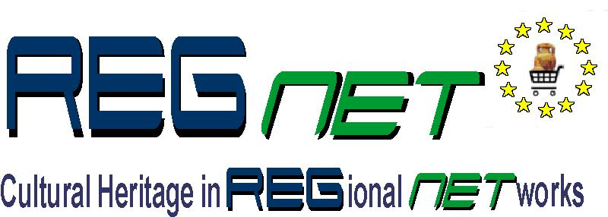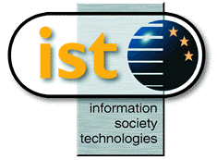

REGNET-IST-2000-26336
Work Sheet
Project acronym | REGNET |  | Contract nr. |  | IST-2000-26336
Type and Number | Responsibility matrix
Work package | WP 3 Validation of the REGNET Demonstrator and preparation of the demonstration
Task | 3.1 Validation of the REGNET Demonstrator
Date of delivery | Contractual |  | Actual | 2002-06-27
Code name | input.doc |  | Version 0 ☑draft final
Distribution Type | Restricted
Authors (Partner) | IMAC
Contact Person | grossmann@imac.de
Abstract | Overview about responsibilities at the side of the content providers (testing) and technical partners (implementation)
Keywords List | Validation concept, test types, responsibilities
Version log

Responsibility Matrix
The following table lists the responsible partners at the side of the content provider for a. the different components of the REGNET system, b. different languages and c. special tests to be carried out. In order to improve and to support the timeliness of communication, the associated technical partner is also listed here. Please use the matrix for direct communication /coordination (see reporting workflows). The validation PM should get at least a copy of all test reports (reporting workflows will be specified separately!

 |  | Content partner | Technical partner
Components |  | Tasks: Functional testing & Scenario Modelling (Validation) | Tasks: Support & Implementation
Components | B2B/B2C
Components | E-Shop (+ Product  Catalogue Man.) | MUS, NRM, LMG, GRAN | ZEUS
Components | E-Procurement | MUS, NRM, LMG, GRAN | VALT
Components | Auctions | MUS, NRM, LMG, GRAN | ZEUS
Components | Ontology
Components | Topic Map Generator | MECH, CC, ALI | CERT
Components | Topic Map Viewer | MECH, CC, ALI | CI
Components | E-Publishing | GRAN, IAT, ONB, NRM | SR
Components | Data Generation | SUL, ONB, KVA, LMG | AIT
Components | Search & Retrieval | ICCS, MECH, CC, SUL | AIT
Components | Portal | ICCS, KVA, ALI | MOT
Components | Multilinguality | TARX, MUS, IAT | MOT
Languages |  | Tasks: Translation of interface | Task: Translation of interface
Languages | Dutch | MECH, MUS, TARX
Languages | German | IMAC, ONB | SR, AIT
Languages | Swedish | NRM, KVA, LMG, SUL
Languages | Bulgarian | ICCS
Languages | Russian | SUSU
Languages | Spanish | GRAN, IAT
Languages | French |  | VALT
Languages | Italian | CC, ALI | SPACE
Languages | Greek |  | ZEUS, SI, CERT
Special | Heuristic Tests | ALI, CC, KVA | MOT
Special | Language Checks | IAT, ONB, TARX, MUS | MOT/Component experts
Validation Project Management
IMAC

