Usort
Manual for Regnet Content Partners
Card Sorting Usability Tests

Revision History
Date | Version | Description | Author
18.6.2002 | 0.1 | Created first draft | IMAC

Table of Content
Revision History 2
Table of Content 3
1. Installation 4
2. Before starting the program 4
3. Start the test 5
4. Carry out the test 7
4.1. Instruction - Step 1 7
4.2. Instruction - Step 2 8
4.3. Instruction - Step 3 9
5. Save the results 10
5.1. Quit the Usort program 10
5.2. Save the results and send them to IMAC 11

Installation
- Obtain the file usort1.8beta.exe
- Save this file on the PC, from which the card sorting tests are carried out
- Double-click on the file and follow the installation Procedures
- After installation: Obtain the files regnet_professional_nav.cld and regnet_user_nav.cld and copy them to the Usort program directory (e.g.: c:\programme\usort\)

Before starting the program
Make sure that all other programs are closed. Otherwise Usort might crash with a runtime error.

Start the test
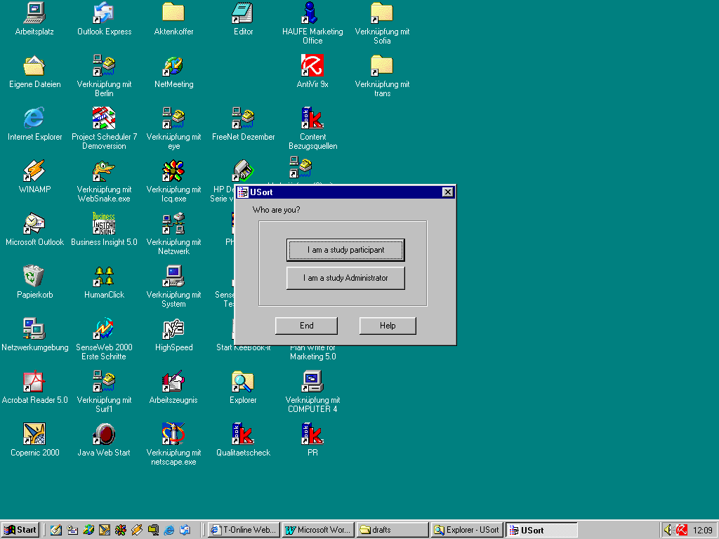
- Click on the Usort logo in the Start Menu
And select the button "I am a study participant"

- Enter a meaningful name for the test person (your organisations shortcut, test type and consecutive number of test person)
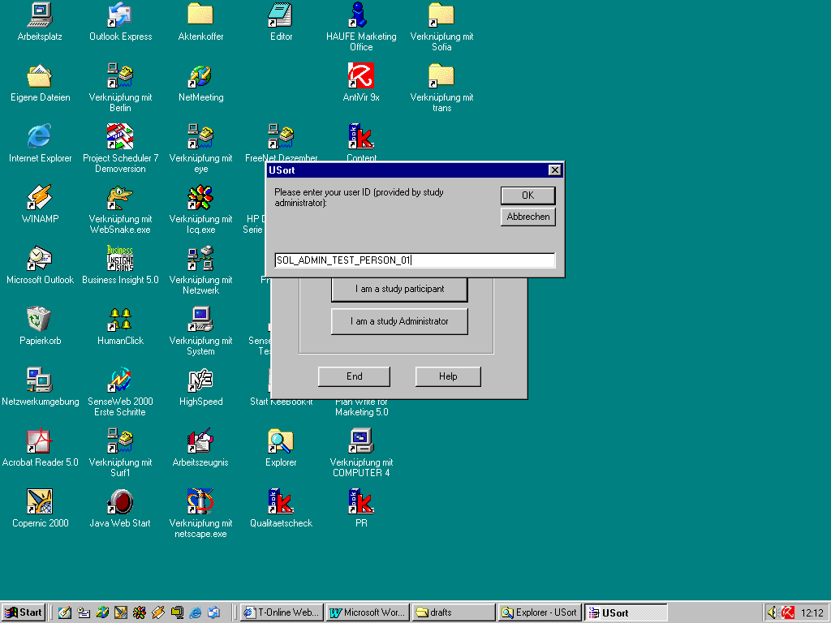

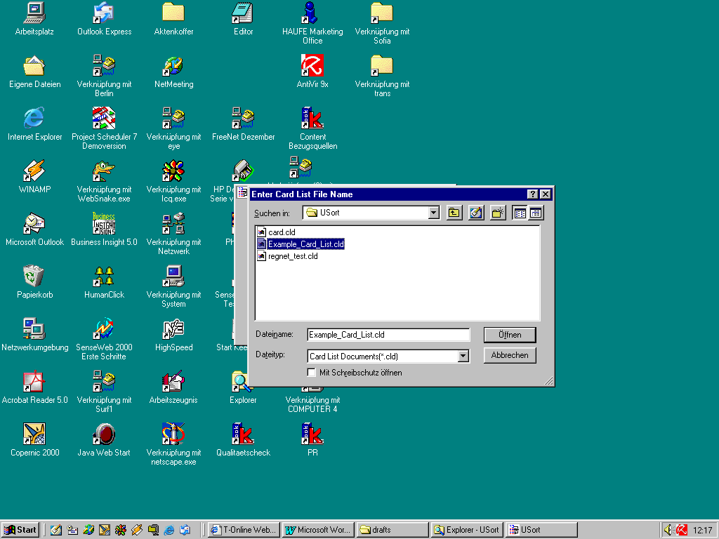
- Select the file which contains the original cards
(regnet_professional_nav.cld for the cards for professional users and regnet_user_nav.cld for the cards for end users)

Carry out the test

Instruction - Step 1
The objective of Step 1 is to create logical groups from the items in the Source field.
- To create each new group, drag an item from the Source field under the bottommost line in the Target field. The single line above and below items in the TARGET field shows that a group has been formed.
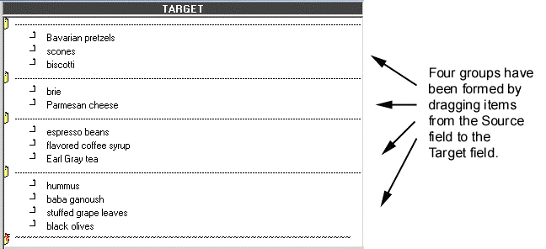2. To add an item to an existing group, drag it from the Source field onto the line above the desired Target group. It will join the group when you release the mouse button.
- To move multiple items to a group, first click the checkbox to the left of each item, then drag the items simultaneously to the Target field.
- If you change your mind about where an item belongs, you can drag it to another group or back to the Source field.
Leave the items you do not know in the Source field.

3. When you are satisfied with the groups you have created, click the right arrow to go to Step 2.
Once you go to Step 2, you cannot return to Step 1.

Instruction - Step 2
The objective of Step 2 is to combine the groups you have already created into higher-level groups. In other words, some of your groups may be similar and may belong together in “groups of groups.”
To create the higher-level groups:
1. Move the similar groups next to each other by dragging the folder icon of one group atop the folder icon of the other.
2. Double-click the separator lines above and below the groups you have put together.
- The single lines will change to double-lines, which indicate a higher-level group.

Repeat steps 1 and 2 for all higher-level groups.

3. When you have created all of your higher-level groups, check for any groups that have not been merged into higher-level groups. Change all the single lines between these original groups to double lines.
- You can double-click to change a line from single to double, and back again.
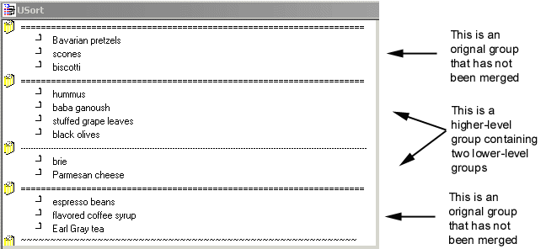
When you are satisfied with the higher-level groups you have created, click the right arrow to go to Step 3. Once you go to Step 3, you cannot return to Step 2.

Instruction - Step 3
The objective of Step 3 is to give a descriptive name to each higher-level group of items.
To assign a name:
1. Click the double-line at the top of a group.
2. Type the name in the dialog box and click OK.

Repeat for each group (double line).
3. When you have finished naming the groups, click the right arrow to finish your session.
- You will be prompted to save your input file as your_user_ID.esd.
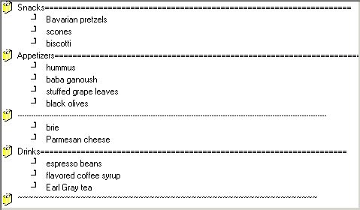

Saving the results and leaving Usort

Quit the Usort program
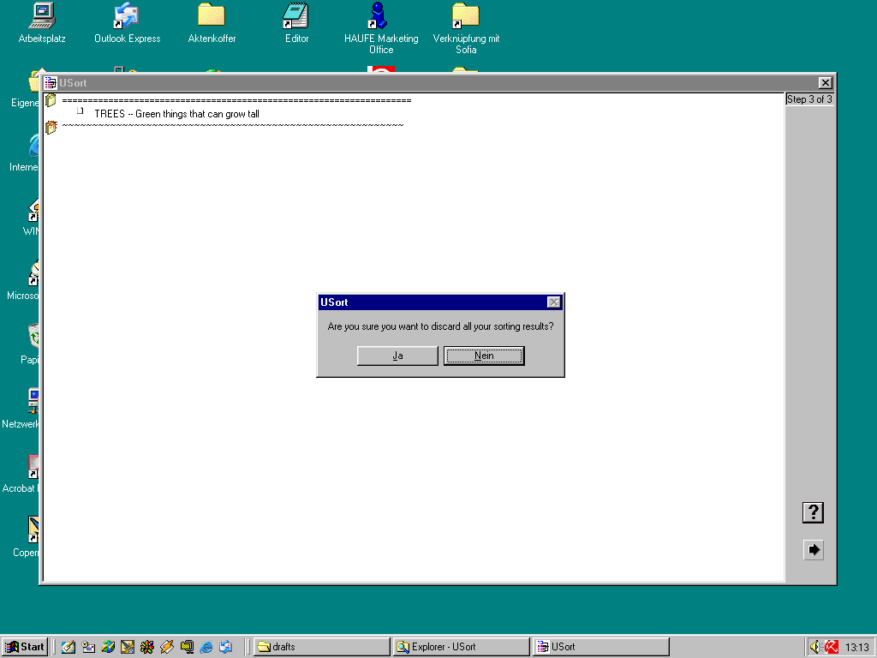
Once you have finished the last step of the test, Usort presents a dialogue in which it ask you to either finish the test or go back to the last step. If you want to finish the test confirm the dialogue by clicking on "yes" or go back to the last step of the test.

Save the results and send them to IMAC
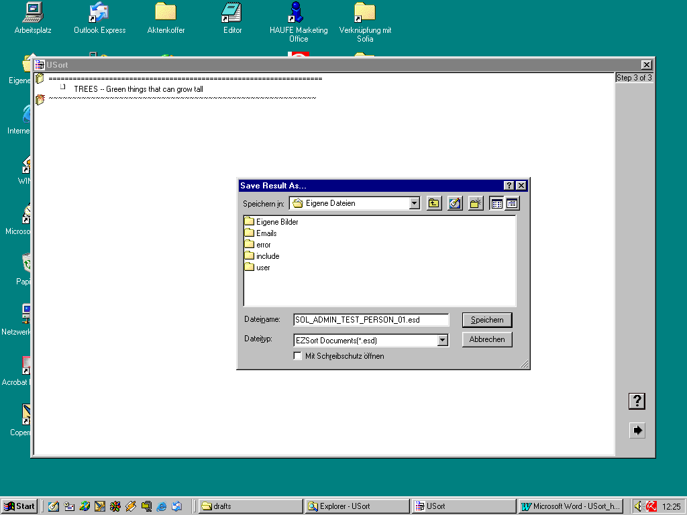
Once you are finished you are requested to enter the name of the results file. Enter a meaningful name for the test person (your organisations shortcut, test type and consecutive number of test person). As soon as you have finished all the tests email all the results file to IMAC.
These are all of your tasks !

IMAC will evaluate the result files of all partners and inform you on the outcome of the card sorting exercise.

