Attachment - PMG-01-01 / 013:
Working Plan for the first three months

Task | Task/WP Description | Deliverables and milestones | Start Date | Coordinator
WP 1 | Analysis of the State of the Art and Development of Concepts | D1, D2, D3 -> 2001-09-30 (1.Milestone) | 2000-04-01 | ZEUS
T 1.1 | Definition of content to be provided | IR 1.1 Interim Report -> 2001-06-30 (D1) | 2000-04-01 | IMAC
T 1.3 | Identification of standards to be used | IR 1.3 Interim Report -> 2001-05-31 (D2) | 2000-04-01 | IAT
T 1.4 | Development of the Systems Specifications | IR 1.4.1 Interim Report -> 2001-06-30 (D2) | 2000-05-01 | VALT
T 1.6 | Definition of Supported Business Functions | IR 1.6 Interim Report -> 2001-06-30 (D3) | 2000-04-01 | VALT
T1.7 | Identification of Market (Segments) and User Groups | IR 1.7.1 Interim Report -> 2001-06-30 (D3) | 2000-04-01 | TINC
WP 5 | Development of a technolo-gical implementation plan (TIP) | D12 -> 2003-03-31 (5. Milestone) | 2000-04-01 | MOT
T 5.1 | TIP - 1. Version | IR 5.1.1 Interim Report -> 2001-06-30 (D12) | 2000-04-01 | MOT
WP 6 | Dissemination and Use Plan | D13 -> 2003-03-31 (5. Milestone) | 2000-04-01 | SPACE
T 6.1 | Information Dissemination | IR 6.1.1 Interim Report -> 2001-06-30 (D13) | 2000-04-01 | SPACE
WP 7 | Project Management | D15 -> 2003-03-31 (5. Milestone)  D16, D17 -> 2001-06-30 | 2000-04-01 | AIT
T 7.1 | Co-ordination | Bimonthly Report -> 2001-05-31 | 2000-04-01 | AIT
T 7.2 | Quality Assurance | IR 7.2 Interim Report -> 2001-06-30 (D14) | 2000-04-01 | MOT

Technical Annex: 9.5 Project planning and timetable

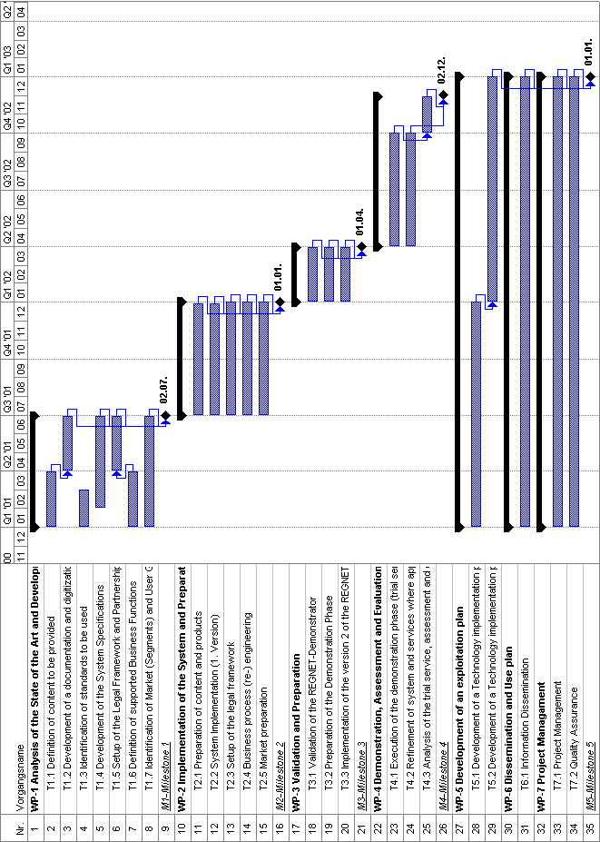

9.6 Graphical presentation of project components
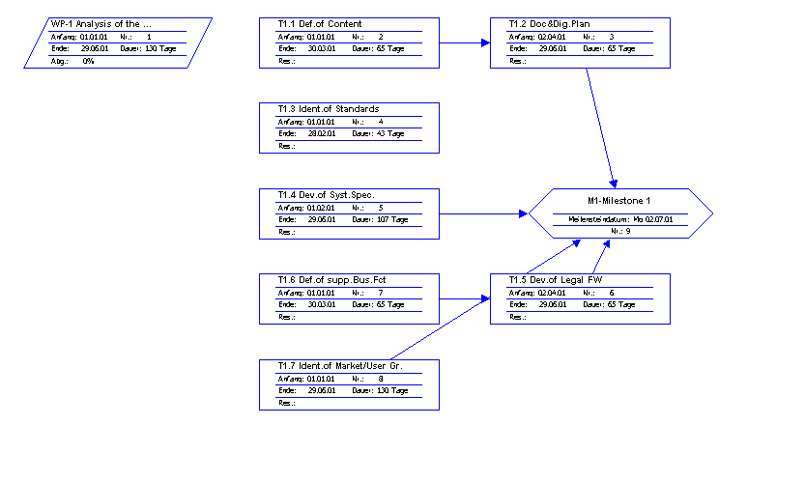
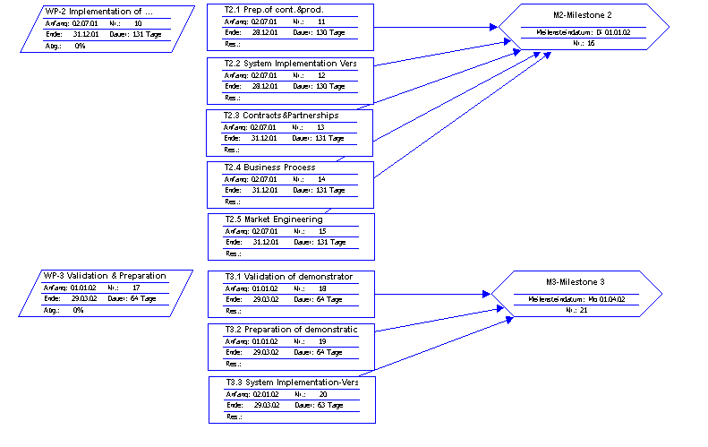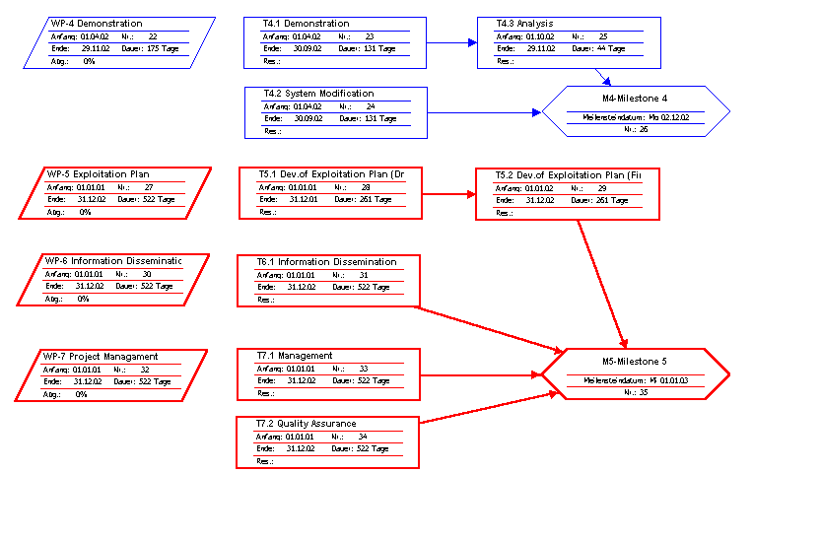

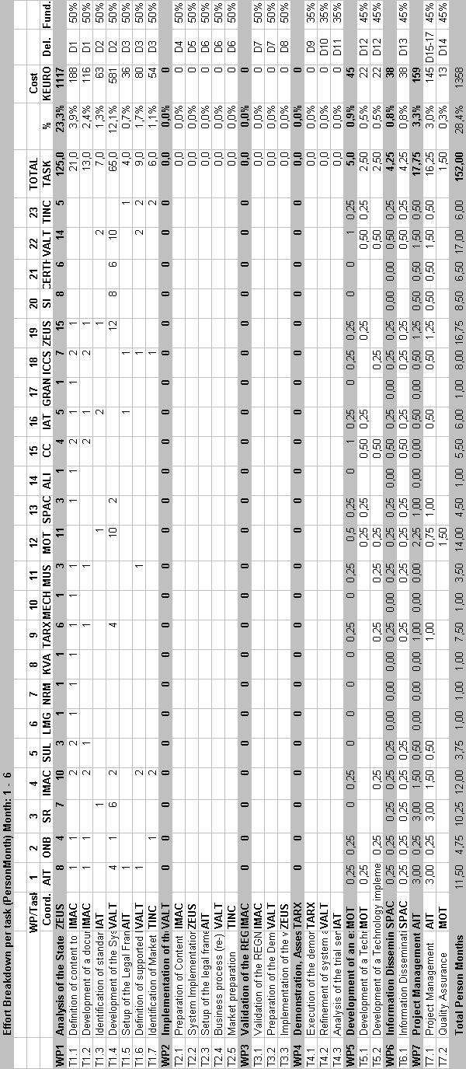



REGNET-IST-2000-26336
Task Brief
WP Number and Title |  | WP x
Task Number and Title |  | T x.y
Task Leader and Contact
Deliverable Number and Title |  | D z
Interm. Report Number and Title |  | IR x.y<.n>
Start Date: | yyyy.mm.dd |  | End Date: | yyyy.mm.dd
Methodology:
Partner | Contact (email) |  | Obligation
- AIT
- ONB
- SR (UniVie)
- IMAC
- SUL
- LMG
- NRM
- KVA
- TARX
- MECH
- MUS
- MOT
- SPAC
- ALI
- CC
- IAT
- GRAN
- ICCS(SUSU)
- ZEUS
- SI
- CERT
- VALT
- TINC

