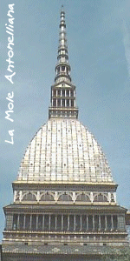 Motorola GSG Italy
most preferred hotels In Turin 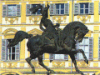

This is a list of Motorola Electronics, GSG Italy’s Recommended Hotels. Please note that the great number of them are located downtown. We suggest you get a taxi from these hotels to reach the facility (the normal journey time should be approximately 20 minutes). Just the first one listed here below is in the vicinity of the facility, approximately 5/10 minutes of driving.

****PACIFIC HOTEL FORTINO  Strada del Fortino, 36 – 10152 TURIN  Phone: (+39) 011 521.77.57  Fax: (+39) 011 521. 77.49  E-mail: hotelfortino@pacifichotels.it  Link: www.pacifichotels.it  Contact Person: | Preferred rates for Motorola  -Single room: €101.00  -Double room: €151.00  -Single use double room: €130.00  -Suite: €210.00  -Suite (residential use): €515.00  Note: This last kind of accommodation requires at least one month of stay and the rate reported is weekly counted  Here following the W/E rates (week-end rates).  -Single room: €86.00  -Double room: €111.00  -Single room use double: €86.00  -Suite: 141.00  Note: These rates include late check-out on Sundays till 5.00 p.m. and free B/B solution for young people less than 15. | No BTI rates
Description:  The “Pacific Hotel Fortino” provides the guests with more than 100 rooms. All of them are well furnished. In addition there are  - 8 Suites mini-flats equipped with hydro massage;  - PC connection, interactive and TV set in all the rooms.  - Wide garage. | Restaurant and Bar: | How to get there:  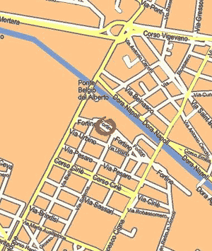

****GRAND HOTEL SITEA  Via Carlo Alberto, 35 - 10123 TURIN  Phone: (39) 011 5170171  Fax: (39) 011 548090  E-mail: sitea@thi.it  http://www.thi.it/english/hotel/sitea/index.htm  Contact person:  Note: You can find further details connecting to the site of  http://travel.mot.com | Preferred rates for Motorola  -Single room (standard): €114  -Single room (superior): €135.50  -Double room: €184.50  -Single use double room: €162.50  -Junior suite: €235  Note: All the fares include the breakfast | Preferred rates by BTI  -Single room (standard): €102.5  -Single use double-room: €207.5  -Double room: €234.00  Note: All the fares include the breakfast
Description:  118 rooms, including three junior suites recently renovated and tastefully decorated.  Individually regulated heating and air conditioning, fridge-bar, room service.  Telephone with direct outside line, database socket, television with remote control, satellite TV, pay TV and cable. | Restaurant and Bar:  The Carignano Restaurant with its elegant Empire style décor is renowned for its preparation of the best regional dishes.  It can seat up to 80 guests. | How to get there:  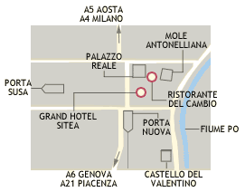

****STAR HOTEL MAJESTIC  C.so Vittorio Emanuele II, 54 10123 TURIN  Phone: (+39) 011. 539153  Fax: (+39) 011. 534963  E-mail: majestic.to@starhotels.it  http://www.starhotels.it/  Contact person: Mrs. Conte | Preferred rates for Motorola  -Single room (standard): €120  -Single use double room: €139  -Double room: €155  -Single use double room:  Superior, €143  -Double room-Superior: €167  -Executive rooms:  - Single use double room: €159  - Double room: €175  -Junior Suite:  - Single use double room: €175  - Double room: €189  -Suite:  - Single use double room: €220  - Double room: €241  Note: All the fares include the breakfast | Preferred rates by BTI  -Single se double room: €155  -Double room: €173  --Executive rooms:  - Single use double room: €178  - Double room: €196  Note: All the fares include the breakfast
Description:  The hotel has162 guest rooms, including those classified as an Executive Room, all very spacious and comfortable. The convention center is made up of 11 configurable meeting rooms, which can accommodate from 20 to 484 for a grand total of 778 people. It is avant-garde in every aspect and is the largest hotel convention center in the city.  EXECUTIVE ROOMS: Designed for the business guests, they are the most innovative solution to combine business and comfort. | RESTAURANT AND BAR:  The "Il Circolo" bar is open until midnight every day and is the ideal place for relaxing break.  The "Le Regine" restaurant inside the hotel offers an excellent international cuisine, together with typical local dishes. Organization of banquets and cocktail parties. Maximum number of persons: Seats 230; Buffet 360; Cocktail 360. | How to get there:  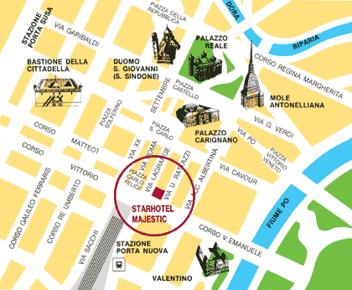

*****Best Western Hotel City  Via Filippo Juvarra 25  10122-Turin  Phone: (+39) 011/54 05 46  Fax: (+39) 011/54 81 88  E-mail:  http://www.bestwestern.com/  Note: You can find further details connecting to the site of  http://travel.mot.com | Preferred rates for Motorola  -Single room (Standard): €116.00  Note: All the fares include the breakfast | Preferred rates by BTI  -Single room (Standard): €116.00  -Double room (Standard): €140.00  Note: All the fares include the breakfast
Description:  *Cable/satellite TV  *All news cable channel  *Air-conditioned  *Hairdryer  *Minibar  *Safe. Charge: .00  *Early check-out fee: (Currency) | RESTAURANT AND BAR:  There is a restaurant inner the hotel where the meals are served there. | How to get there:  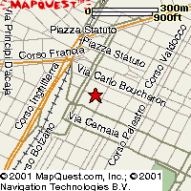
****JOLLY HOTEL AMBASCIATORI  Corso Vittorio Emanuele, 104 10121 Torino  Phone: (+39) 011. 5752  Fax. (+39) 011. 544978  torino_ambasciatori@jollyhotels.it  http://www.jollyhotels.it/eng/  Note: You can find further details connecting to the site of:  http://travel.mot.com | Preferred rates for Motorola  -single room standard: €116  -double room standard: €139 | No BTI rates
Description:  199 rooms with air conditioning | RESTAURANT AND BAR  “Il Diplomatico” restaurant offers a modern environment; it was restored one year ago. The main hall can accommodate more than 130 people; in addition there are other little halls with 120 people of capacity. The cookery is international but even regional and the wine’s menu is rich and various. | How to get there:  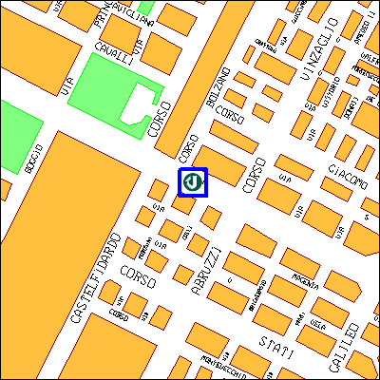
****JOLLY HOTEL PRINCIPI DI PIEMONTE  V. P. Gobetti 15-10123 TURIN  Phone: (+39) 011/55 77 111  Fax: (+39) 011/53 24 96  torino_principidipiemonte@jollyhotels.it  http://www.jollyhotels.it/eng/ | Preferred rates for Motorola  -Single room (standard): €145  -Double room (standard): €171  -Single room (superior): €157  -Double room (superior): €183 | No BTI rates
Description:  106 room with air conditioning, satellite Tv, minibar | RESTAURANT AND BAR  “L’ Gentilhomme” restaurant is inside the hotel and the main hall can accommodate more than 45 people. The cookery is international but regional too. The choice of wine is various and vast. | How to get there:  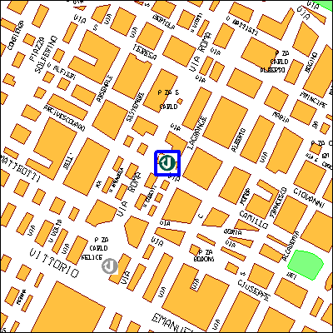
***JOLLY HOTEL LIGURE  P.za Carlo Felice 85  10123 TURIN  Phone: (+39) 011/556 41  Fax: (+39) 011/53 54 38  E-mail:torino_ligure@jollyhotels.it  http://www.jollyhotels.it/eng/  Note: You can find further details connecting to the site of:  http://travel.mot.com | Preferred rates for Motorola  -Single room (standard): €116  -Double room (standard): €140 | No BTI rates
Description:  169 rooms with air conditioning | RESTAURANT AND BAR:  "Il Birichino" restaurant, bar, meeting rooms | How to get there:  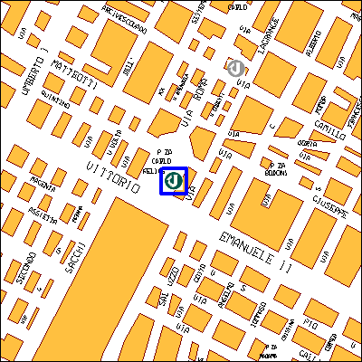

PREFERRED HOTELS BY BTI

(the hotels’ quality listed here below are guaranteed by BTI which offers preferred fares for the guests, but please NOTE they are not Motorola preferred suppliers)

- ****Quality HOTEL ATLANTIC
Via Lanzo, 163
BORGARO TORINESE
Phone: (+39) 011/450 00 55
Fax: (+39) 011/470 17 83
Fares:
- Single room: €97.00
- Double room: €97.00
Note: Breakfast is included.
This hotel is particularly suggested
to whom likes staying near the airport.

- ****Turin PALACE
Via Sacchi, 8
TORINO
Phone: (+39) 011/56 25 511
Fax: (+39) 011/56 12 187
Fares:
- Single room: €103.24
- Double room: €133.69
Note: Breakfast is included.
This hotel is placed by P.ta Nuova Rail station

- ****DIPLOMATIC
Via Cernaia, 42 TORINO
Phone: (+39) 011/56 12 444
Fax: (+39) 011/54 04 72
Fares:
- Single room: €99.00
- Double room: €134.00
Note: Breakfast is included.
This hotel is placed by P.ta Susa Rail station

RESIDENCES

****Executive Residence
Via Nizza, 28 – 10125 TORINO
Phone #: +39 011 650 77 07
Fax #: +39 011 650 77 00
E-mail: hotel.executive@tin.it

Rates: €1.400 per month for least 30 days’ permanence
(open space with cooking area)

In case you would like to have breakfast service included the rate would increase at €1.600 per month

****Star Residence
Via Susa, 5 – 10138
Phone #: +39 011 43 46 100
Fax #: +39 011 43 46 131
www.residencestar.com
E-mail: resistar@tin.it

Monthly permanence:
-Small single-room flat €1080.00
-Big single-room flat: €1200.00
-Small single-room flat with a night area: €1300.00
-Double-room flat: €1450.00
-Duplex Double-room on two floors: €1600.00

For the accommodation of a second person
-Monthly rate €130.00
-Daily rate €16.00

Weekly permanence:
-Single occupation €400.00
-Double occupation €500.00

Daily permanence:
-Single occupation €62.00
-Double occupation €78.00

Parking rate: -Per month €82.00
-Per week €30.00
-Per day €6.00

****Residence Nizza
Via Nizza, 26
Phone #: +39 011 65 22 111
Fax #: +39 011 66 93 927
www.residencenizza.it

Monthly permanence:
-Small single-room flat: €1000.00
-Small single-room flat (double bed): €1188.00
€1214.00
€1239.00
-Double-room flat (double bed): €1340.00

Parking rate: Per month €63.00

