REGNET Team Meeting 21-22 (23) November 2002 DEN HAAG

Dear Partners,
As to stimulate you all to come to the Regnet Team Meeting please find hereunder some information on Den Haag, how to get there etc.

The meeting will take place in the Museon, Stadhouderslaan 41, 2517 HV Den Haag. www.museon.nl

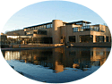

The hotel for this meeting is “Hotel Corona”, Buitenhof 39-42, 2513 AH, Den Haag. www.corona.nl

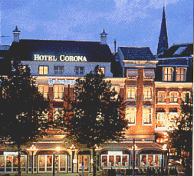

We reserved a block of rooms, negotiated “favourable” rates for the rooms. A single room in this 4-star Golden Tulip hotel costs 95 Euro during the weekend (i.e. Fri, Sat and Sun) and 110 Euro during the week. Breakfast is 15 Euro. As to compensate this price a little, Museon will take care of the costs of the lunches. And since we can accommodate the meeting in the Museon, there will be no costs for the meeting locality. Every room has an Internet-connection via a separate RJ11 wall outlet (analogue PSTN). The use of this connection is charged to your room. There are also Internet-connections available in the Museon.

In the accompanying template you can fill in your choices. We have also added the possibility to book the hotel for Saturday night.

May we ask to fill in the template as soon as possible and send it back to the e-mail address mentioned hereunder. This to be able to book a room, give the necessary confirmations to the hotel and make certain that we can accommodate everybody.

The partners who wish an accommodation different from the one that we propose can contact us on an individual basis at the e-mail address mentioned hereunder. We will then try to set up the necessary arrangements.

The first meeting day (Thursday 21 November) will start at 9.00 hours and coffee will be ready and waiting for you.

More details, tram and bus numbers for travelling to hotel, Museon etc. will be sent shortly after you have registrated for the meeting.

Rob Schouten
rschouten@museon.nl

