3rd Review Presentations  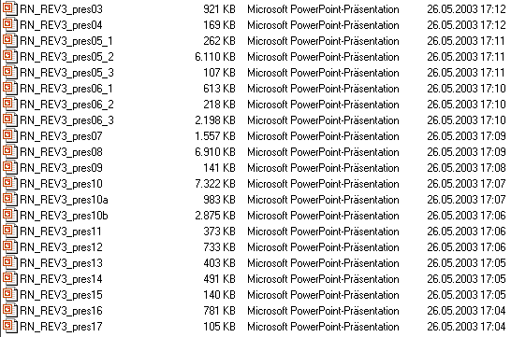 |   Cultural Heritage in  REGional NETworks  REGNET IST-2000-26336  3rd Review Presentations  2003-03-27, Luxembourg    Copyright © 2003 The REGNET Consortium

